|  |  |
| --- | --- |
| Software installation and commissioning manual | |
|  | |
|  |  |

|  |  |
| --- | --- |
| Publication type: | Software Installation and  Commissioning Manual |
| Publication number: | ACC |
| Title: |  |
| Subject: |  |
| Issue: | 2.1.1 |
| Publication date: | 28 November 2014 |
| Total number of pages: |  |
| Author: |  |
| Quality Control: |  |

Table of contents

Page #

Figures 7

Tables 10

References 12

Introduction 13

About the installation and commissioning manual 13

Safety instructions 15

Revision history 15

1. Part 1: The operators Manual 16

1.1 Human Machine Interface 16

1.2 Taskbar 16

1.2.1 User rights 17

1.2.2 Palette 18

1.2.3 Mimics 18

1.2.3.1 Mimics 19

1.2.3.2 General 19

1.2.3.3 Mimic examples 19

1.2.3.4 Reading the mimic 20

1.2.4 Logbook 22

1.2.4.1 Logbook groups 22

1.2.4.2 Logbook appearance 23

1.2.4.3 Logbook status indication 23

1.2.4.4 Logbook search bar and buttons 24

1.2.5 Group viewer 26

1.2.5.1 The search bar 27

1.2.6 Settings 28

1.2.7 Alarm Mimic 29

1.2.7.1 Alarm icons 30

2. Alarm System 33

2.1 Introduction 33

2.2 Alarm handling 33

2.3 Alarm handling in the alarm mimic 35

2.3.1 Explanation of alarm rights 35

2.4 Duty alarm system 36

2.4.1 Extra buttons alarm mimic 39

2.4.2 Duty alarm principal 42

2.4.3 Alarm types 42

2.4.3.1 Alarm detection for analogue signals 42

2.4.3.2 Alarm detection for on/off (two state) signals 42

2.4.3.3 Alarm detection for on/off signals with line check 43

2.4.4 Attended alarm mode 43

2.4.5 Unattended alarm mode 43

2.4.6 How to acknowledge an alarm 44

2.4.7 How to silence an alarm (not at ECR) 44

2.4.8 When will an alarm disappear 44

3. Personnel alarm 44

3.1 Engineer Deadman 44

3.1.1 Scope 44

3.1.2 The Engineer Deadman System incorporates the following operational modes: 44

3.1.3 Operational State 45

3.1.4 Reset function 45

3.1.5 Emergency call facility 45

3.2 BNWAS 46

3.2.1 Introduction 46

3.2.2 The HMI overview 46

3.2.3 The HMI explained 47

3.2.4 The setup page 49

4. Annex 1 Mimic control 53

4.1 Mimic components 53

4.2 Component behaviour 55

5. Part 2: Extra settings for (Commissioning) Engineer 61

5.1 General 61

5.2 Users 61

5.2.1 User name 62

5.2.2 Login at startup 62

5.2.3 Password 62

5.2.4 Language 62

5.2.5 Rights 62

5.2.6 Add / Remove 63

5.3 Field settings 65

5.3.1 Alarm 66

5.3.1.1 Alarm levels 66

5.3.1.2 Inhibit Properties 67

5.3.1.3 Auxiliary Properties 68

5.3.2 Min/Max 69

5.3.2.1 Instrument range 69

5.3.2.2 Setpoints 70

5.3.2.3 Setpoint delay 70

5.3.2.4 Decimals 70

5.3.2.5 Default unit 71

5.3.2.6 Filter 71

5.3.2.7 Pulse/Request time 71

5.3.3 Tune 72

5.3.3.1 Tune Table 72

5.3.3.2 Result 74

5.3.3.3 Sender 74

5.3.4 Comment 75

5.3.4.1 Group label 75

5.3.4.2 Group label logbook 75

5.3.4.3 Field label 76

5.3.4.4 Field label instrument 76

5.3.5 Auto Switch 77

5.3.5.1 General 77

5.3.5.2 Autoswitch Method 77

5.3.6 Log 79

5.3.6.1 Logging 79

5.3.6.2 Interval 79

5.3.6.3 Filename 79

5.3.7 Logging with trending 79

5.4 Alarm stations 82

5.4.1 Alarm Matrix 82

5.4.2 The matrix 83

5.4.2.1 This station 83

5.4.2.2 Is fallback for 83

5.4.2.3 Show all alarm stations 84

5.4.2.4 Alarm group rights/Duty alarm rights 84

5.4.2.5 Adjustments 84

5.4.2.6 How to set Alarm Group Rights 84

5.4.3 Background 87

5.4.4 Alarm Panels 88

5.4.4.1 Mimics 88

5.4.4.2 VPN 89

5.4.4.3 BNWAS 89

5.4.4.4 Wheelmark 89

5.4.5 Alarm groups 90

5.4.6 Alarm Settings 91

5.4.7 Preferences 92

5.4.8 Taskbar 92

93

5.4.9 GPS/NMEA 94

5.4.10 GPS calculates the position in/The position is shown in 94

5.4.11 Trace of received NMEA data 94

5.5 Configuration 95

5.5.1 General 95

5.6 License 95

5.7 Serial 96

5.7.1 General 96

5.7.2 COM ports 96

5.7.2.1 COM port assignment 97

5.7.2.2 Special note on printers 100

5.7.3 Serial LAN ports 101

5.7.3.1 Serial LAN server 101

5.7.3.2 Type (Moxa UC-711X) 102

5.7.4 CAN ports 103

5.7.5 Overview connected devices 104

5.7.6 IP-Address standardization 105

5.8 Wago 106

5.8.1 General 106

5.8.2 Adding a field to the Wago 107

5.8.3 Wago “Type” explanation 108

5.8.4 Type and behavior 109

5.8.5 Wago calibration 114

5.9 Network 117

5.10 System Layout 118

5.11 Soft PLC 119

5.11.1 General 119

5.11.1.1 Basics 119

5.11.2 Simple example 119

5.11.2.1 Start 120

5.11.2.2 Control 123

5.12 Tank Tables 124

5.12.1 General, 124

5.12.2 Types of sensors 124

5.12.2.1 Floating sensor 124

5.12.2.2 Capacitive sensor 124

5.12.2.3 Pressure sensor 124

5.12.3 Calculations 126

5.12.4 Offset 126

5.12.5 Inserting sounding tables 129

5.12.5.1 Tank Group 130

5.12.5.2 Excel import 130

5.12.5.3 Import from excel 133

5.12.6 Trim and List 134

5.12.6.1 Roll and Pitch in the Tank Table 135

5.12.6.2 Trim and list in Excel 136

5.13 WatchIO 139

5.13.1 Programming 139

5.13.2 Communication problems 141

6. BNWAS Settings 142

6.1.1 Configuration screen 142

7. Performance 147

7.1.1 Preface 147

7.1.2 Modules 147

7.1.3 Memory 148

7.1.5 Threads 149

7.1.6 Network 150

7.1.7 IP Owner List (which OWS is handling which ip’s) 151

7.1.8 IP 152

7.1.9 Serial 153

8. Commissioning 157

8.1 Purpose 157

8.2 Preconditions 157

8.3 Safety information 158

8.4 Commissioning steps 158

8.4.1 Wiring schematics 158

8.4.2 Wiring, cables and connections 158

8.4.3 System components 160

8.4.4 System start-up 160

8.4.5 NavVision software 161

8.4.6 Firmware devices 161

8.4.7 LAN and serial connections 162

8.4.8 CAN bus connections 163

8.4.9 Wago 163

8.4.10 PLC program 164

8.4.11 Wago performance 164

8.4.12 Buttons 165

8.4.13 Alarms and viewers 165

8.4.14 Tank calibration 166

8.4.15 Servers and clients 166

8.4.16 Alarms 167

8.4.17 Network connection 167

8.4.18 Viewer and mimics 168

8.4.19 Cold start and completion of test 169

Figures

Figure 1‑1: NavVision taskbar 16

Figure 1‑2: User selection 17

Figure 1‑3: Palette options 18

Figure 1‑4: Mimic menu 19

Figure 1‑5: Mimic example 1 20

Figure 1‑6: Legend mimic 20

Figure 1‑7: Tank mimic 21

Figure 1‑8: Alarm list and logbook in mimic 21

Figure 1‑9: logging groups, all selected 22

Figure 1‑10: interconnecting log appearance 23

Figure 1‑11: Status indication log-entries 23

Figure 1‑12: Logging colors 24

Figure 1‑13: Logbook search bar and buttons 24

Figure 1‑14: Search calendar 25

Figure 1‑15: Print button 25

Figure 1‑16: Up- down buttons 25

Figure 1‑17: Group viewer 26

Figure 1‑18: Group Viewer columns 27

Figure 1‑19: Search bar 27

Figure 1‑20: Alarm groups 27

Figure 1‑21: Categories group 28

Figure 1‑22: Categories subgroup 28

Figure 1‑23: Group viewer in alarm 28

Figure 1‑24: Group viewer mimic and I/O location 28

Figure 1‑25: Alarm mimic 29

Figure 1‑26: Print button 31

Figure 1‑27: Up- down buttons 31

Figure 2‑1: typical alarm sequence 34

Figure 2‑2: Alarm group row 35

Figure 2‑3: silence/acknowledge-button 35

Figure 2‑4: typical Alarm panels 36

Figure 2‑5: Typical DAP screen 39

Figure 2‑6: Bridge set-up icons 39

Figure 2‑7: ER set-up icons 39

Figure 2‑8: Call function 41

Figure 2‑9: Duty select function 41

Figure 2‑10: receiving call message 41

Figure 2‑11: Crew information 42

Figure 3‑1: Password entrance panel 45

Figure 3‑2: Main BNWAS HMI 46

Figure 3‑3: HMI top bar 47

Figure 3‑4: HMI main screen 47

Figure 3‑5: HMI bottom bar 48

Figure 3‑6: HMI Panel 48

Figure 3‑7: Setup screen 49

Figure 3‑8: Keypad 50

Figure 3‑9: Setup main screen 50

Figure 3‑10: NavVision HMI on DAP 51

Figure 3‑11: NavVision Native screen 52

Figure 4‑1: Pop-up balloon 55

Figure 4‑2: control doughnut 56

Figure 4‑3: Vertical bar with alarm lines 56

Figure 4‑4: Edit keyboard 57

Figure 5‑1: Users 61

Figure 5‑2: Rights 62

Figure 5‑3: Add / Remove 64

Figure 5‑4: Field settings 65

Figure 5‑5: Alarm settings 66

Figure 5‑6: Inhibit Properties 67

Figure 5‑7: Inhibit When 68

Figure 5‑8: Inhibit When 2 68

Figure 5‑9: Min/Max settings 69

Figure 5‑10: Engine 1 oil pressure indicator (0 - 10 bar) 69

Figure 5‑11: Zone marking on older versions 70

Figure 5‑12: Decimals 70

Figure 5‑13: Default unit 71

Figure 5‑14: Tune table 72

Figure 5‑15: Tune Example 1 73

Figure 5‑16: adjusted tune table 73

Figure 5‑17: Tune Example 2 74

Figure 5‑18: Sender box 75

Figure 5‑19: Comment 75

Figure 5‑20: Autoswitch 77

Figure 5‑21: Autoswitch choices 77

Figure 5‑22: Auto Switch Conditions 78

Figure 5‑23: Auto Switch condition 78

Figure 5‑24: Logging 79

Figure 5‑25: Trending instrument 80

Figure 5‑26: Selection boxes 80

Figure 5‑27: time line 80

Figure 5‑28: Trending adjustments 81

Figure 5‑29: Saved trending file 81

Figure 5‑30: Station Matrix 83

Figure 5‑31: Settings example 85

Figure 5‑32: Alarm station settings 85

Figure 5‑33: Select by dragging 85

Figure 5‑34: Duty Select function 86

Figure 5‑35: Call Select function 87

Figure 5‑36: Alarm Panels 88

Figure 5‑37: Alarmpanel icons (Settings) 88

Figure 5‑38: Select the mimics 89

Figure 5‑39: Alarm Groups 90

Figure 5‑40: Alarm Settings 91

Figure 5‑41: Taskbar menu 92

Figure 5‑42: License 95

Figure 5‑43: COM ports 96

Figure 5‑44: Drop-down menu (device interfaces) 97

Figure 5‑45: COM port assignment 98

Figure 5‑46: additional configuration 98

Figure 5‑47: Comm Port Settings 99

Figure 5‑48: Printer settings 100

Figure 5‑49: Serial LAN ports 101

Figure 5‑50: Type (Moxa) 102

Figure 5‑51: Interface 103

Figure 5‑52: Standard 104

Figure 5‑53: Overview connected devices 105

Figure 5‑54: Wago configuration 106

Figure 5‑55: Wago expanded view 107

Figure 5‑56: Sensor-window 108

Figure 5‑57: Sensor type list 109

Figure 5‑58: Wago Device Manager 112

Figure 5‑59: Operating mode switch (Wago) 113

Figure 5‑60: Calibration 114

Figure 5‑61: Graph (WAGO calibration) 115

Figure 5‑62: Graph Calibrated 116

Figure 5‑63: Network 117

Figure 5‑64: System Layout 118

Figure 5‑65: Soft PLC 119

Figure 5‑66: SoftPLC Rename 120

Figure 5‑67: SoftPLC pop-up 121

Figure 5‑68: SoftPLC Assign Field 122

Figure 5‑69: SoftPLC first Line 122

Figure 5‑70: SoftPLC First Line_2 122

Figure 5‑71: Tank Pressure Sensor 125

Figure 5‑72: Tune table 127

Figure 5‑73: Tune Example 1 127

Figure 5‑74: adjusted tune table 128

Figure 5‑75: Tune Example 2 128

Figure 5‑76: Tank Tables 129

Figure 5‑77: Tank Group Drop Down 130

Figure 5‑78: Filling in tank tables 130

Figure 5‑79: Excel tabs 131

Figure 5‑80: Example Sounding Table 131

Figure 5‑81: Excel sheet import list 132

Figure 5‑82: Excel list sorted 133

Figure 5‑83: Imported Table 134

Figure 5‑84: Roll and Pitch 135

Figure 5‑85: Max Trim 135

Figure 5‑86: Max List 136

Figure 5‑87: Trim/List example 136

Figure 5‑88: trim and list excel example 137

Figure 5‑89: Tank Table excel Trim and List import 138

Figure 5‑90: WatchIO panel 140

Figure 5‑91: Exported nautic fields 140

Figure 5‑92: watchIO.uc.ini 141

Figure 6‑1: BNWAS configuration screen 142

Figure 6‑2: General settings 142

Figure 6‑3: IP address settings 143

Figure 6‑4: Wago output bit setting 144

Figure 6‑5: Wago Input bit setting 145

Figure 6‑6: Input Output counting Wago (i=Input, o=Output) 146

Figure 7‑1: Performance 147

Figure 7‑2: Memory 148

Figure 7‑3: Threads 149

Figure 7‑4: Network 150

Figure 7‑5: IP Owners List 151

Figure 7‑6: Performance > IP 152

Figure 7‑7: Serial 153

Figure 7‑8: Additional Serial Data 154

Figure 7‑9: Communication Diagnostics 1 155

Figure 7‑10: Communication Diagnostics 2 156

Tables

Table 1‑1: NavVision taskbar 16

Table 1‑2: Logging groups 22

Table 1‑3: Logbook colors 24

Table 1‑4: Group Viewer columns 27

Table 1‑5: Alarm Icons 31

Table 2‑1: Alarm panel buttons 38

Table 2‑2: Alarm mimic set-up icons 40

Table 4‑1: Control element status 57

Table 4‑2: Control elements and color animation 58

Table 4‑3: Control elements with status indication 59

Table 4‑4: Control elements with speed indication 60

Table 4‑5: Other control elements 60

Table 5‑1: Alarm Group Rights 84

Table 5‑2: Duty Alarm Rights 86

Table 5‑3: Port assignments 103

Table 5‑4: Pressure sensor explanation 125

Table 5‑5: Tank Tables 129

Table 5‑6: WatchIO 141

**NOTICE**

**This document contains proprietary information.**

**No part of this document may be photocopied, reproduced or translated into another language without the prior written consent of   
Free Technics B.V.**

References

[A] Sensorlist Manual

Introduction

The software installation manual provides instructions for adjusting, setting and configuring NavVision. The chapters and sections are organized in chronological order in which the relevant component must be installed and configured (where applicable).

About the installation and commissioning manual

The software installation manual contains the following chapters:

* Chapter “The Operators Manual” handles about the standard Operators Manual.
* Chapter “Duty Alarm System” explains how to work with the AM(C)S system and how the different parts are integrated in NavVision.
* Chapter “Personal Alarm” Explains the work and feel of the different Deadman-systems provided within NavVision.
* Chapter “Annex 1 Mimic control” contains extra information about mimics within the system.
* Chapter “Part 2: Extra settings for (Commissioning) Engineer” Gives extra information on settings within the system that are for all kind of engineers.
* Chapter “BNWAS Settings” is an extra explanation of the configuration settings for the BNWAS.
* Chapter “Performance” shows a tool for checking performance of the system on a deeper level.
* Chapter “Commissioning” contains a description of procedures to realize the acceptance test on-board the vessel.



*for specific information on interfaces, but also in depth information on here mentioned features, as well as here not mentioned features, we refer you to the specific manuals from NavVision that can be obtained through Free Technics.*Abbreviations list

AC Alternating Current

AI Analog IN

AO Analog Out

CAN Controller Area Network

COM Communication

CPU Central Processing Unit

DAP Duty Alarm panel

DC Direct Current

DI Digital In

DIN Deutsches Institut für Normung

DO Digital Out

DM Dead Man’s

ECR Engine Control Room

FT Free Technics

GEA General Engineers Alarm

GND Ground

GPS Global Positioning System

GRP Group

ID Identification  
I/O Input/Output

LAN Local Area Network

LED Light Emitting Diode

LPU Local Processing Unit

MAC Media Access Control

Mbps Megabit per second

NC Normally Closed

NMEA National Marine Electronics Association

NO Normally Open

OWS Operator Work Station

PIN Personal Identification Number

PLC Programmable Logic Controller

Rx Receive

SMS Short Message Service

SRAM Static Random Access Memory

TCP/IP Transmission Control Protocol/ Internet Protocol

TFT Thin Film Transistor

Tx Transmit

UDP User Datagram Protocol

USB Universal Serial Bus

Safety instructions

* This section provides only a summary of the safety requirements and notes in the following sections. To protect your health and prevent damage to the AM(C)S equipment or vessel, it is essential to read and carefully follow the safety instructions.*

The indications NOTE, CAUTION and WARNING have the following significance:



*NOTE:  
An operating procedure, practice or condition etc., which it is important to emphasize.*

**

*CAUTION:*

*An operating procedure, practise or condition etc., which, if not strictly observed, may damage AM(C)S equipment or crash NavVision software.*

* WARNING:*

*An operating procedure, practise or condition etc., which, if not carefully observed may result in personal injury or damage to the vessel.*

Revision history

Revisions issued since publication.

|  |  |  |  |
| --- | --- | --- | --- |
| **Issue** | **Date** | **Revision** | **Reason** |
| 1.0 | August 26, 2010 |  | initial release |
| 1.1 | July 19, 2012 | Update | Adjustments |
| 1.2 | September 14, 2012 | Update | Adjustments |
| 1.3 | September 20, 2012 | Extra information | Tank Tables |
| 1.4 | November 1, 2012 | Alterations | Edited |
| 1.5 | January 22, 2013 | Extra information | Tank tables calculations |
| 1.6 | February 26, 2013 | Update | Trending |
| 1.7 | March 03, 2013 | Update | Divers |
| 1.8 | April 14, 2013 | Update | Divers |
| 1.9 | June 13, 2013 | Update | Divers |
| 1.11.15 | November 21 2013 | Update | Divers |
| 1.12.16 | November 22, 2013 | Update | System Layout |
| 2.1.1 | November 30, 2014 | Decimus Update | New version |

# Part 1: The operators Manual

## Human Machine Interface

The FT NavVision *Human Machine Interface* (HMI) displays the current state of any physical device (I/O) on one or more monitor screen(s) by color, animation or values.

Moreover, when an undesirable state of a device is detected the operator will be notified by means of an audible and/or visible alarm signal. Messages concerning the alarm are added to the FT NavVision list of active or unacknowledged alarms (*Alarm Page*). This list can be displayed by clicking the Imtech logo in the center of the taskbar.

The HMI also supports remote platform control. Operators can control the platform (vessel) via the HMI.

## Taskbar

NavVision’s main User Interface (UI) element is the taskbar, positioned on top of each screen. The taskbar is home to the shortcuts to various settings, modules and mimics.

In addition, when an alarm is registered, the middle portion of the taskbar turns a bright red and shows the most recent unacknowledged alarm, the number of active alarms, and the total number of unacknowledged alarms. A single mouse click on this portion of the taskbar links to the extensive alarm viewer, showing the data for each active alarm such as time, alarm group, status and duration.

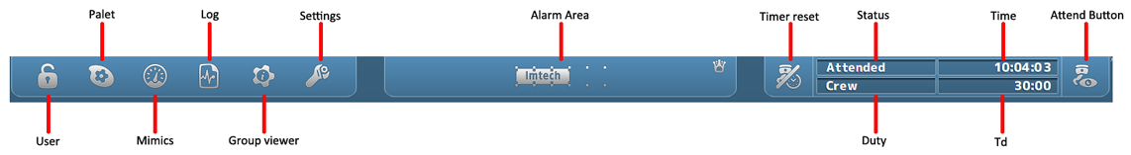

Figure 1‑1: NavVision taskbar

|  |  |
| --- | --- |
| **Takbar Icon** | **Explanation** |
| User | Setting of user and user rights |
| Palette | Setting of colors and day, dusk or night mode |
| Mimics | Selecting the mimics |
| Log | Show the log files |
| Group viewer | Show information on all I/O |
| Settings | Entry to all settings |
| Alarm Area | Click to show/hide alarm mimic |
| Timer Reset | Reset deadman timer, show active/inactive state |
| Status | Show status of attendance of the ER |
| Duty | Show person on duty |
| Time | Time |
| Td | Time dormant (for deadman timer) |
| Attend Button | Attend/unattended button for ER or Bridge |

Table 1‑1: NavVision taskbar

### User rights

FT NavVisionhandles control rights by using log-in credentials (username and password), and assigning rights to these credentials. These rights limit access to the system's configuration, therefore ruling out any edits that may harm the system made by unauthorised crewmembers.

Users can be added, edited or removed. Adding, editing and removing users, together with assigning their rights, can only be done by an administrator, i.e. a top-level user.

For every profile made, permissions can be set. The system is delivered with three pre-configured user-profiles, namely:

1. *Administrator*: has all rights;
2. *Guest*: can only use the available viewers;
3. *Operator*: can only alter display mode and/or units.

Login is required upon system start-up. After start-up, users can log off and log in using the dedicated button on the taskbar. By clicking the button, the following window will appear:

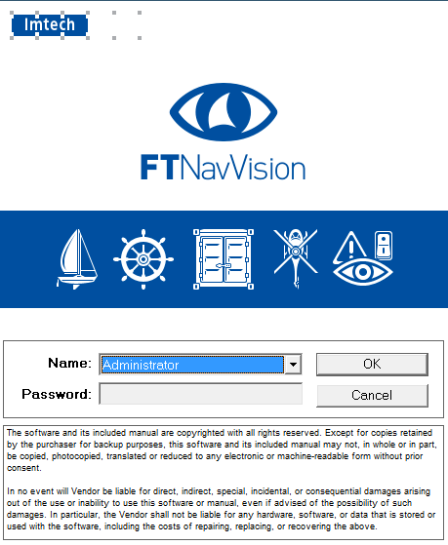

Figure 1‑2: User selection

By clicking the drop-down menu “Name”, you can choose which user you want to start. Provide the password if necessary and click “OK”.

### Palette

The palette is meant to give a quick selection to change the color settings of the screen. When you click the button, you’ll be presented with 4 choices (see Figure 1‑3).

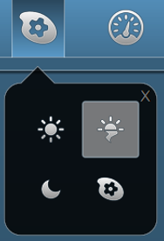

Figure 1‑3: Palette options

From left to right (beginning top left), there are three predefined buttons: Day, Dusk and Night. These choices give you the right colors and brightness for these specific periods of time. The last one is the palette selection tool. Using this, you can change the colors of the three presets to your liking.

**

*When you change the colors of a preset, be aware that there is no “Default” setting. It might be hard to get the colors back to their old state.*

### Mimics

When you click the mimic button, you’re presented with a grid of mimics available to you. It‘s possible that you have all the mimics as numbers so you have to choose the right number (see Figure 1‑4).

If you know the right number for the mimic you want to see, simply click on the corresponding icon.

Quite often, the only mimic icon that is presented is number one. This is the home mimic. From the home-mimic you can then navigate to other mimics.

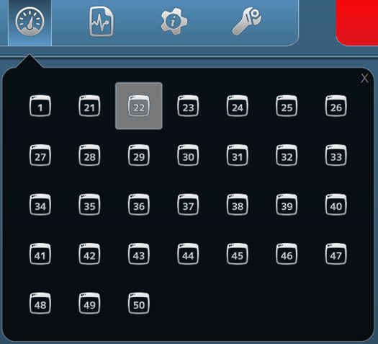

Figure 1‑4: Mimic menu

#### Mimics

The FT NavVision mimic presentation function provides schematic and graphical overviews of the vessel’s systems like navigation lights, electrical, piping and hydraulic overview.

The screens and mimics presentations are automatically updated with live data of the platform components illustrating components and/or system status.

Via these screens and mimic pages, the operator is able to monitor and control the vessel by using the trackball or touch-screen as a pointing device by selecting elements and their associated commands.

#### General

In general, we say that every page that represents a set of values, switches or any other representation of data is a mimic. The mimics within the system are all freely adjustable within the design stage. After the system is delivered, changes can be made by the NavVision engineers, on appointment. Small changes to the mimic can be made by a trained and skilled operator, who is granted some extra rights in the system. This trained crewmember will have the documentation, so we won’t discuss the changing of mimics in this manual.

#### Mimic examples

Although the mimics are freely adjustable, the main setup will be greatly alike on your screen. Imtech has defined some rules that the mimics have to live up to. This results in an overall recognizable style of mimics that gives it the modern and stylish look and feel.

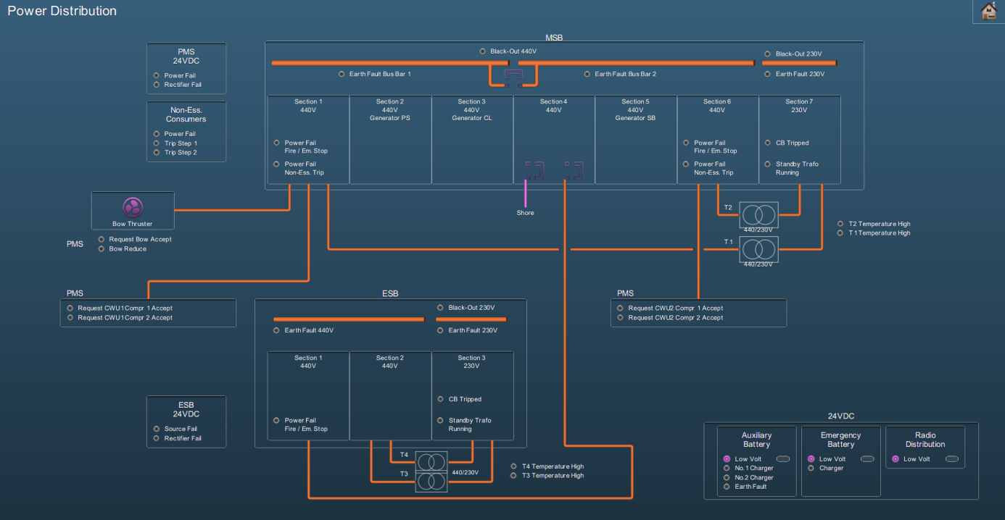

Figure 1‑5: Mimic example 1

#### Reading the mimic

Some installations contain a special *legend* mimic. This mimic explains the symbols, variations, colors etc. that you can find in your system’s mimics (see Figure 1‑6). If there is ever a doubt in what you observe on the mimic you are watching, please refer to this mimic.

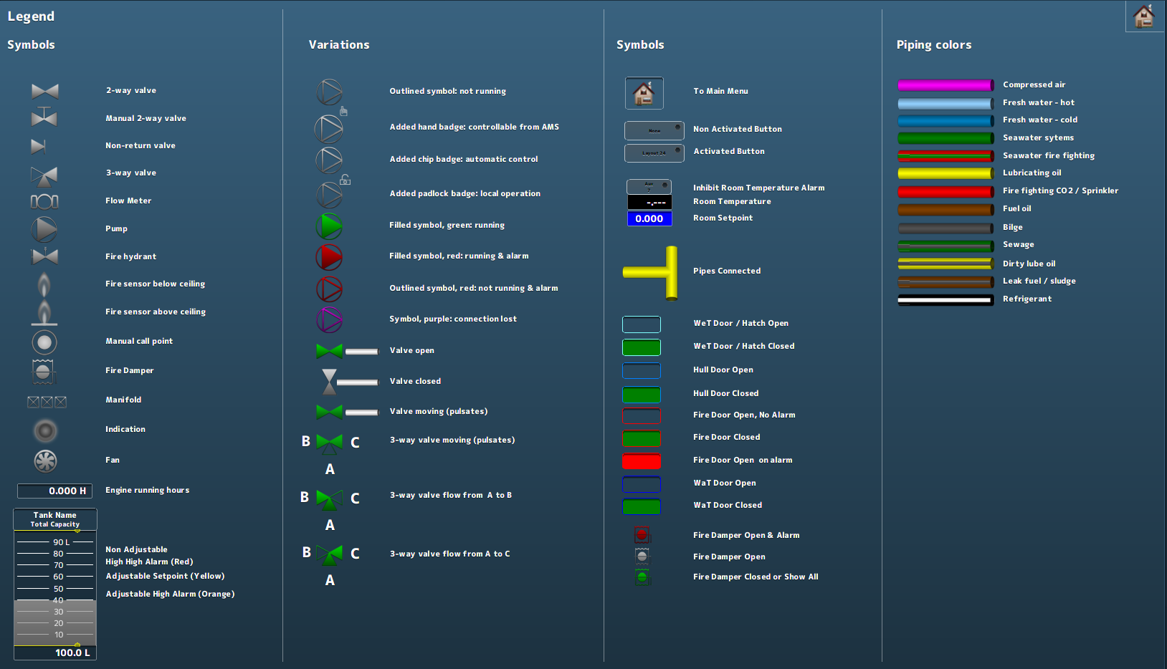

Figure 1‑6: Legend mimic

Other mimics can show a variety of information. There can be mimics for power distribution, tank volumes (see Figure 1‑7), fire alarms and many more. It is also possible that you have a combination of subjects on one mimic. Mimics are perfectly capable of displaying camera feeds or trend graphs.

As a special feature you can show the alarm list or the logbook on (part of) the mimic (see Figure 1‑8).

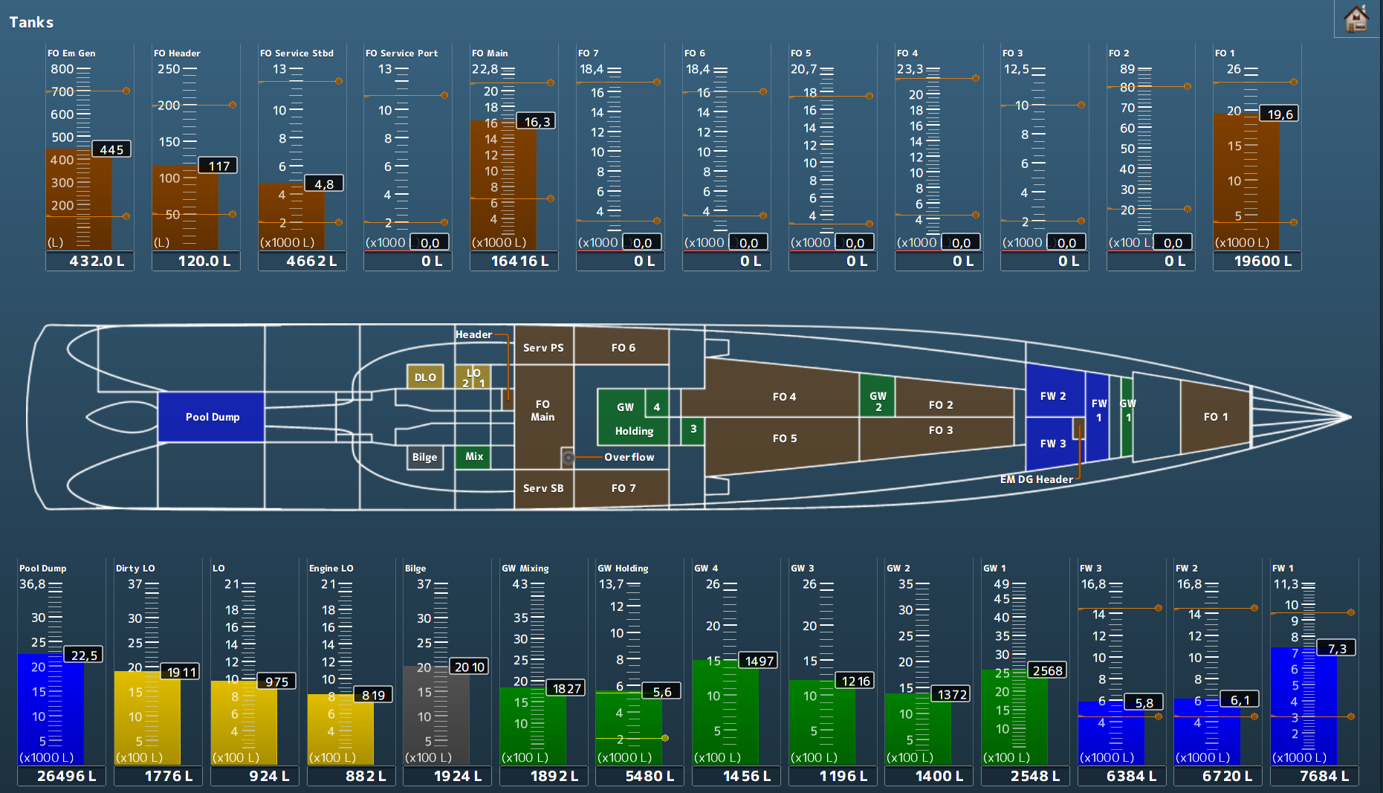

Figure 1‑7: Tank mimic

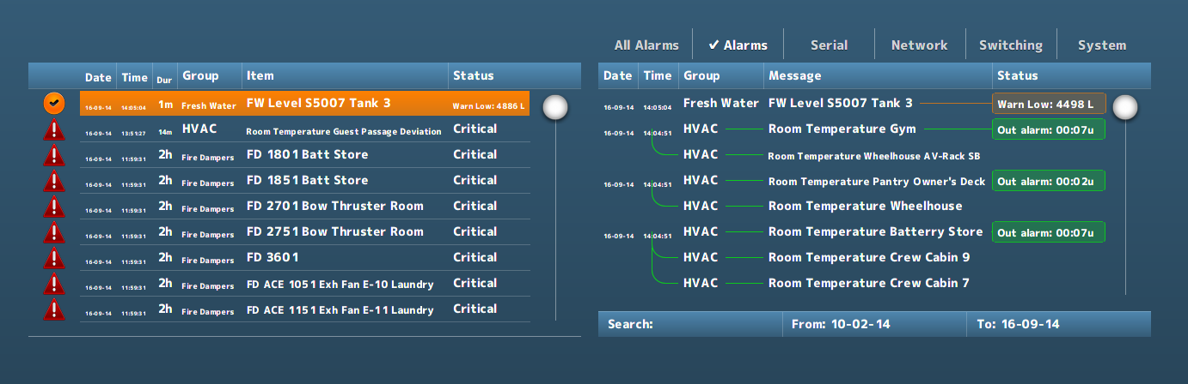

Figure 1‑8: Alarm list and logbook in mimic

**

*More extensive explanation on control in a mimic can be found in Annex 1 (See Chapter 6, page 53).*

### Logbook

During normal operation, all system events are registered chronologically. By clicking the *Logbook* button (see Figure 1‑1), these registered system events are displayed in a dedicated screen. It is also possible to show the logbook in any mimic (see Figure 1‑8).

#### Logbook groups

In order to separate various categories of information from each other, log entries are stored in various logging-groups. You can select them all or just a few of them, or even one if you need to focus on these entries. Just by selecting the category label at the top of the list, you filter the information you need (see Figure 1‑9).



Figure 1‑9: logging groups, all selected

|  |  |
| --- | --- |
| **Logging group** | **Explanation** |
| All Alarms | Alarms from all stations (even alarms you might not see on this station will be logged) |
| Alarms | All alarms from this station (all alarms that are visible on this station will be logged) |
| Serial | All serial information available on this station will be logged (initializing, finalizing and errors) |
| Network | All network information available on this station will be logged (Connecting, conn. Failed and errors) |
| Switching | All system, network and program switching |
| System | All process information and errors |

Table 1‑2: Logging groups

#### Logbook appearance

All identical log entries that appear at the same time will be interconnected as shown in the following figure (see Figure 1‑10).

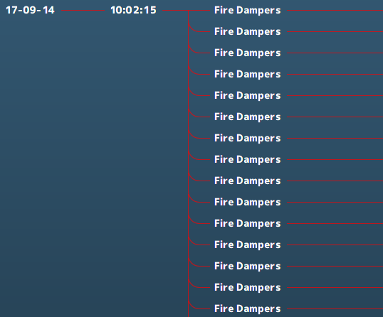

Figure 1‑10: interconnecting log appearance

#### Logbook status indication

All entries will have an explanatory status indication at the end of the entry line. This will give an indication about the reason that the indication is in the logbook (see Figure 1‑11).

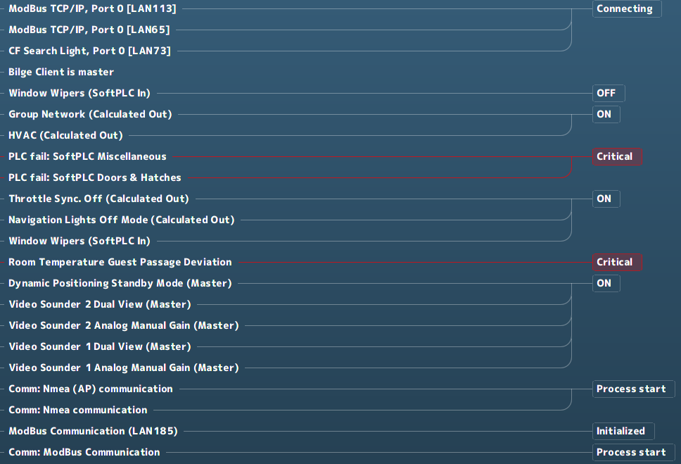

Figure 1‑11: Status indication log-entries

When logging alarms, this status indication will also be colored.

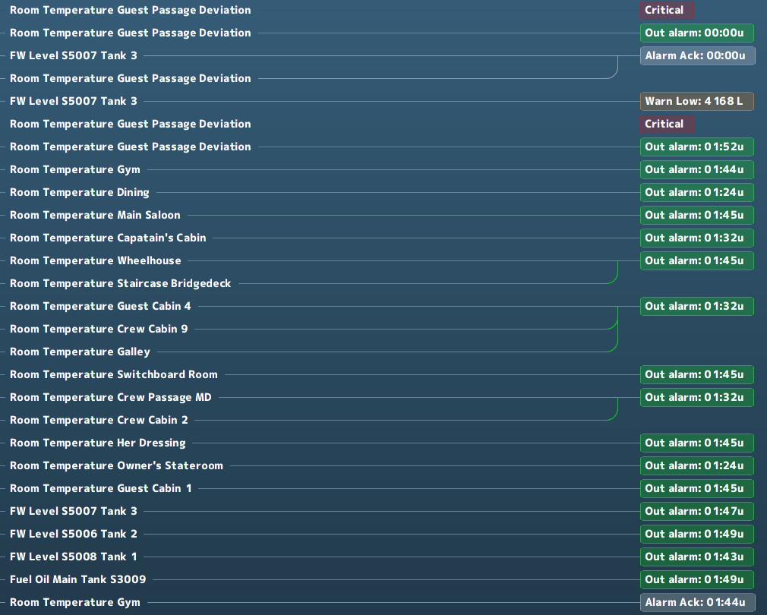

Figure 1‑12: Logging colors

|  |  |
| --- | --- |
| **Logging colors** | **Explanation** |
| Grey | Acknowledged |
| Green | Out of alarm or OK |
| Yellow | Caution |
| Orange | Warning |
| Red | Critical, Slowdown and Shutdown |

Table 1‑3: Logbook colors

#### Logbook search bar and buttons

At the bottom of the logbook, you will find a search bar and a few buttons (see Figure 1‑13). In the search bar, you can click and type the name of the listing you are looking for. After hitting *Enter* the listing is shown, if available.



Figure 1‑13: Logbook search bar and buttons

If you click on the “From:” or “To:” on the search bar, a new window will appear (see Figure 1‑14). This window is a fully working calendar from which you can choose a “From” or “To” date. After you have entered the date and pressed the checkmark, the entries that occurred in the entered timeframe are shown.

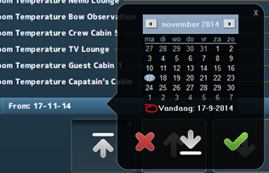

Figure 1‑14: Search calendar



Figure 1‑15: Print button

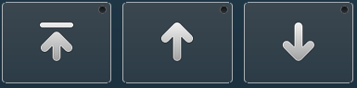

Figure 1‑16: Up- down buttons

If you click the *Print* button, you can print the logbook (if a printer is available). With the *Up* & *Down* buttons you can scroll to the top, up or down.

### Group viewer

The *Group Viewer* is the place within FT NavVision that holds the necessary information about all connected I/O. In this window, you can find a descriptive line for all the sensors with their connections and dependencies (see Figure 1‑17).

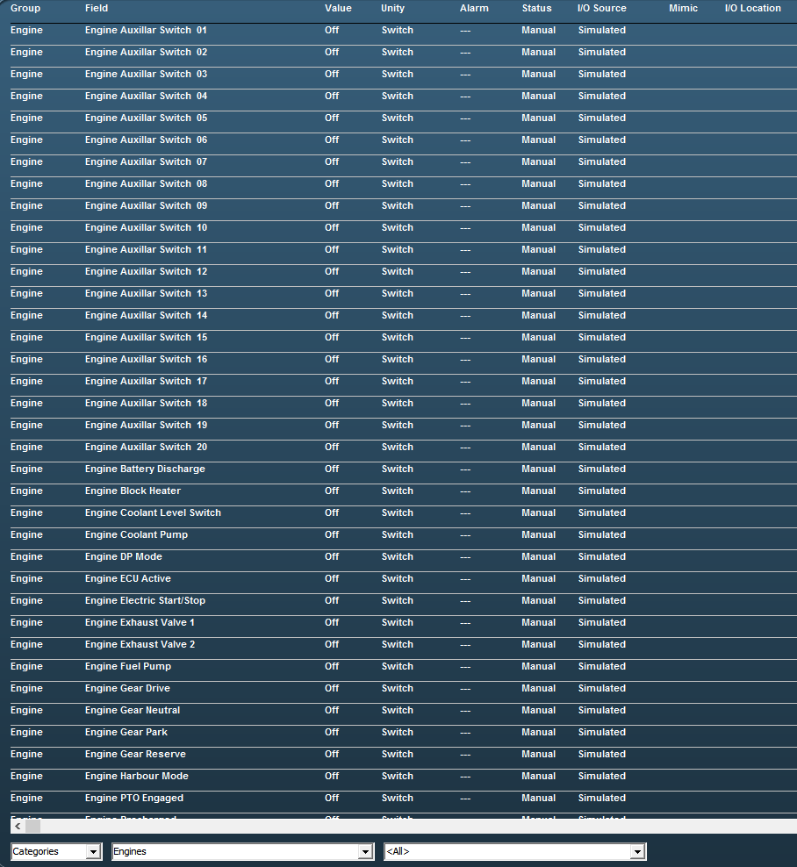

Figure 1‑17: Group viewer

There are various columns that each list a specific piece of metadata of an I/O point in clear language or digits and colors.

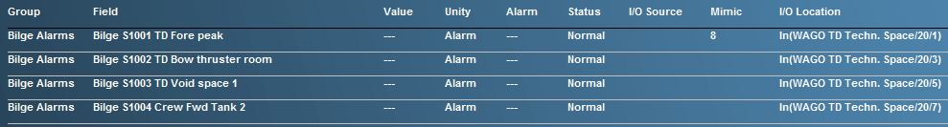

Figure 1‑18: Group Viewer columns

|  |  |
| --- | --- |
| **Column** | **Explanation** |
| Group | The alarm group the I/O point belongs to |
| Field | The item name of the I/O point (FT NavVision ID-tag) |
| Value | Actual value of the I/O point |
| Unity | The Unity of the I/O point |
| Alarm | Shows if the I/O point is in alarm and the value of the alarm |
| Status | Status of the I/O point |
| I/O Source | The source (interface) the I/O point comes from |
| Mimic | The mimic(s) the I/O point value is present |
| I/O Location | The location where you can find the I/O point physically |

Table 1‑4: Group Viewer columns

#### The search bar

Using the search bar, you can reduce the amount of searchable data to a specified group. This way it is easier to pinpoint the faulty I/O point you are looking for (see Figure 1‑19).



Figure 1‑19: Search bar

In the first drop-down menu, you can choose between *Categories* and *Alarm Groups* in which you change between the standard arrangement of categories as set in FT NavVision or the division in alarm groups.

When choosing for *Alarm Groups,* you have the choice to narrow the selection down even further to the specific alarm group that you are looking for (see Figure 1‑20).

When you choose for the *Categories*, you can narrow it down to the group and even subgroup for that particular I/O point (see Figure 1‑21 and Figure 1‑22).

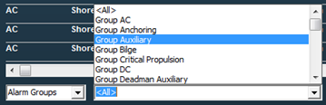

Figure 1‑20: Alarm groups

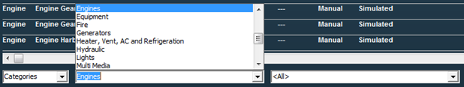

Figure 1‑21: Categories group

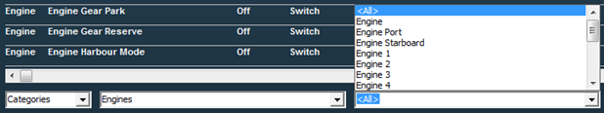

Figure 1‑22: Categories subgroup

If there is an I/O point currently in alarm status, it will give information on the fact that it is in alarm (red) and what its status is (see Figure 1‑23). Also the mimic it is presented on and the I/O location can be read from the group viewer (see Figure 1‑24).



Figure 1‑23: Group viewer in alarm

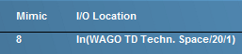

Figure 1‑24: Group viewer mimic and I/O location

### Settings

The settings Icon is not applicable to the operator. There is nothing in this submenu that may be adjusted by an operator.

### Alarm Mimic

The *alarm mimic* is the central place where all relevant alarms are shown in clear and unambiguous language and coloring. The smaller *Alarm area* in the taskbar will always be available and visible. Here, each alarm will be shown immediately. When you click the area, the larger Alarm mimic is shown (see Figure 1‑25).

**

*The Alarm mimic will always be on top of all the other windows, so if you want to look at other mimics, you will need to close the alarm mimic first.*

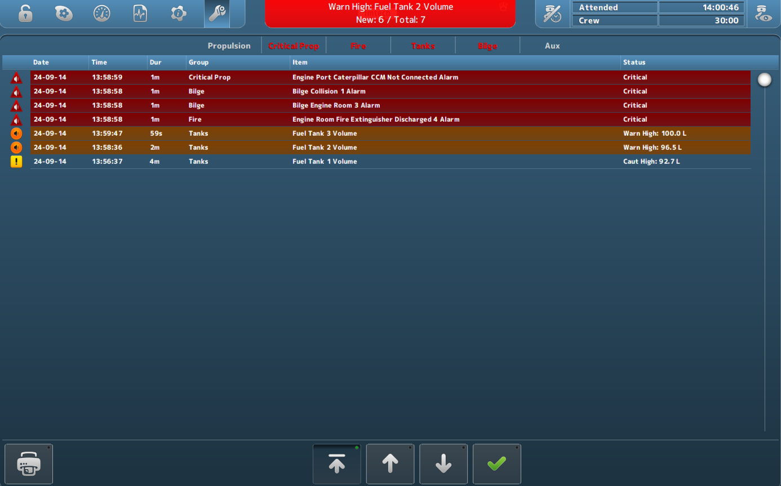

Figure 1‑25: Alarm mimic

Depending on which rights your station has, more or less buttons and/or alarm-information are shown.

The order will always be as follows:

* Critical alarms
* Warnings
* Cautions
* Time of appearance

So the latest *critical alarm* will always be on top. The latest *warning* will always be on top, after all *critical alarms.* Similarly, the latest *caution* will always be on top after all *critical alarms* and/or *warnings*.

#### Alarm icons

The alarm icons have distinctive colors and symbols, so you can see exactly what is going on with each alarm. A brief explanation of each icon is shown in the following table.

|  |  |
| --- | --- |
| **Icon** | **Explanation** |
|  | Critical alarm: Unacknowledged |
|  | Critical alarm: Silenced |
|  | Critical alarm: Acknowledge not allowed |
|  | Critical alarm: Acknowledged |
|  | Critical alarm: Rectified |
|  | Critical alarm: Transferred |
|  | Warning: Unacknowledged |
|  | Warning: Silenced |
|  | Warning: Acknowledge not allowed |
|  | Warning: Acknowledged |
|  | Warning: Rectified |
|  | Warning: Transferred |
|  | Caution: Unacknowledged |
|  | Caution: Silenced |
|  | Caution: Acknowledge not allowed |
|  | Caution: Acknowledged |
|  | Caution: Rectified |
|  | Caution: Transferred |

Table 1‑5: Alarm Icons

The bottom of the alarm mimic houses buttons for printing and scrolling.



Figure 1‑26: Print button



Figure 1‑27: Up- down buttons

Upon clicking the *Print* button, you can print the alarm list (if a printer is available). With the *Up/Down* buttons you can scroll up, down or jump to the top of the list.

**

*The rest of the Alarm mimic will be explained in Chapter 2 (Duty Alarm System) and in chapter 0 (Personnel Alarm).*

# Alarm System

## Introduction

The alarm system provides clear and unambiguous representation of all the alarms that take place at a certain time and present that on any screen that has the rights to show that alarm. There is a difference between the alarm system and the Duty alarm system. The alarm system shows all the alarms to all the stations with the specific rights. The Duty alarm system divides the (machinery) alarms to a station “on duty” in case of an unmanned machinery space.

## Alarm handling

Alarm handling is determined in a set of international rules by standardization organisations. These rules are visualized in Figure 2‑1.

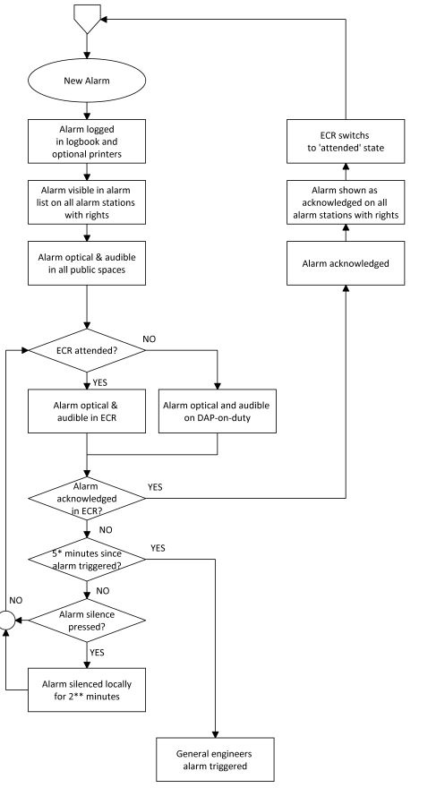

Figure 2‑1: typical alarm sequence

## Alarm handling in the alarm mimic

As shown in Figure 1‑25, all cautions, warnings and critical alarms will be shown in the taskbar and, more extensively, in the main window of the Alarm mimic. In *Table 1‑5: Alarm Icons,* you will find the explanation of the various alarm icons and their meaning.

When you look further at the alarm mimic, you’ll notice more values and buttons. The row just above the alarm window (see Figure 2‑2), is the *alarm group row*. Depending on the alarm groups set here at initialisation of the system, you can see in which groups the alarms on the alarm page reside.



Figure 2‑2: Alarm group row

When even a single alarm within a group is active, the group label will turn red. This way you can see quickly in which group there are alarms.

When you click on this specific group label, the alarm mimic will be filtered to show only the specific alarms in that group. This will come in handy when you have a lot of alarms on the screen. After 10 seconds it will revert to the complete alarm list.

When you want to silence or acknowledge an alarm, you can double click on the alarm entry. Depending on the rights your station has, double-clicking will either silence, acknowledge or do nothing with the entry. Alternatively, you can click the silence/acknowledge-button (see Figure 2‑3) to silence/acknowledge all visible alarms in the alarm mimic. Depending on how many alarms you have, you will need to click one or more times to do this for all the alarms as this action only applies to the alarms currently visible on the screen.

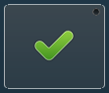

Figure 2‑3: silence/acknowledge-button

### Explanation of alarm rights

During commissioning of the system, all stations will be set to their respective alarm station names with the distinctive rights set accordingly. Class demands that the only place where an alarm may be acknowledged is the space where you can act upon the alarm directly. This usually means that 99 percent of the alarms can only be acknowledged in either the engine room (ER) or the engine control room (ECR). For the other stations, the rules state that the alarms (if shown) can only be silenced. This means that the alarm stays unrectified and unacknowledged and only the buzzer will be silenced (at most for 3 minutes).



*If you are unable to acknowledge or silence alarms, you probably don’t have the rights.*

## Duty alarm system

The *Duty Alarm System* provides (machinery) alarms to bridge, cabins and public areas for an unattended (unmanned) machinery space. The duty alarm system is configured upfront.

*Duty Alarm Panels* (DAP’s, see Figure 2‑5) at specific locations are connected with the automation system via the LAN-network. They display the information for machinery alarms and settings such as alarm group status, operation status, and on-duty selection.

The duty alarm system provides for signaling of Engine Control Room (ECR) to the cabins and bridge by a *Duty Alarm Panel* (DAP) or on a *Local Operator Panel* (LOP).

An engineer on duty can be selected from the *Operator Workstation* (OWS). He will be warned when an critical alarm is present in the unmanned engine room.

An engineer can be called on duty from the ECR on the OWS. Each station has its own caller identification.

When no DAP is used, the duty alarm system can be implemented with small or larger hardware panels as shown in the following figures:

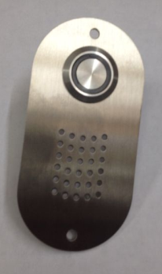 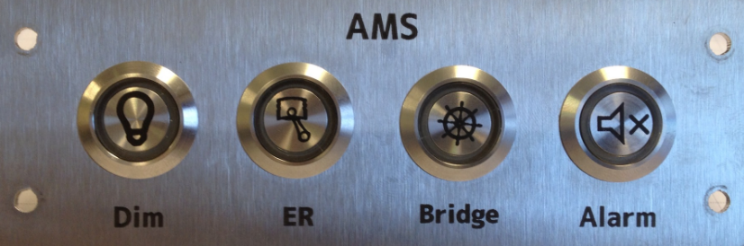

Figure 2‑4: typical Alarm panels

These panels come in the following editions, with their own respective operation.

|  |  |
| --- | --- |
| Panel horizontal-vertical | |
|  | |
|  | |
| Location of use: | Crew cabins that can be selected for Bridge duty as well as for ER duty |

|  |  |
| --- | --- |
| Panel horizontal-vertical | |
|  | |
|  | |
| Location of use: | Crew cabins that can be selected for ER duty |

|  |  |
| --- | --- |
| Panel horizontal-vertical | |
|  | |
|  | |
| Location of use: | Crew cabins that can be selected for bridge duty |

|  |  |
| --- | --- |
| Panel horizontal-vertical | |
|  | |
|  | |
| Location of use: | At each entrance door of the ER, or in the ECR |

|  |  |
| --- | --- |
| Panel horizontal-vertical | |
|  | |
|  | |
| Location of use: | Main or secondary bridge |

|  |  |
| --- | --- |
| Panel horizontal-vertical | |
|  | |
|  | |
| Location of use: | All spaces where Bridge duty crew can be available (no duty select) |

|  |  |
| --- | --- |
| **Button** | **Explanation** |
|  | Dim the button LED’s of that panel  Illuminates when panel is active |
|  | Silence the alarm  Illuminates when an alarm is active |
|  | No push activity  Illuminates when ER duty |
|  | No push activity  Illuminates when Bridge duty |
|  | Press for attended/unattended mode  Illuminates when attended |
|  | No push activity  Illuminates when timer is active |

Table 2‑1: Alarm panel buttons

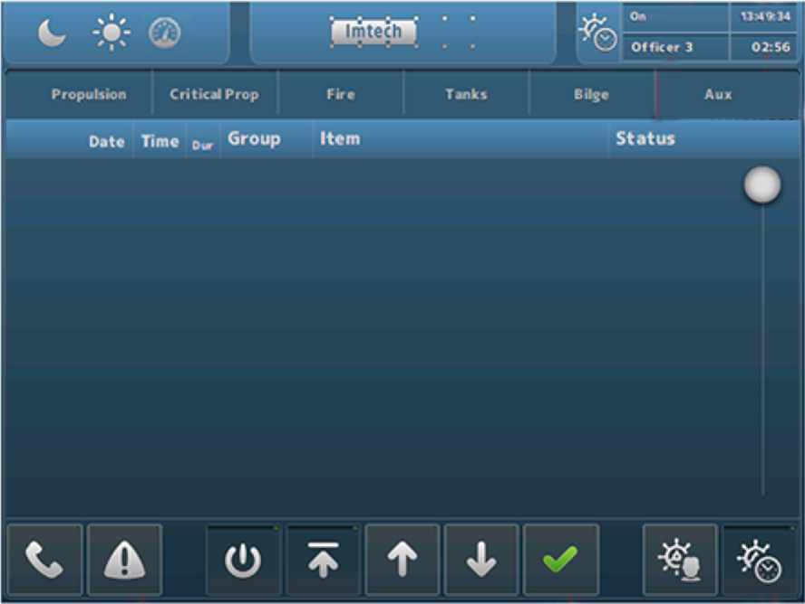

Figure 2‑5: Typical DAP screen

### Extra buttons alarm mimic

Depending if the station is set as a specific alarm station, some extra buttons will appear at the bottom of the alarm mimic. When the OWS is set-up as a bridge station, the icons as shown in Figure 2‑6 will appear. When the OWS is set-up as an ER station, the icons as shown in Figure 2‑7 will appear.



Figure 2‑6: Bridge set-up icons



Figure 2‑7: ER set-up icons

The meaning and handling of these icons are explained in the following table.

|  |  |
| --- | --- |
| **Button** | **Explanation** |
|  | Press to print (part of) the alarm list |
|  | Press and select space or crewmember to call |
|  | Switch station On/Off (when applicable) |
|  | Scroll to top |
|  | Scroll up |
|  | Scroll down |
|  | Acknowledge or silence alarms |
|  | Select crew for Bridge duty |
|  | Switch BNWAS On/Off |
|  | Select crew for ER duty |
|  | Switch personnel alarm On/Off |

Table 2‑2: Alarm mimic set-up icons

The *Call* and *Duty Select* buttons have some additional choices, depending on who you can call or who you can select for duty. This will be configured upfront and will look as in Figure 2‑8 and Figure 2‑9. First select the *Call* or *Duty Select* button and then choose from the following menu.

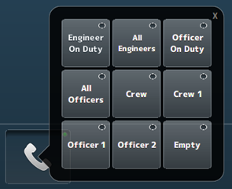

Figure 2‑8: Call function

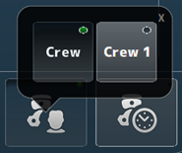

Figure 2‑9: Duty select function

Additionally, you can see the station that is calling you on the main screen (while hearing a buzzer tone if available). You can click on the message to make it disappear (see Figure 2‑10).

The person that is on duty will be visible on all stations in the right upper corner of the screen.

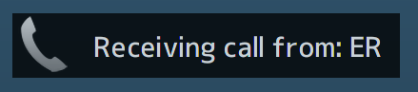

Figure 2‑10: receiving call message

Finally in the upper right corner of the alarm mimic some crew and time information will be shown (see Figure 2‑11). Here you can see if the ER is attended or unattended, who is on duty, the time and the timer (remaining time) from either the ER Personnel alarm or the BNWAS alarm.

The left button is the reset button for the timer. The right button is the same as the button *Switch station On/Off*.



Figure 2‑11: Crew information

### Duty alarm principal

The duty alarm system is used for the transfer of alarms to the technical crew in case of an unattended machinery space. The duty alarm system will be configured from a particular OWS. The duty alarm system provides unambiguous audio visual annunciation of alarms and warnings via a dedicated banner located at the top of the alarm panel screen.

A watch and call system extends the central alarm system to engineers' cabins and public areas when machinery spaces/control rooms are unattended.

### Alarm types

#### Alarm detection for analogue signals

The following functions are included:

* Instrument failure alarms
* Low-low process alarms with or without action (slow-down)
* Low process alarms
* High process alarms
* High-high process alarms with or without action (slow-down)
* Return to normal detection with dead-band to avoid alarm fluctuations
* Adjustable filter factors to filter fluctuations in the incoming signals
* Time delay of alarm triggering and return to normal messages.

#### Alarm detection for on/off (two state) signals

The following functions are included:

* High process alarms
* Return to normal detection
* Time delay of alarm triggering and return to normal messages.

#### Alarm detection for on/off signals with line check

The following functions are included:

* High process alarms (open or closed)
* Line broken alarm
* Line short alarm
* Return to normal detection
* Time delay of alarm triggering and return to normal messages.

### Attended alarm mode

NavVision will transfer the alarm to the activated location.

In case of an attended or manned machinery space this location will be the:

* Engine Control Room (ECR)
* Accommodations (e.g. mess room and public areas).

### Unattended alarm mode

In case the machinery space is left “unmanned”, alarms that will come in will be redirected immediately to the selected Duty Alarm Panel.

The “Unattended” mode can be activated on the workstation in de ER or the ECR.

NavVision will direct the alarm to the activated location.

In case of an unattended or unmanned machinery space this will be:

* The engineer on-duty
* Engine Control Room (ECR)
* Accommodations (e.g. mess room and public areas).

New alarms are indicated respectively on the DAP of the engineer on duty in the ER and in public spaces such as the mess room. On the panels, the alarm sounding (horn/buzzer) can be silenced (only local), but the alarms still need to be acknowledged on the OWS within the relevant technical area.

If alarms are not acknowledged within a specific period of time, the *General Engineers Alarm* (GEA) is invoked, independent from the *Attended/Unattended* mode. Once the GEA goes off, the alarm will sound on all alarm stations

## 

### How to acknowledge an alarm

The alarms must be acknowledged on the OWS in the Engine (Control) Room by means of:

* Double clicking the corresponding alarm line (alarm viewer)
* Click the Silence/Acknowledge button

### How to silence an alarm (not at ECR)

You can silence an alarm on all other locations (except GEA and Fire alarms).

This will silence the local alarm buzzer for 3 minutes, but will not acknowledge the alarm.

The engineer is required to go to the Engine (Control) Room to acknowledge the alarm.

### When will an alarm disappear

An alarm will disappear only when rectified AND acknowledged. Acknowledged alarms will show in the normal instrument colour.

# Personnel alarm

## Engineer Deadman

### Scope

The purpose of an Engineer Deadman System is to monitor engine room activity and detect engineer disability which could lead to marine accidents. The system monitors the awareness of the *engineer on duty* and automatically alerts another qualified engineer if for any reason the engineer on duty becomes incapable of performing his duties. This purpose is achieved by a series of indications and alarms to alert first the engineer on duty and, if he does not respond, then to alert another qualified engineer by means of a general alarm.

Additionally, the Engineer Deadman System may provide the engineer on duty with a means of calling for immediate assistance if required. The Engineer Deadman System should be operational whenever the engine room is attended and/or manned, unless inhibited by the Chief Engineer.

### The Engineer Deadman System incorporates the following operational modes:

* Manual ON (In operation when engine room is attended)
* Manual OFF (Does not operate under any circumstances)

*The Deadman timer can only be switched on or off by inserting a password. This to prevent illicit usage of the Deadman timer (see Figure 3‑1). Fill in the password and press enter, or the green checkmark to engage. The red “X” is to return.*

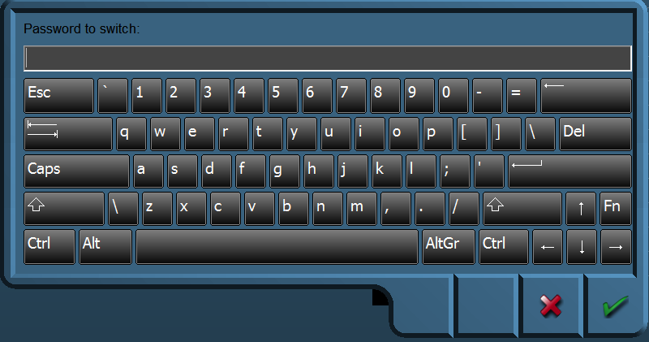

Figure 3‑1: Password entrance panel

### Operational State

Once operational, the alarm system remains dormant for a period of 30 minutes. At the end of this dormant period, the alarm system initiates a visual and audible indication on the AMS.

### Reset function

It is not possible to initiate the reset function or cancel any audible alarm from any device, equipment or system not physically located in areas of the engine room or ECR (local silence is allowed).

The reset function is only available in positions in the engine room and ECR. The reset function is easily accessible from the anywhere in the engine room.

The reset function cancels the visual indication and all audible alarms and initiates a further dormant period. If the reset function is activated before the end of the dormant period, the period should be re-initiated to run for its full duration from the time of the reset.

A continuous activation of any reset device triggers the emergency call facility within 3 seconds.

### Emergency call facility

Means are provided in the engine room to immediately activate the visual and audible alarm by means of an Emergency Call push button or similar. Holding any reset button for at least 3 seconds also triggers the emergency call facility.

## BNWAS

The BNWAS (Bridge Navigational Watch Alarm System) is a similar personal safety system, designed for use on the bridge.

### Introduction

It is possible that you use the BNWAS as a standalone version, but it can also be used in conjunction with the UniMACS bridge. It can even be used with other bridge systems as long as these systems give the standard EVE-messages.

In this manual, we will address both ways in the same explanation since their differences are mainly HMI-related and do not affect functionality.

When we discuss the interface of the BNWAS system, it can be the interface on the standalone BNWAS or on the integrated BNWAS. It can be the interface on the bridge-panel, but also the interface on the panel in the captain’s cabin. What follows is an integral explanation of the BNWAS functionality.

### The HMI overview

The HMI consists of a main screen that holds all functionality for the BNWAS and a setup-screen that can be used to enter the necessary settings. In the following figures, we will explain the functionality and functions on the HMI.

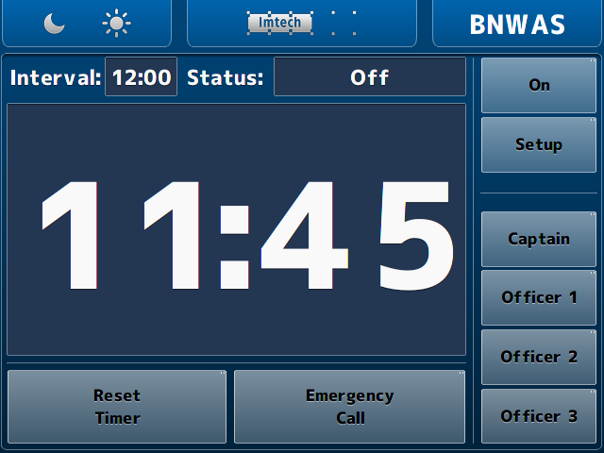

Figure 3‑2: Main BNWAS HMI

### The HMI explained

The functions of the HMI are described in the following figures. These are mostly self-explanatory. Where not explicitly clear, an additional explanation is given.

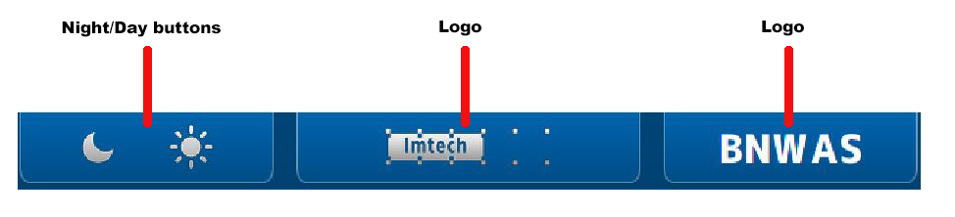

Figure 3‑3: HMI top bar

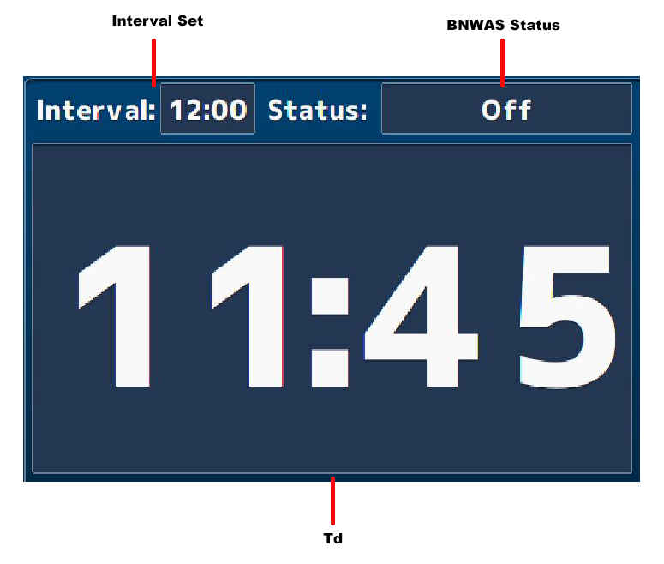

Figure 3‑4: HMI main screen

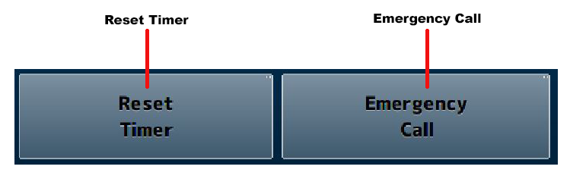

Figure 3‑5: HMI bottom bar

*The reset timer and emergency call buttons are only available when the panel is placed on the bridge. Any other location will show these buttons, but they will not be operational.*

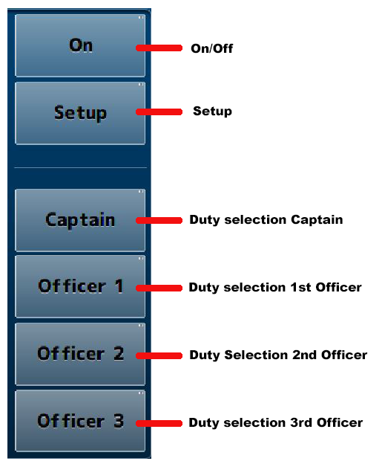

Figure 3‑6: HMI Panel

**

*When you operate the* On/Off *or* Setup *button a keypad will appear where you have to type a passcode. (See* Figure 3‑8*).*

### The setup page

By clicking on the setup button a new screen will appear. This is the setup screen. It looks quite the same as the main window as it has only a few settings in the main panel (see Figure 3‑9).

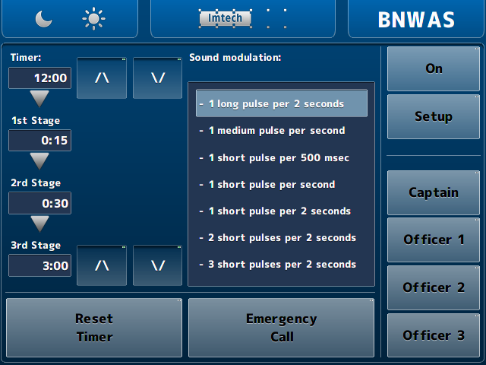

Figure 3‑7: Setup screen

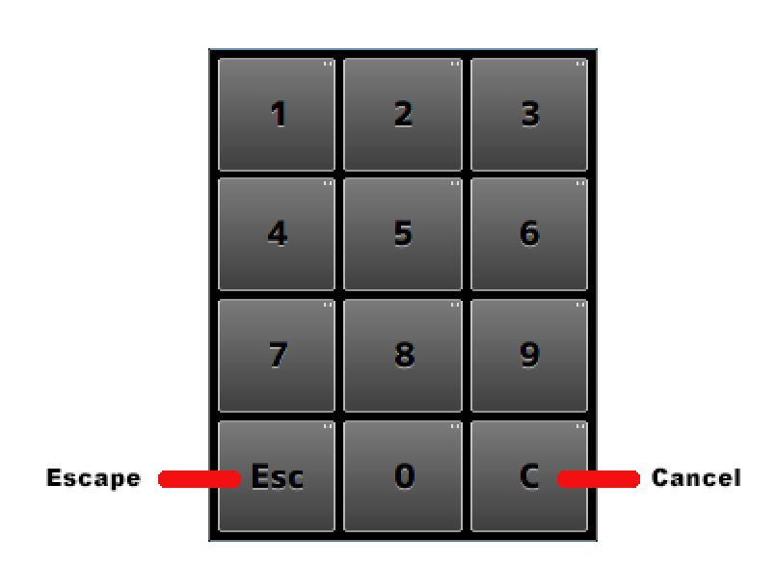

Figure 3‑8: Keypad

The functions, with their respective explanation, are shown in the following figure.

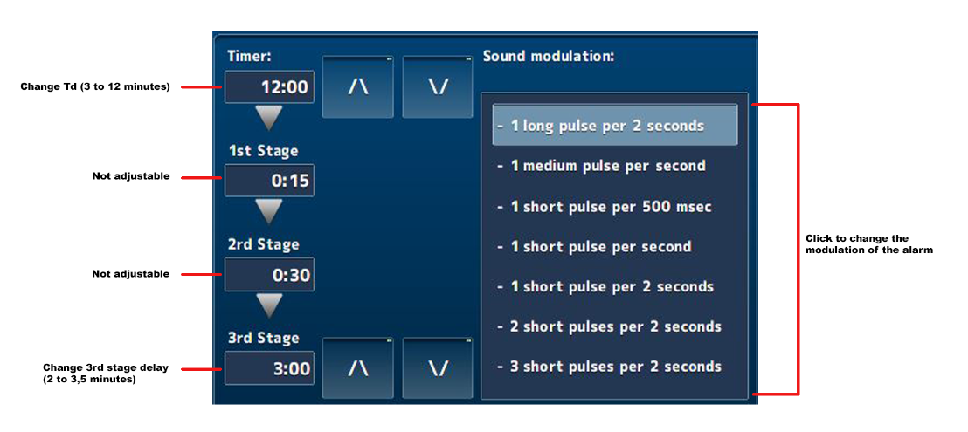

Figure 3‑9: Setup main screen

**

*With the arrow buttons in the setup page, you can increase or decrease the Td and/or 3rd stage delay time.*

Once a working NavVision server is connected to the same system, the HMI of NavVision will be overwritten on the DAP’s. It is just the HMI. The BNWAS will still be the one that handles all the BNWAS features.

It will look as in the following figure:

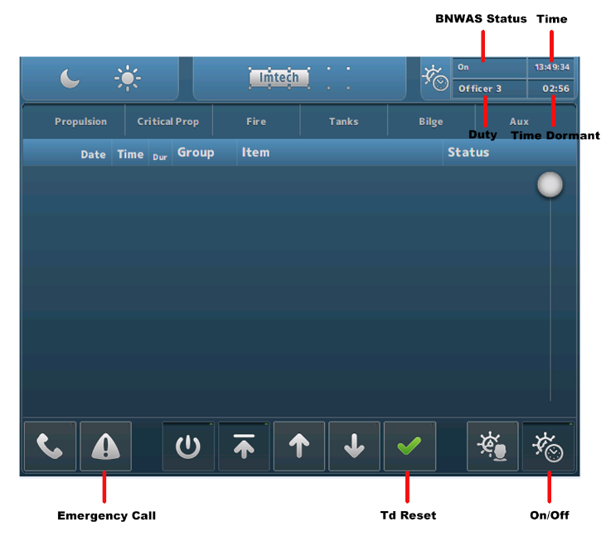

Figure 3‑10: NavVision HMI on DAP

On the NavVision server, you will have an equal kind of display as shown in the following figure.

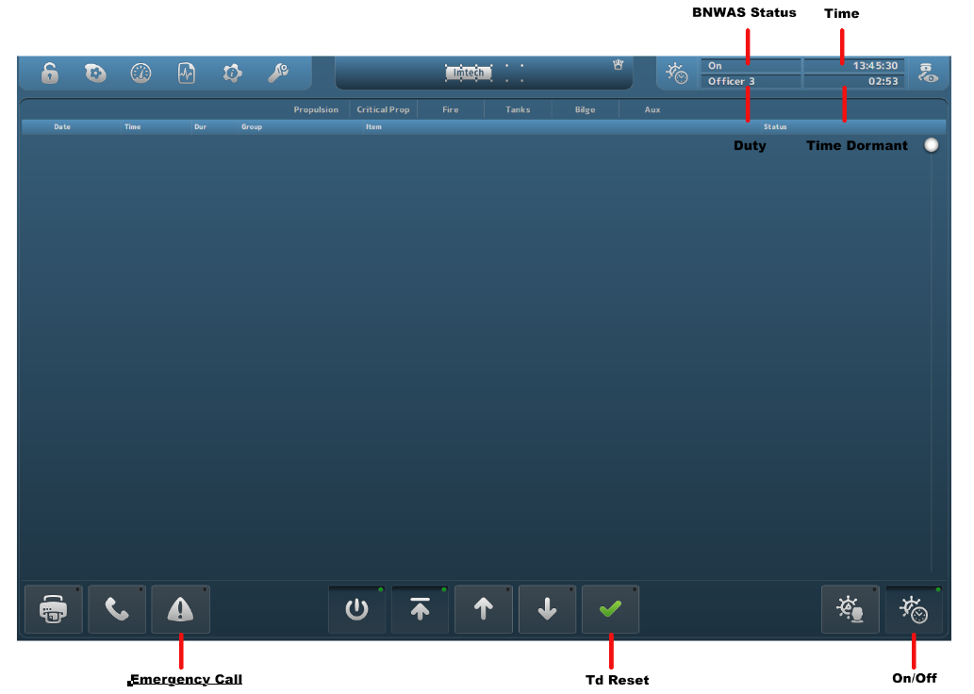

Figure 3‑11: NavVision Native screen

# Annex 1 Mimic control

Control elements are used to interface a wide range of *Control* devices like pumps, fans, valves, generators, etc. via their relevant starter unit. Since these element types are suitable to process a wide range of components, several symbols are defined to represent each type.   
Color animation is used to show the actual element status.

Chevrons, a single filled chevron (arrow) for low - and a double filled chevron (arrow) for high speed, show the difference between a control element running at high speed and a control element running at low speed. Chevrons without filling indicate an off condition.

## Mimic components

The mimic contains a lot of components which, together, make up for the representation of the ship or a specific system on the ship. Components can be some of the following different forms:

|  |  |
| --- | --- |
|  | Label |
|  | Icon |
|  | Value |
|  | Button |
|  | Horizontal Level |
|  | Vertical Level |
|  | Small Graph |
|  | Slider Control |
|  | Instrument |
|  | Indicator |
|  | Propulsion |
|  | DP View |
|  | Joystick |
|  | Propulsion |

## Component behaviour

Each component can have its own behaviour. Sometimes it is just representing a value and sometimes there is some extra functionality available. The following examples will give you an idea of some of the possibilities.

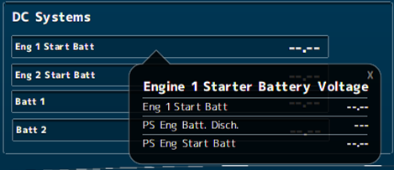

Figure 4‑1: Pop-up balloon

When you double-click on a value, a balloon will pop up with some additional information (see Figure 4‑1).

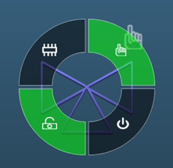

Figure 4‑2: control doughnut

When you click on items that you can control, a radial menu will appear. Depending on the element and its settings, you can control different aspects of the item (see Figure 4‑2). For the control elements, see Table 4‑1, Table 4‑3, Table 4‑4 and Table 4‑5.

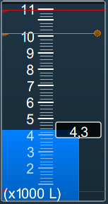

Figure 4‑3: Vertical bar with alarm lines

In the vertical bars (often used for tanks) you can see the warning and critical alarm levels. The critical alarm levels (red) are not changeable since these are mandated by class. The warnings (orange) can be changed by dragging the lines with your mouse on the little dot at the end of the line. This way, you can use it for example when filling a tank. You get a warning (visual and audible) when the warning line is crossed.

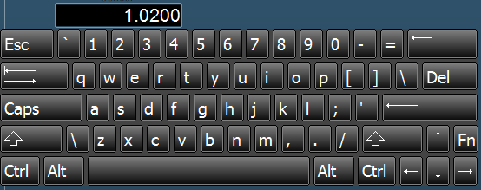

Figure 4‑4: Edit keyboard

When you have an *edit-enabled* value, you can click on it and a keyboard will appear (see Figure 4‑4). You can fill in an amount and press enter to change the desired value. It will not be possible to change it beyond the min/max values.

|  |  |  |
| --- | --- | --- |
| **Status** | **Control element** | **Symbol** |
| Operable in two speeds, system off | Double chevron (no fill) |  |
| Operable in two speeds, system running at low speed | Double chevron (single chevron filled) |  |
| Operable in two speeds, system running at high speed | Double chevron (double chevron filled) |  |
| Operation is disabled (local control only or controlled by other OPC) | Padlock |  |
| Manual operation (controlled remotely) | Hand |  |
| Automatic operation (controlled by ACS) | Chip |  |

Table 4‑1: Control element status

|  |  |
| --- | --- |
| **Colour** | **Description** |
| **Grey** | Control element off (stopped), device is ok |
| **Green** | Control element on (running), device is ok |
| **Orange** | Control element in warning condition |
| **Purple** | Control element defective |
| **Red** | Control element in alarm condition |

Pump and generator control elements

|  |  |  |  |
| --- | --- | --- | --- |
| **Centrifugal pump** | **Piston pump** | **Generator** | **Status description** |
|  |  |  | Off |
|  |  |  | On (condition ok) |
|  |  |  | On, warning condition |
|  |  |  | On,  defective condition |
|  |  |  | On,  critical condition |

Table 4‑2: Control elements and color animation

|  |  |  |  |
| --- | --- | --- | --- |
| **3-way valve OFF** | **Status description** | **3-way valve ON** | **Status description** |
|  | 3-Way valve off (status indication only) |  | 3-Way valve on (status indication only) |
|  | 3-Way valve off, auto (control by AMCS) |  | 3-Way valve on, auto (control by AMCS) |
|  | 3-Way valve off, auto  (local control) |  | 3-Way valve on, auto  (local control) |
|  | 3-Way valve off (local control) |  | 3-Way valve on  (local control) |
|  | 3-Way valve off, manual (controlled by AMCS) |  | 3-Way valve on, manual (controlled by AMCS) |
|  | 3-Way valve off, manual (local control) |  | 3-Way valve on, manual (local control) |

Table 4‑3: Control elements with status indication

|  |  |
| --- | --- |
|  | Centrifugal pump on,  operable in two speeds, system off |
|  | Centrifugal pump on,  operable in two speeds, pump running at low speed |
|  | Centrifugal pump on,  operable in two speeds, pump running at high speed |

Table 4‑4: Control elements with speed indication

|  |  |  |
| --- | --- | --- |
|  |  | Fan off & on |
|  |  | 2-way valve off & on |
|  |  | Check valve off & on |

Table 4‑5: Other control elements

# Part 2: Extra settings for (Commissioning) Engineer

## General

Under Settings you will find all the tabs that you can use to configure and fine-tune the NavVision system. These settings need to be done by the engineering department. Also commissioning engineers need to know how to work with these settings.

## Users

The tab “Users” features all the adjustments to set up different access control for different users. The main reason for user access control is protecting the system. By limiting the user changing the configuration settings etc. the chance of disturbing system operation is limited as well.

Basically only three users are available. Administrator is the user status for Engineers of Imtech and its representatives. This login has all the rights available. This is logical because at commissioning and installation you need to be able to alter all the settings.

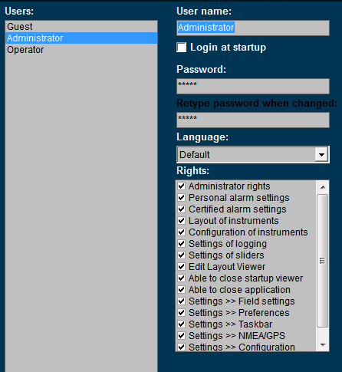

Figure 5‑1: Users

### User name

This is a box that shows the active user name. You can also alter the name here..

### Login at startup

Tick this box to set the default user at startup (default operator).

### Password

**

*The user name “Administrator” is always password protected (standard this is “admin”).*

If a password is required please type password here. When changing the password or typing the password for the first time, retype password at next field “retype password when changed”.

### Language

In the box “Language” you can choose for “default” or “local”. If you choose “default” the main language will be English.

By choosing “local” you can set any kind of language for the comments section. So the GroupLabel, Item and label can be changed under fieldsettings/comments and it will be shown in the operators mode where you have chosen for “local” as language. If you change the default language to local, you will have to define the English language as well for that user in case you want to put it back again at a certain time. Default language always will be English.

In the Sensorlist it is possible to change these Local values as well. See the “sensorlist manual” for further details.

### Rights

Rights can be set (by check mark) for each user. Rights are divided in several subgroups. Each user can have one or more rights. By putting a check mark you can set the rights.

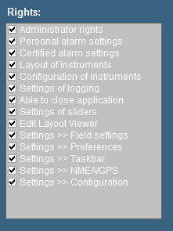

Figure 5‑2: Rights

|  |  |
| --- | --- |
| **Rights** | **Explanation** |
| Administrator rights | The right to change settings and user settings |
| Personal alarm setting | Set personal alarms directly in the instruments |
| Certified alarm setting | Set certified alarms in Field settings > Alarms |
| Layout of instruments | Change layout of instruments (i.e. unit, analogue-digital etc.) |
| Configuration of instruments | Change fields that instruments are representing |
| Settings of logging | Make logs of incoming data (see “Configuration > Field settings > log”) |
| Able to close application | Decides if the button to close FT is available |
| Settings of sliders | Allow setting of sliders in layout viewer |
| Edit layout viewer | Makes it possible to change the layout viewer |
| Settings > Field settings | Allows changing the field settings (see “Tools > Field Settings”) |
| Settings > Preferences | Allows changing the preferences (see “Tools > Preferences”) |
| Settings > Taskbar | Allows changing the taskbar (see “Tools > Taskbar”) |
| Settings > NMEA/GPS | Allows using “Tools > NMEA/GPS” tab |
| Settings > Configuration | Allows changing of configuration settings |

* **Administrator rights**All rights.
* **Operator rights**  
  Limited rights to prevent accidental alterations

**

*Under “Operator rights” you will NEVER get the rights as mentioned below.*

* Administrator rights
* Certified alarm setting
* Configuration of instruments
* Settings of logging
* Settings of sliders
* Edit layout viewer
* Settings > Field settings
* Settings > Configuration

### Add / Remove

Via the “Add / Remove” buttons a user can be added or removed.

For example you need to add a user for the shipyard or the installation company. Click “Add” and fill in a new user name. For the removal of a user, click the user then click “Remove” and acknowledge.

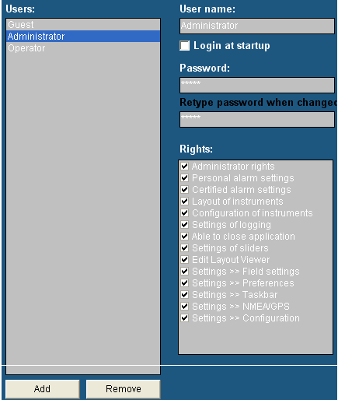

Figure 5‑3: Add / Remove

**

*Setup the new user direct at the beginning of the setup. In this way the user will get access to all settings and adjustments. If you set a new user after you’ve finished installing and adjusting the system, this will result in an empty user.   
All adjustments you’ve made are not visible. You can get the adjustments you made to appear in the new user by copying the content of the “administrator.ini” to the new user ini-file (i.e. shipyard.ini). For more information please refer to section “Adjusting ini-files”.*

## Field settings

Under “Tools > Configuration > Field Settings” you’ll find the tools to adjust and fine-tune on field label basis. For every I/O you attach a label onto you will find different ways of tuning in each tab of field settings.

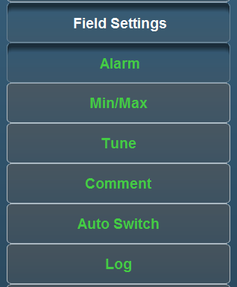

Figure 5‑4: Field settings

The following settings are available:

* **Alarm**  
  Settings of user alarms, warning alarms, critical alarms, Alarm group settings, SMS settings, inhibit settings
* **Min/Max**  
  Setting of instrument range, zone marking, default unit and filter
* **Tune**  
  Setting of tuning table, see results and sender
* **Comment**  
  Check and change group label, group label logbook, field label and field label instrument
* **Auto Switch**

Make various in-and outputs react on each other.

* **Log**  
  Setting and enabling/disabling logging for each field label.

### Alarm

Choose the field you would like to change the alarm settings for (e.g. “Steering and Propulsion >Rudder > Angle”).   
Depending on the field selection, a number of field settings are available. In this example the following settings are allowed:

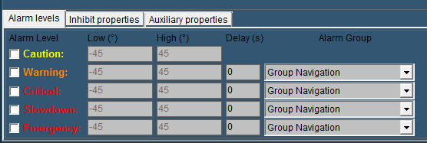

Figure 5‑5: Alarm settings

A field like this “rudder alarm” is not set as alarm by default. It gives an analogue value, in this case within the range -45 degree and +45 degree. Now within this range you can set a few alarms. The settings that can be altered are the following:

#### Alarm levels

* **Caution**Via this check box the user alarm settings are set. In this example you can set the alarm threshold (low and high). Usually you will not set them here but in the instrument itself (it is a user alarm) but you can check and/or change them here. This alarm will only give a visual alarm.
* **Warning**   
  The warning alarm is a dedicated alarm to warn the user when certain thresholds are exceeded. This alarm can have a dedicated delay and a dedicated alarm group (i.e. a high or low alarm).   
  Choose these thresholds widely within the boundaries of the capabilities of the attached device (check specific manual for the values)
* **Critical**To set the critical alarm thresholds (i.e. too high or too low) (check specific manual for these values).Critical alarms are typically TooToo Low and Too Too High.
* **Slowdown**

This is a grade higher alarm than the Critical. It means that immediate action is required without further ado.

* **Emergency**

When there is an emanate threat, like Watertight Doors that aren’t closed during sailing, an emergency alarm is in place. Everything has to stop to prevent this alarm from going any further.

**When the field represents an Engine or a Generator. The Emergency Alarm Level will be changed by the Shutdown Alarm Level. In this case it will take further actions (when implied) to shut down the engine to prevent further damage.

* **Delay(s)**The time (in seconds) the system will wait before it will show the specific alarm that is triggered. This is necessary if a hysteresis is needed (i.e. a bilge alarm that is on the edge of the alarm by the rocking of the ship, will not go of all the time if you put in a delay)
* **Alarm Group**Here you can put the alarm in a specific group. By putting it in a group you can manage the rights of different users on whether they can silence or acknowledge these alarms.

#### Inhibit Properties

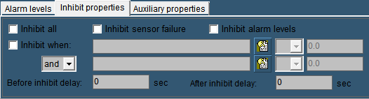

Figure 5‑6: Inhibit Properties

There will be certain occasions where you do not want the alarm to go off. For example an oil pressure alarm from an engine will normally also be in alarm when the engine is shut down. This is not wanted as an alarm. Or when a sensor is broken and there is no time to repair it for a while, it will be easier to inhibit the “Defect Alarm” of this sensor until you have time to repair it.

* **Inhibit All**

This checkbox is used to inhibit all the alarms from this particular sensor. Especially when the sensor is defect, it will come in handy. In the alarm page you will constantly see that the sensor is inhibited, so you won’t forget.

* **Inhibit Sensor Failure**Some sensors (i.e. 4-20 mA) tends to go a little bit out of range. Normally this will be no problem. However if a 4-20 mA sensor drops below 4 mA or goes higher than 20 mA, NavVision will see this as a sensor failure and will give an alarm. If you think it is just the range of the sensor that is giving the problem, you can check this box to stop these alarms.
* **Inhibit Alarm Levels**If you have set alarm levels as mentioned in “Alarm Levels” And you need them to be shut off for a while, check this box.
* **Inhibit When**

In the earlier mentioned oil pressure alarm, you don’t want that alarm to go off when the engine is not running. This is where “Inhibit When” will help. In the inhibit properties of that particular sensor you mark the checkbox. Now you search the belonging engine running field in the box next to that, by clicking the tab besides that.

While you want the alarm to be inhibited when the engine is not running, in the next field you choose “<” from the dropdown menu. Finally you set an amount (in this case 0.5) in the adjacent field. Now, when the engine is not running, the alarm will not sound (see Figure 5‑7). Finally you can choose an additional field (And/Or) to specify even further. For example you can use the Shaft Speed RPM as backup (see Figure 5‑8).



“Before Inhibit Delay” and “After Inhibit Delay” are delays to catch up for irregularities in the sensors behavior.

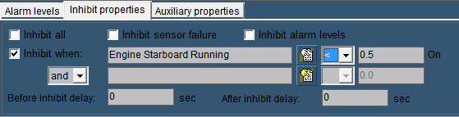

Figure 5‑7: Inhibit When

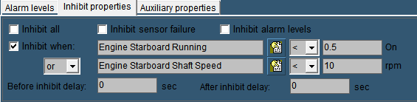

**Figure 5‑8: Inhibit When 2

*If you specify just one inhibit field, make sure the “and/or” box is set to “and”. Otherwise the alarm field will not work.*

#### Auxiliary Properties

* **Alarm Sound:**

Obsolete

* **Send SMS When Alarm Active**If you have the SMS Alert License you can tick this checkbox to send a text message to your phone, every time the alarm is triggered.
* **Alarm on Request Timeout**especially valves will have a long time to open or close. You can set a timeout on the time to get an alarm if the conditions aren’t met in the given time.
* **Alarm When Not Ready**

If the sensor is equipped whit an output to state that it is not ready, tick this checkbox to get an alarm.

### Min/Max

Under “Tools > Field Settings > Min/Max” (see Figure 5‑9) the instrument boundaries can be set. For example the “Engine 1 Oil Pressure” instrument can be set as follows:

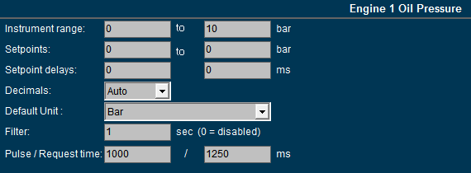

Figure 5‑9: Min/Max settings

#### Instrument range

The instrument range field is used to define the measuring range (scale) of the instrument.   
For example: the indicator below is scaled from 0 to 10 bar.

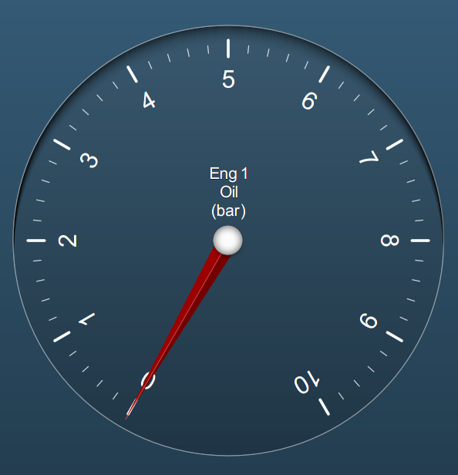

Figure 5‑10: Engine 1 oil pressure indicator (0 - 10 bar)

#### Setpoints

If the sensor values and their working ranges are known, you can set a zone marking. It puts a grid over the desired values on the instrument, to verify if the readings are correct.

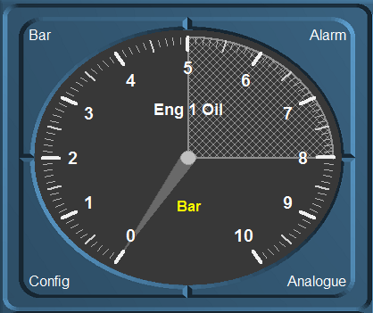

Figure 5‑11: Zone marking on older versions



For now this is only working in older versions of NavVision. It is not yet implemented in the new Mimic instruments, but it will be in the future.

#### Setpoint delay

Whit the delay you can set a time in milliseconds before an alarm will be triggered. This prevents recurring alarms if the sensor is working on the edge of the setpoint

#### Decimals

To make sure that in a mimic all the decimals in a value are of the same length, you can choose the number of decimals here. This will make it easier to get the same decimals for different values as FT NavVision© will calculate its own decimals. Standard is “Auto”.

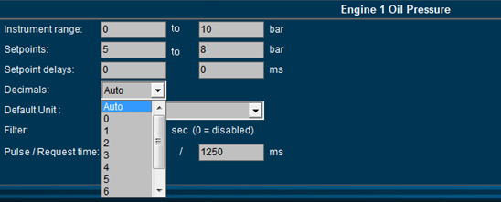

Figure 5‑12: Decimals

#### Default unit

At startup each instrument will show the unity in which it will display the data. Depending on the sensor type select the desired unity (see Figure 5‑13).

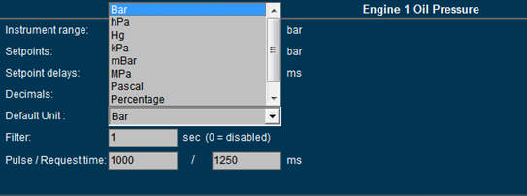

Figure 5‑13: Default unit



*In a mimic you can choose a secondary value to show in the mimic itself. See chapter about mimics*.

#### Filter

If an instrument reading seems to be a little erratic, you can select a higher number (see Figure 5‑13) to dampen the movement of the instrument pointer.

#### Pulse/Request time

The pulse time is the time a pulse will last after pressing the button in milliseconds. If you need a longer pulse (i.e. for starting or stopping a generator) you can change it here.

The request time is how long a request stays active. For example: some valves will take up to 30 seconds to open or close. If the time is set to 1250 ms and the valve didn’t get a feedback that it was opened or closed, it will stop or give an alarm. If you increase the amount of time here, NavVision will wait for that longer time to give an alarm.

This also goes for requests that are send over Modbus etc. sometimes you need to let it wait for a longer time.

### Tune

Tune is used to finetune the sensors outcome to make a more accurate readout.

#### Tune Table

The “Tune table” settings allows the user to fine-tune the output of a sender.  
 **Example 1: Sensor value too low.**  
In such a case you must change the “Input value”. You can change the input value as follows:Input value= 0.8 → Real value = 1.  
The statement above implies that for every input of 0.8 bar the output (actual reading) is 1 bar. In other words, any sensor input value of 4 bar corresponds with an instrument reading of 5 bar. You can make at most 29 correction points.  
  
**Example 2: Sensor value too high.**Change the input value as follows: Input value = 1.2 → Real value = 1.  
The statement above implies that for every input of 1.2 bar the output (actual reading) is 1 bar. In other words, any sensor input value of 5 bar corresponds with an instrument reading of around 4 bar. You can make at most 29 correction points.  
.

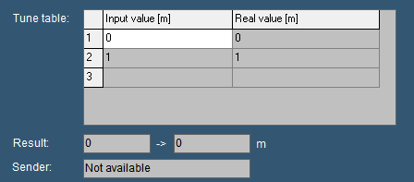

Figure 5‑14: Tune table

If you need an offset you can do that by using the Tune-table as well.

As shown in the x/y-matrix (see Figure 5‑73), it gives a linear line that is 0-output at 0-input and 1-output at 1-input.



Figure 5‑15: Tune Example 1

When you want to set an offset, you have to change at least 2 set-points to make the whole line go up and stay linear (see Figure 5‑74). If you change just 1 point it will skew in another direction. As soon as you set 2 new set-points in the tune-table, the line will move up- or downwards and will be linear adjusted (see Figure 5‑75).

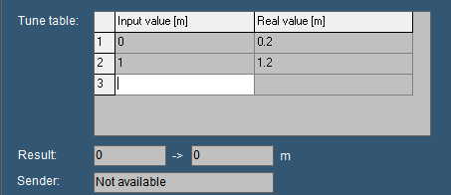

Figure 5‑16: adjusted tune table



Figure 5‑17: Tune Example 2

#### Result

The “Result” box displays the exact incoming measuring data. The second box displays this data as translated by NavVision.   
If for example the sensor gives a pressure (bar) output for every 20 mV, the real time result may read “100 → 5 bar”. As a result the sensor reads “100 mV” and indicated as “5 bar” on the instrument.



*Values may differ per sensor type.*

#### Sender

The “Sender” box (see Figure 5‑18) displays the interface where the data is coming from. If the sender field shows “Not available” the sensor isn’t giving any data (for a reason why it is not giving data, check the troubleshooting section).   
Items you can see in the box “sender” are: NMEA, Wago, Serial, Modbus, Calculated in, etc. this gives you an indication where the signal is coming from.

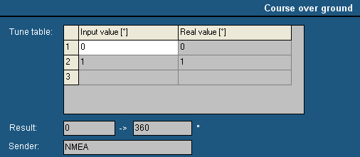

Figure 5‑18: Sender box

### Comment

In the “Comment” section you can change the names of different fields to get an overall clarity. These names can be changed for the clarity in an instrument or a logbook if the sensor has an explicit name. Sometimes you have to use an auxiliary field when the name for that sensor is not available.

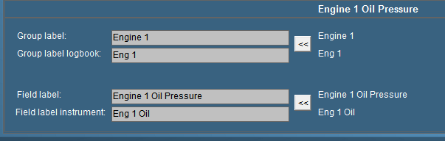

Figure 5‑19: Comment

#### Group label

Via “Group label” you can assigns a field to a specific “Alarm” group. The name is written in full so there will be no misunderstanding. It is especially handy if you have different sensors, which are arranged in different groups. Once grouped, you change them in “Group label”.

#### Group label logbook

This is the label that is shown in the logbook (see chapter logbook). To save space you type an abbreviation of the group label. This is helpful to check in the logbook. All the alarms in the Logbook will have a group available so it is distinct where to place the alarm.

#### Field label

The field label is the exact indication of the sensor. For every sensor in NavVision you need a unique ID. That ID is the field label. Whether it is already preprogrammed or you rename an auxiliary field, that field label represents from then on the sensor. Knowing this, NavVision can connect this sensor to an instrument, calculate with it etc. mostly you will see the representation of this field label in the Wago, but it is possible you find it in other, programming or calibration files.

#### Field label instrument

The name of the sensor showed in the instrument is set in the field label instrument. While there isn’t always that much space in an instrument, we use an abbreviation of the “Field label”. If you have to make up a name yourself be sure to choose a name that is representing the sensor and is clear, even in the abbreviation.



*To switch back to the old settings, just click on the arrow-button on the right side*

### Auto Switch

#### General

Under auto switch you can automate some of the actions of I/O in a decent easy manner, without knowledge of PLC programming. It is used to make small automations within the program.

#### Autoswitch Method

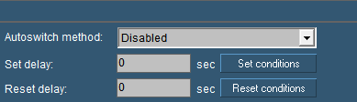

Figure 5‑20: Autoswitch

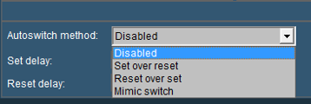

Figure 5‑21: Autoswitch choices

|  |  |
| --- | --- |
| **Autoswitch option** | **Explanation** |
| Autoswitch Method | Here you choose how the switch works  Disabled: not working  Set over Reset: Set is standard position  Reset over Set: Reset is standard position  Mimic Switch: for use in a mimic without attached sensor |
| Set Delay | Delay time for Set condition |
| Reset Delay | Delay time for Reset condition |
| Set conditions | Set conditions on how to react (see Figure 5‑22) |
| Reset conditions | Set conditions on how to react (see Figure 5‑22) |



*The mimic Switch function is important if you want to use a button in a mimic that isn’t attached to any field in NavVision. Here you can use it as a freely programmable button to trigger other events like “Harbor Mode” or others.*

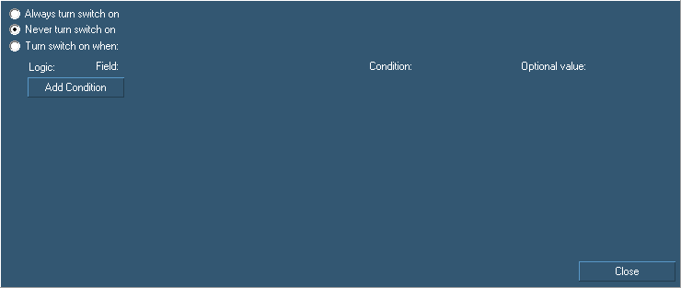

Figure 5‑22: Auto Switch Conditions

|  |  |
| --- | --- |
| **Autoswitch conditions** | **Explanation** |
| Always turn switch on | Switch is always on/visible |
| Never turn switch on | Switch is always off/unvisible |
| Turn switch on when | Let you add logic to turn a switch on |
| Add Condition | Alter the conditions that you need to make the switch work |

For example if you have a switch that turns on the bilge pump, you can also let it switch on when a certain event occur. So if you have a high alarm from that bilge, you can make the switch go on by saying so in the conditions field (see Figure 5‑23)

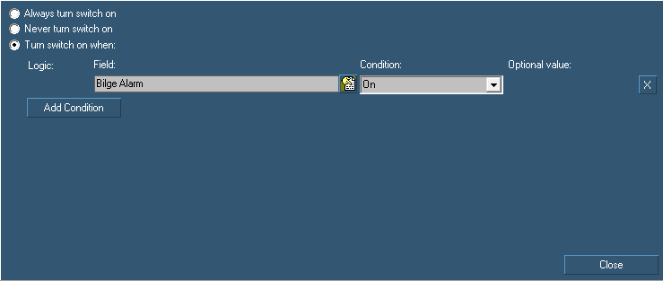

Figure 5‑23: Auto Switch condition

Under conditions you find a lot of settings tah you can use in different situations. You can experiment to get the right adjustments you need.

### Log

For troubleshooting and examination purposes you can log all the fields. All the data coming in on each specific field can be saved to a log file.

Go to “Tools > Field Settings > Log” and choose the right field (e.g. Engine 1 Oil Pressure).

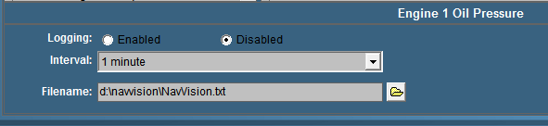

Figure 5‑24: Logging

#### Logging

Choose whether to enable or disable the logging on this field.

#### Interval

Depending on the data on the field you can choose an interval her form 1 second to 2 hours. Useless to say that the log file is getting a lot bigger at an interval of 1 second. Be very precautious when using this.

#### Filename

Here you can chose the name and place where you save the log file.

### Logging with trending

When you have mimics available, you automatically have the possibility to make a trending mimic. Trending is very useful for troubleshooting and you can also use it to log activities.

In an empty mimic make a trending instrument. You will get the following instrument (see Figure 5‑25). At the right side you can choose the field that you want to see in your trend-instrument.

Click with your mouse on the box at the right side of the trending window. A dialog box will appear (see Figure 5‑26). Here now you can chose the field that you want to track.

Once you have chosen a field a new box will appear. Clicking on the colored line will take you to the color adjustment window, so you can give every trend a distinct color.

Moving your mouse over the trend-lines give you an exact date and time for every event on that line (see Figure 5‑27).

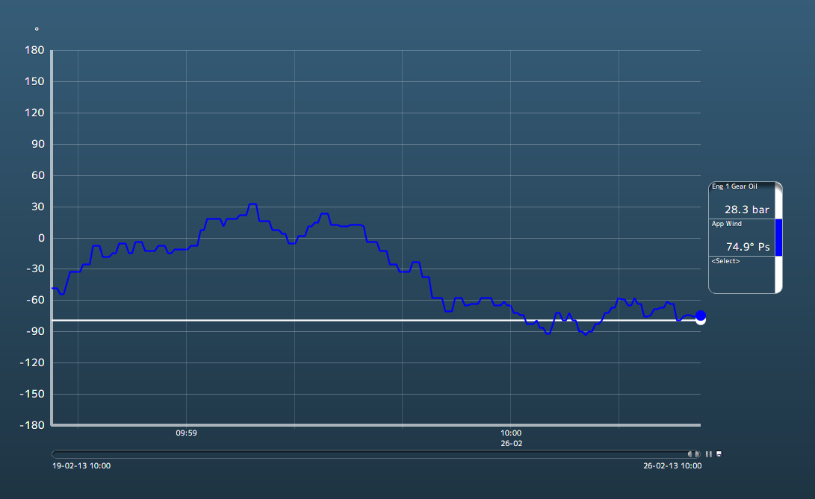

Figure 5‑25: Trending instrument

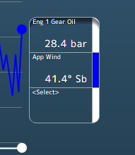

Figure 5‑26: Selection boxes

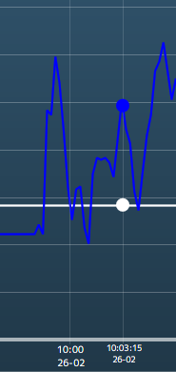

Figure 5‑27: time line

The line underneath the trending page is adjustable. You can take one of the corners to adjust the length of the trend to the interval time that you like to use (see Figure 5‑28).

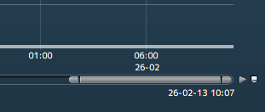

Figure 5‑28: Trending adjustments

Next to that line you can see a play button to make it interactive. You can play or pause the trending. Next to the play button is a save-icon. If you want to save the trending, click on the icon, find a place to save and give the file a name NavVision will save it to a .csv file that you can open with Excel (see Figure 5‑29).

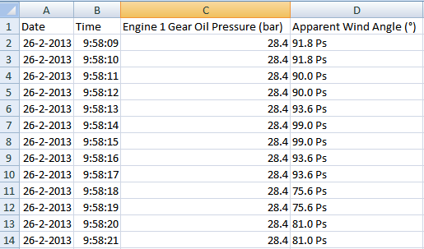

Figure 5‑29: Saved trending file

## Alarm stations

The installation on board can be divided into different parts (alarm stations) which all can have different rights concerning the completion of alarms. Besides that it is proficient to have different rights for different groups onboard it is also prescribed by organizations such as Lloyds Register etc. there are preset names to choose from.   
These groups can be setup with specific alarm-rights. You can understand that the crewmess has other rights on alarms as the Engine Room or the Wheelhouse. Also the same goes for many other stations around the ship as there are the captain’s cabin, Flybridge, etc.

### Alarm Matrix

The alarm matrix defines which alarms get to which workstation or panel, what a workstation or panel is allowed to do and which rights workstations or panels have. This all in sequential order and within range of class rules.

If you start up the system the first time, the matrix will be set to standard. If this is not the case you can remove the “AlarmPanels.uc.ini” out of the network folder and restart. NavVision will start a new default matrix.

**

*Although an engineer or administrator can alter these settings, we at NavVision will deliver the system within class rules. Any alteration is solely the responsibility of the administrator.*

### The matrix

The matrix can be found in NavVision under Tools/Alarm Stations (see Figure 5‑30).

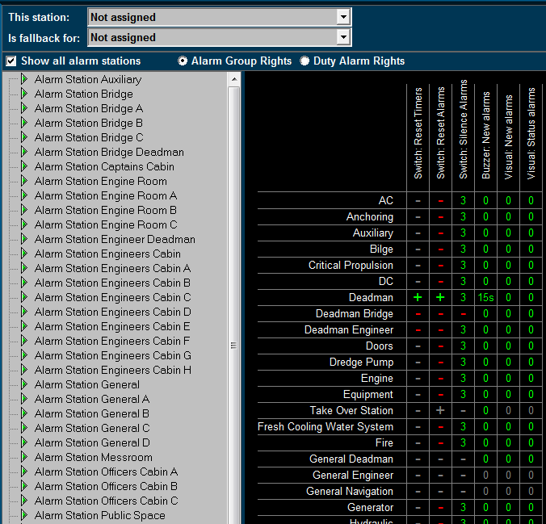

Figure 5‑30: Station Matrix

As you can see the default settings are already in place. Things you cannot do are protected and will show a grey line. Additional settings that are allowed are shown with a red line.

#### This station

Defines the station this computer is set on. All the alarm settings of that station are also valid for the PC screen you are working on. If set to “Not Assigned” no specific alarm restriction is set. All alarms will be visible and can be silenced or acknowledged.

#### Is fallback for

This defines which rights this computer will get once the station set in this box is not working. If this would be the wheelhouse pc it could be a fallback station for the engine room. When the engine room pc should be out for whatever reason, the wheelhouse station will take over the tasks and rights of the engine room pc. This way all the important tasks can still be handled.

#### Show all alarm stations

Ticking this box switches between showing all, or all available alarmstations.

#### Alarm group rights/Duty alarm rights

Choose either of these two to switch between changing alarm group rights or duty alarm rights.

#### Adjustments

On the left pane you can choose the alarm station to be adjusted. The adjustments will only be valid for that particular station. When you choose to set this station (i.e. Alarm station bridge) on an alarm panel or another Server or client, these will have the same settings automatically.

**

*All the settings in the diverse alarm stations will automatically be set in all the other pc’s (servers and clients) which are connected. You won’t have to change all PC’s separately. On the left panel you will find all the groups that are available in the system. Groups that are in use by the system are shown in the right pane. Other groups will not be available. You can set the alarm options for each separate group.*

*When finished, all alarm options of each alarm group will be set within the specific alarm stations.*

The following options are available for Alarm Group Rights:

|  |  |
| --- | --- |
| **Alarm group option** | **Explanation** |
| Visual: status alarms | Shows any alarm even if it is acknowledged |
| Visual: new alarms | Shows new alarms for this group |
| Buzzer: new alarms | Sounds buzzer on new alarms for this group |
| Switch: silence alarms | Allows to silence the alarms for this group |
| Switch: reset alarms | Allows to acknowledge the alarms for this group |
| Switch: reset timers | Allows resetting of timers (i.e. dead man’s timer) |

Table 5‑1: Alarm Group Rights

#### How to set Alarm Group Rights

Fields are set separately by pointing the mouse onto that field and right click it. The “Reset” fields will turn to “+” and the other fields will turn to “0” which simultaneously means that the delay is set to “0” minutes.

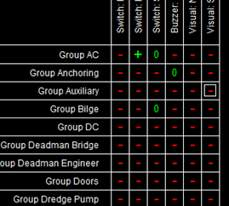

Figure 5‑31: Settings example

If you want to set a field to a higher delay (i.e. you want to silence an alarm for 3 minutes) you must left click the field. A menu will appear where you can change the settings including the delay time. Check “Enable the selected cells” and choose a delay time. You can choose the delay time in minutes or seconds by checking the appropriate box (see Figure 5‑32).

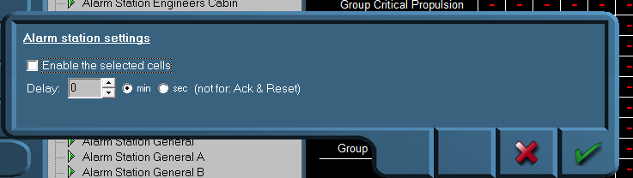

Figure 5‑32: Alarm station settings

In addition, you can do this for different cells at the same time, by clicking and dragging the mouse over the preferred cells (see Figure 5‑33).

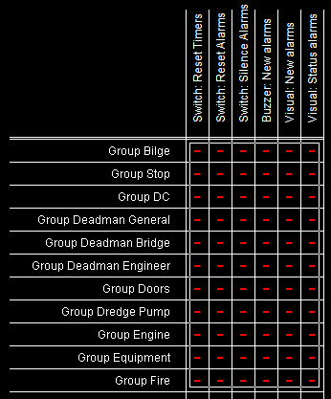

Figure 5‑33: Select by dragging

If you want to disable the alarm settings, deselect the checkbox “Enable the selected cells”.

The following options are available for Duty Alarm Rights:

|  |  |
| --- | --- |
| **Alarm group option** | **Explanation** |
| Call Allowed | Marks if other stations are allowed to call this station |
| Bridge Duty | Marks if station can be selected for Bridge Duty |
| Bridge Duty Select | Marks if station can select bridge duty |
| ER Duty | Marks if station can be selected for ER Duty |
| ER Duty Select | Marks if station can select ER duty |
| Activate station | Marks if station is allowed to switch on or off |

Table 5‑2: Duty Alarm Rights

The “Call Allowed” and “Duty” is shown in the alarm mimic on the main workstations (see Figure 5‑34 and Figure 5‑35).

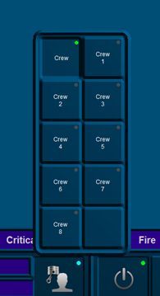

Figure 5‑34: Duty Select function

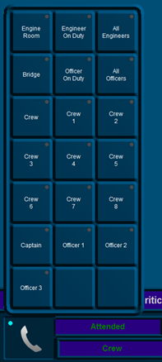

Figure 5‑35: Call Select function



*The NavVision fields for call and duty select can be found under Field Settings/Alarm/Crew/Crew Alarms.*

### Background

To elaborate a little bit further we will explain a bit more about the use of alarm stations. Each station will be in a particular part of the ship (i.e. wheelhouse, engine room, crewmess, chief engineer cabin etc.) All these stations have their own rights on which alarms they can hear or see and how they can act upon such an alarm. For example, the engine room is the place where all the alarms normally will be visible and almost always the only place where alarms can be acknowledged. This is because regulations require that alarms can only be acknowledged on that part of the ship where you can act upon the alarm and take precaution action on that alarm. Now in the crewmess (a public space) all kind of people have access to the workstation. It is not advisable that these people have rights to acknowledge the alarm. So in this space you can set the Alarmstations rights for the crewmess, so that they don’t have the rights to acknowledge.

You can imagine that in the wheelhouse they do not want to see all the alarms concerning propulsion etc. merely navigational alarms are mostly enough on the bridge. Here you can set the alarm stations to only show navigational alarms and not propulsion alarms.

### Alarm Panels

Often we use smaller panels as a workstation in diverse rooms (especially the smaller cabins and messroom) these panels are called DAP (Duty Alarm Panel). These DAP’s have to be pointed out to the system. Under Alarm Stations>Alarm Panels you can set these DAP’s (see Figure 5‑36).

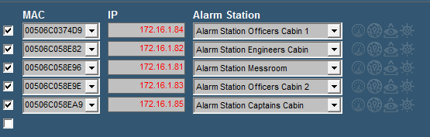

Figure 5‑36: Alarm Panels

|  |  |
| --- | --- |
| **Alarm group option** | **Explanation** |
| Checkbox | Switch the particular DAP on or off |
| MAC | Type the MAC-address of the DAP here |
| IP | IP address in range 172.xx.0.81 and so on |
| Alarm Station | Choose which station it will represent (for alarm settings) |



*After changing these settings choose “accept and restart communication” to activate the changes.*

There are a few items, shown as icons behind the lines, which give extra functionality to the station (see Figure 5‑37).



Figure 5‑37: Alarmpanel icons (Settings)

#### Mimics



When switched on you can choose which mimics can be shown on the alarmpanel. By clicking on the mimic-icon behind the alarmpanel, you can choose which mimic will be available on that panel (see Figure 5‑38).

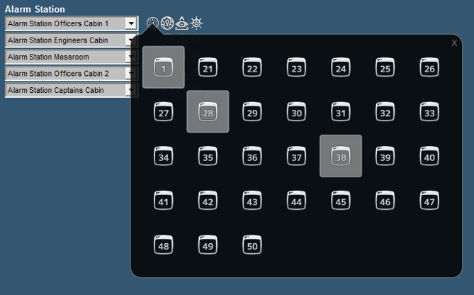

Figure 5‑38: Select the mimics

#### VPN



When you have an alarmpanel like a tablet which is connected to the ships network through VPN, you need to check the icon “VPN”. This prevents NavVision from pinging the station constantly.

#### BNWAS



When the panel needs to function as a BNWAS panel besides the other functions, you need to check this Icon. Upload button will appear with which you can set it.

#### Wheelmark



When the wheelmark needs to be shown on the alarmpanel, you need to check this icon to enable the show wheelmark for the particular panel.

### Alarm groups

In Alarm Groups you can define the looks of the DAP’s and the workstation it is running on (see Figure 5‑39).

Under “duty alarm panels” you can set the rows and columns that you want to see if they are in alarm. You can choose up to 2 rows and up to 5 columns. Under “assigned alarm groups” you can define which alarm group you will see. Just click on a field and choose the specific alarm Group.

“This Station” defines the look and feel of the OWS. In default mode you have the same layout as a standard alarm page. You can also choose to only see a list of alarms or a list of alarms with the controls for silencing etc.

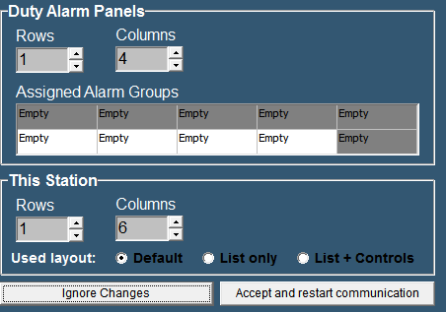

Figure 5‑39: Alarm Groups

**

*After changing these settings choose “accept changes” to activate the changes.*

### Alarm Settings

Here you can specify different alarm settings.

Under “Duty Alarm System” you can choose the following:

**Automatic deactivate of public space When ER attended:** if you do not want the alarms to sound in all the public spaces when there is someone at watch in the ER

**Alert duty Cabin When ER turns unattended:** To notify the person on duty that there is nobody in the ER anymore and his watch begins.

**Alert Bridge when ER turns unattended:** Just for convenience.

Under **“Personal Alarm System”** you can choose if the Deadman timer starts again with every new alarm and if a mouse-movement will rest the timer of the BNWAS.

Under **“BNWAS”** you can choose whether to use the standard NavVision BNWAS or the dedicated external BNWAS which is the new standard for NavVision. If you choose the external BNWAS you can click the BNWAS Configuration button to configure the BNWAS. This will be explained in a separate topic and in the BNWAS Manual.

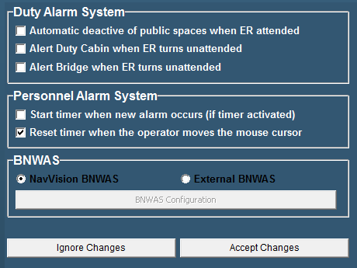

Figure 5‑40: Alarm Settings

**

*After changing these settings choose “accept changes” to activate the changes.*

### Preferences

This function is obsolete. It will be deleted in a future release.

### Taskbar

To open the NavVision taskbar menu, select “Tools > Taskbar”.

The taskbar menu is used to configure the taskbar.

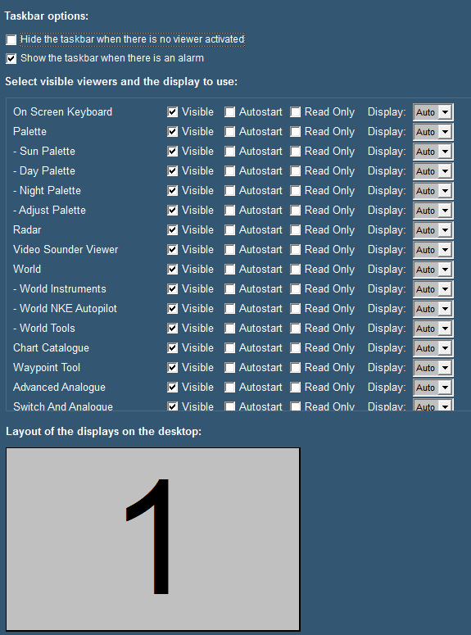

Figure 5‑41: Taskbar menu

The following taskbar settings are available:

|  |  |
| --- | --- |
| **Setting** | **Description** |
| Hide the taskbar when there is no viewer activated | This option allows you to hide the taskbar, in case all viewers are inactive. This function can be disabled, by moving the mouse cursor to the top of the screen. |
| Show the taskbar when there is an alarm | This option allows the taskbar to appear whenever an alarm occurs. This overrides the previous setting of the hidden taskbar. |
| Visible | This option allows you to select the availability of viewers. You can select the viewer that must be displayed and be accessible through the taskbar or not. |
| Autostart | The second option enables you to determine the viewers that automatically open at startup of the software. |
| Read Only | This option prevents people to alter settings in the viewer or mimic |
| Display | The display box defines the screen used for each viewer. The number shown symbolizes the displays as shown at the bottom of the screen. “Auto” means that it will appear at the first free screen. If there is a number, the viewer will appear on that screen. Only available if you have more screens attached. |
| Layout of the displays on the desktop | This setting allows you to show the placement of the different screens connected to your system. The display order, size and the number available for display of viewers are shown. |

#### 

*As of release 9.18.03.3522 it is possible to hide the “close” button to make sure people do not shutdown the program accidently. Just uncheck the checkmark box for the close button*

### GPS/NMEA

The GPS/NMEA page is merely a reference to check data. You can use it to see if data from GPS or NMEA devices is coming into the system and if the data is right.

### GPS calculates the position in/The position is shown in

These two fields can be used to change the calculating method of the GPS sets. In almost any case you can leave them as they are.

### Trace of received NMEA data

In the window below the text you will find all the NMEA data that is coming in. With the eraser you can clear the data from the window. By checking/unchecking the box from “Rx” or “Tx” you get respectively only received, only transmitted or all data.

If the string you see in the window is green, the data is recognized by NavVision and can be processed. This doesn’t directly mean that the data is correct, but only that the string is sent in the right style. If the string is grey, it is no longer available or not in the correct style and won’t be processed by NavVision.



*While NavVision repeats a lot of NMEA data for multiple purposes, it is wise to uncheck the “Tx” box when you are checking the incoming data.*

## Configuration

### General

Under configuration you will find all the tabs that you can use to configure and fine-tune the NavVision system. These settings need to be done by the engineering department. Also commissioning engineers need to know how to work with these settings.

## License

To give rights to use a specific part of the software, NavVision uses licenses to open up these parts of the software. Depending on which licenses are bought, viewers will be visible and strings will be processed (see Figure 5‑42).

Under “License” you can see which viewers, communication etc. are opened in your version. If you see a license and it is green, this means that the license is valid. If the license is red it is not valid. If there is no license and the stripes in the box are green or red it means the same, only than the license is freed up by another license (i.e. Navigation Pro license will also open up NMEA, so the stripes under NMEA will be green).

Normally you won’t have to alter anything here. Free Technics will provide you with a “Key.uc.ini” with all the necessary licenses available. The program will read the licenses from the ini-file and put them in place at startup. Sometimes however you can check here if you miss a certain viewer or if a communication protocol doesn’t seem to work. If you are missing a single license, you can fill it in here and it will be set in the ini-file as well.

**

*Missing licenses are also mentioned in the logbook. Please refer to the chapter “Logbook” for more information.*

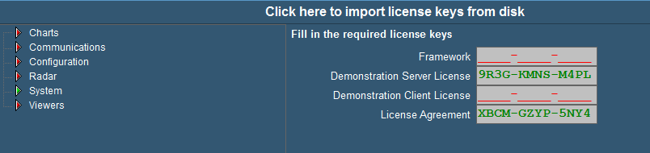

Figure 5‑42: License

## Serial

### General

Under “Tools > Configuration > Serial” the following menus are available;

* COM ports
* Serial LAN ports
* CAN ports
* MasterBus Devices
* Overview connected devices.

### COM ports

Under “Tools > Configuration > Serial > COM ports” (see Figure 5‑43) all COM ports as found by NavVision ® become visible. At the first startup they are no COM port yet assigned (i.e. COM port menu does not show any COM port data).

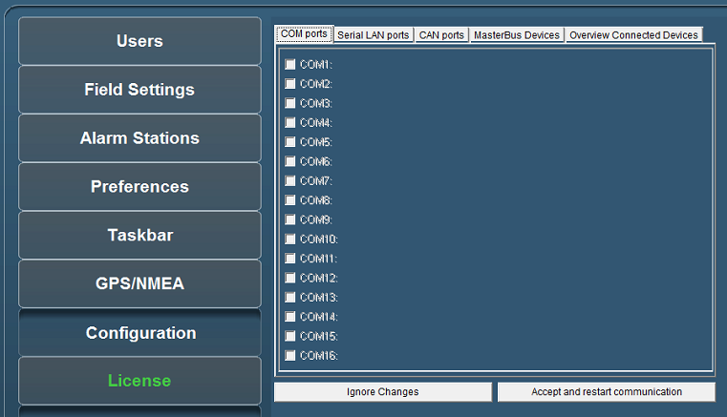

Figure 5‑43: COM ports

#### COM port assignment

**

*Use the right device interface (protocol) and verify the baudrate etc.*

Check the respective wiring schematics to determine the COM port arrangement and assignment. Tick off the relevant COM port (1, 2, 3, etc.) and select the required device interface (protocol) by means of the drop-down menu (see Figure 5‑44 and Figure 5‑45).

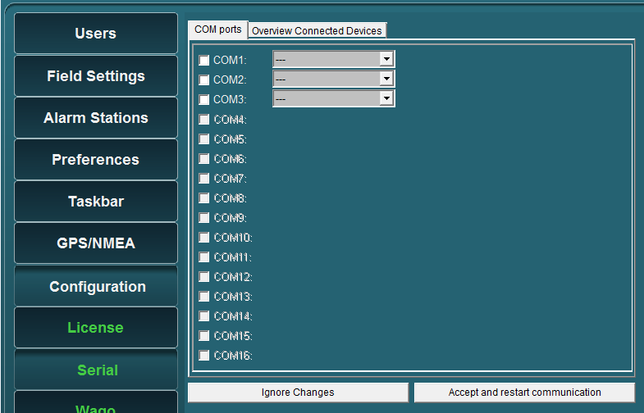

Figure 5‑44: Drop-down menu (device interfaces)

At completion, confirm the settings by clicking “Accept and restart communication” (see Figure 5‑44).

Check the appropriate NavVision viewer to verify if the COM-port is correct and if there is any data communication.

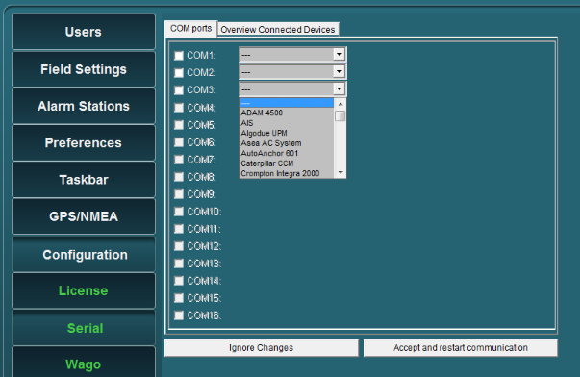

Figure 5‑45: COM port assignment

Additional information on the selected port can be configured by clicking on the sign behind the drop-down menu (see Figure 5‑46). A new box will open.

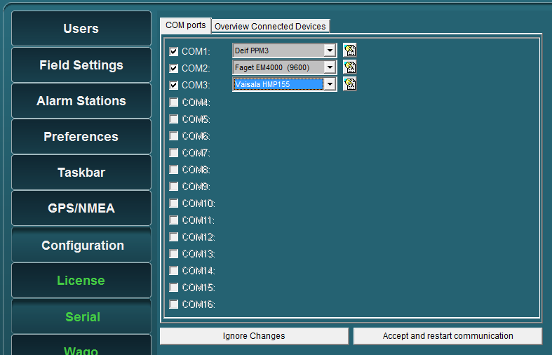

Figure 5‑46: additional configuration

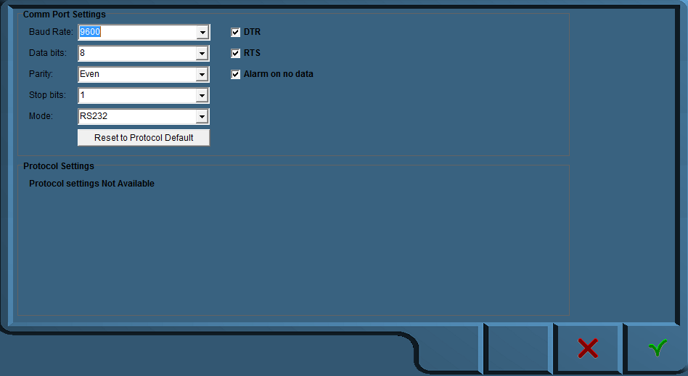

Figure 5‑47: Comm Port Settings

In this additional configuration menu (see Figure 5‑47) you can force all the settings for the regarding Communication port. The following fields apply:

* Baud Rate: Set the appropriate baudrate (see manual attached device)
* Data Bits: The number of data bits in each character can be 5 (for Baudot code), 6 (rarely used), 7 (for true ASCII), 8 (for any kind of data, as this matches the size of a byte), or 9 (rarely used). 8 data bits are almost universally used in newer applications. 5 or 7 bits generally only make sense with older equipment such as teleprinters.
* Parity: The parity bit in each character can be set to none (N), odd (O), even (E), mark (M), or space (S). None means that no parity bit is sent at all. Mark parity means that the parity bit is always set to the mark signal condition (logical 1) and likewise space parity always sends the parity bit in the space signal condition. Aside from uncommon applications that use the 9th (parity) bit for some form of addressing or special signalling, mark or space parity is uncommon, as it adds no error detection information. Odd parity is more common than even, since it ensures that at least one state transition occurs in each character, which makes it more reliable. The most common parity setting, however, is "none", with error detection handled by a communication protocol.
* Stop Bits: Stop bits sent at the end of every character allow the receiving signal hardware to detect the end of a character and to resynchronise with the character stream. Electronic devices usually use one stop bit.
* Mode: In mode you can set the protocol that the serial port is using to communicate. Refer to your device for the proper protocol. You can choose between RS232, RS422 and RS485. In some occasions you can’t choose Mode because the interface protocol can only work in a predefined Mode (i.e. NMEA is always RS232).
* DTR: Data Terminal Ready, indicates presence of DTE to DCE (set high or low)
* RTS: Request to send, DTE requests the DCE prepare to receive data (set high or low)
* Alarm on no data: Gives an alarm when there is no data on the Comm port
* Reset to protocol default: Resets standard configuration for chosen protocol

#### Special note on printers

Under the Com port assignment, if you choose “printer” there will be an additional configuration part. You can set which data you want to be printed by checking the appropriate checkmark (see Figure 5‑48). While NavVision supports two printers, you can add different data to the separate printers.

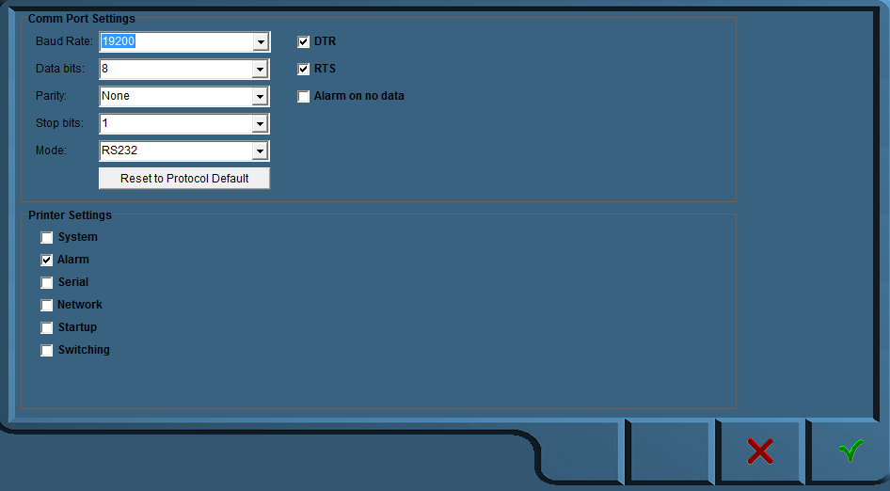

Figure 5‑48: Printer settings

### Serial LAN ports

Under “Serial LAN ports” (see Figure 5‑49) the attached serial LAN device can be addressed and when necessary be calibrated.

The following fields are available;

* Serial LAN server
* Type (serial LAN server)
* IP address
* MAC address
* Data/control port
* LAN1 and LAN2

After installation a calibration procedure must follow, to ensure that the LAN device will function properly.

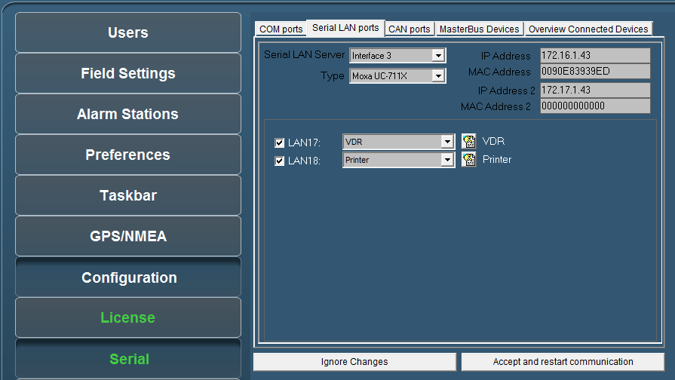

Figure 5‑49: Serial LAN ports

#### Serial LAN server

Under “Serial LAN ports > Serial LAN server” (see Figure 5‑50) the server to be assigned can be selected. In addition under “Type” the LAN server type can be selected.

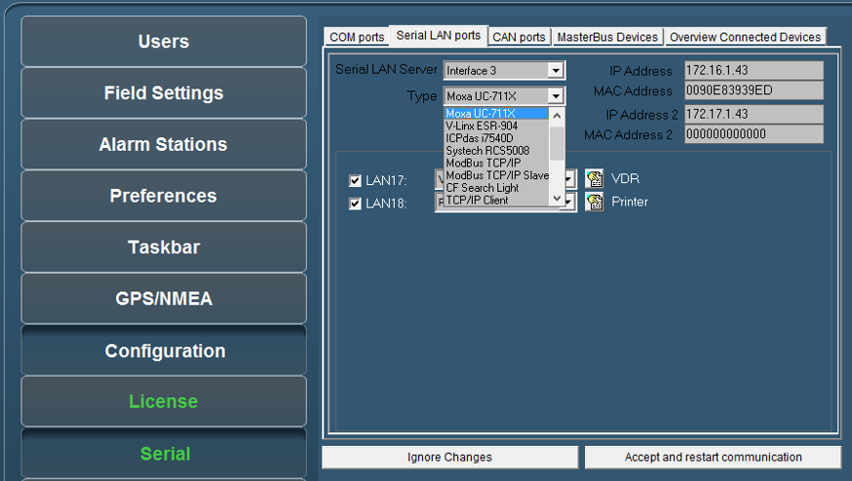

Figure 5‑50: Type (Moxa)

#### Type (Moxa UC-711X)

The Moxa is found under “Type” > “Moxa UC-711X” (see Figure 5‑50).   
Fill in the IP address of the Moxa unit under “IP Address” (use same range as the PC i.e. 172.16.x.x, for Moxa the last digits are in the 40 range).   
The very first connected Moxa unit is set to IP address 172.16.1.41 and the next available to 172.16.1.42 etc.



*The MAC address can be found on the sticker underneath the unit.*

For the Moxa unit it is necessary to use a MAC address specified under “MAC Address”.

If necessary, verify the LAN1 and/or LAN2 settings and choose the appropriate device interface / protocol.

To confirm the settings, click “Accept and restart communication” and verify if the serial data is working within NavVision.

Other possibilities can be chosen in the port-assignment drop-down. These refer to the different protocols that can be set here. You can find these protocols as catalogue in Table 5‑3.

|  |  |  |  |
| --- | --- | --- | --- |
| **Protocols** |  |  |  |
| Adam | Frigomar_626C | MTU | Soft PLC |
| AIS | FSI_2DACM | MVECP | Sounder |
| Algodue | Generic | Nke | Switch |
| Asea | Gensys | Nmea | SygoDraft |
| AutoAnchor601 | J1708 | Nmea Mecmar | TMA4S |
| BMV501 | J1939 | Nmea Nacos | Vaisala_CL31 |
| BMV602 | KiloPakIguard | Nmea Quantum | Vaisala_LT31 |
| BTM1 | Littau Anchor | Nmea2000 | Vaisala_PTB330 |
| Camera | Lutron | OPC Client | Vaisala_PW |
| Can | MalinDraught | PC | VDR |
| Cat | Masterbus Modbus | PPM3 | Victron |
| CF Smartview | Mastervolt | Printer | VictronVEBus |
| Crompton | Mitsubishi_DMS_II | Remote Monitoring | VisiplexPaging |
| DssKeypad | ModBus | Sae | Wago |
| EM4000 | ModBus Slave | SD41 | WatchIO |
| EmpirBus | MPC30 | SMS |  |

Table 5‑3: Port assignments

### CAN ports

Under “Serial > CAN ports” the following menus are available:

* Interface
* Standard
* IP
* Group.

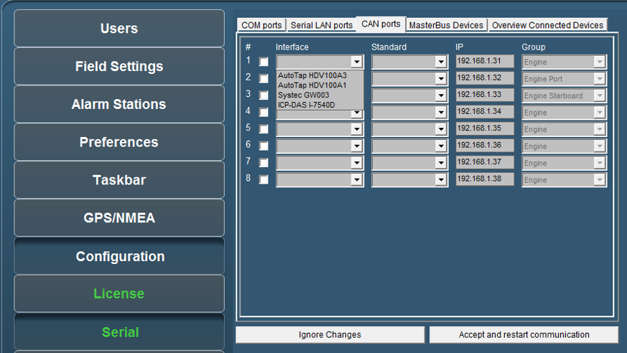

Figure 5‑51: Interface

Under interface you can choose different kinds of Can-interfaces. The most used one is the ICP. If you come across an older version, you can choose it here (see Figure 5‑51).

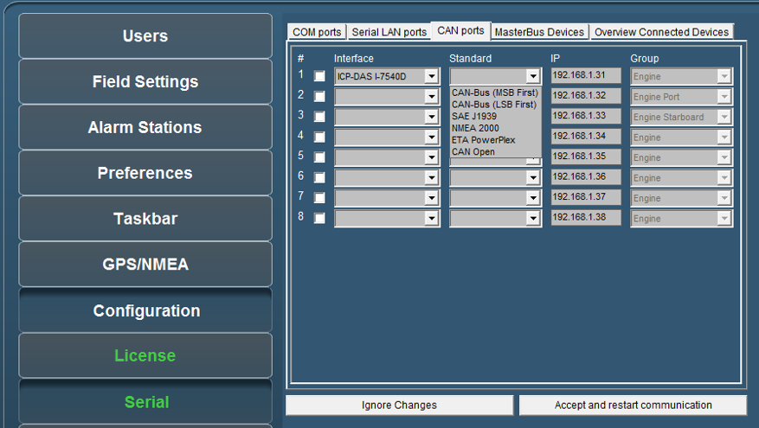

Figure 5‑52: Standard

Under Standard you choose the protocol you want to use with the interface (see Figure 5‑52). Most widely used are the NMEA 2000 and the SAE J1939. Which to use is depending on your attached protocol.

Under IP you can select the right IP address that reflects the connected ICP for example. You can best leave it as it is by default (which will become the 172.16.1.x range). For information on how to set the right IP-address in the ICP, please refer to the ICP installation manual.

The group you choose reflects under which group the information will be stored in NavVision. If you, for example, want the information from the interface to show up under Engine Port, you select that under Group (see Figure 5‑52).

After each change you need to hit “Accept and restart communication” to save it to the system.

### Overview connected devices

Under “Serial > Overview Connected Devices” (see Figure 5‑53) an overview of the connected devices is shown.

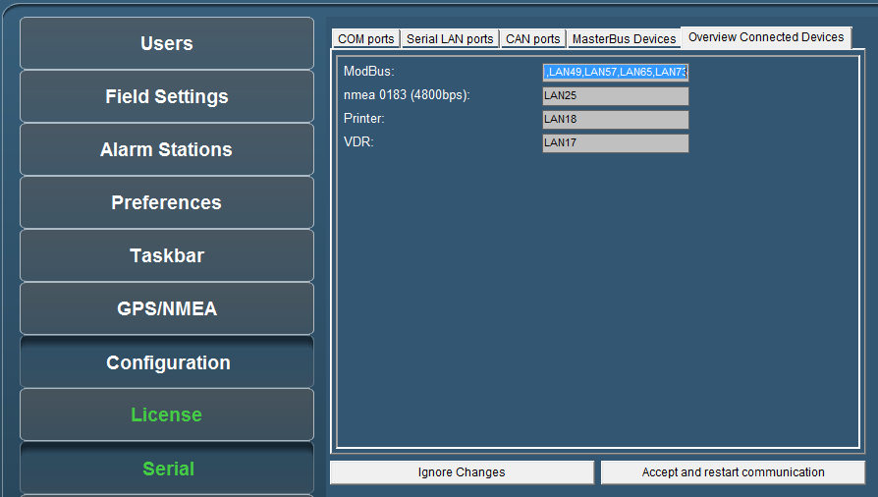

Figure 5‑53: Overview connected devices

### IP-Address standardization

For standardization purposes the same IP-addresses are used throughout each system. In the table below you’ll find the IP-addresses (standard protocol) for most instruments.

|  |  |
| --- | --- |
| **Detail** | **IP-Address** |
| PC I/O | 172.16.x.x (172.16.24.35 for key number 2435) |
| PC I/O next ring | 172.17.x.x (172.17.24.35 for key number 2435) |
| Duty Alarm Panels  (DAP) | Using range x.x.1.8y  Depending on the network connected, this will result in:  DAP 1: 172.16.1.81  DAP 2: 172.16.1.82  DAP 3: 172.16.1.83 |
| Serial LAN servers | Using range 172.16.1.4x (attached to I/O subnet 172.16) INT 1: 172.16.1.41 INT 2: 172.16.1.42 INT 3: 172.16.1.43 |
| Wago | Using range 172.16.1.9x (attached to I/O subnet 172.16) Wago substation 1: 172.16.1.91 Wago substation 2: 172.16.1.92 Wago substation 3: 172.16.1.93 |
| CAN-Interface | Using range 172.16.1.3x (attached to I/O subnet 172.16) CAN interface 1: 172.16.1.31 CAN interface 2: 172.16.1.32 CAN interface 3: 172.16.1.33 |
| Axis | Using range 172.16.1.24x (attached to I/O subnet 172.16) Axis cam server 1: 172.16.1.241 Axis cam server 2: 172.16.1.242 Axis cam server 3: 172.16.1.243 |

## Wago

### General

Under “Tools > Configuration > Wago” (see Figure 5‑54) all detected and connected Wago devices become visible including the server to which they are connected to.   
You can check the MAC-address and see if the Wago is connected or not.

In general, by means of the sensor list changes are made. But for minor changes or to improve the control of the device, please refer to this menu.

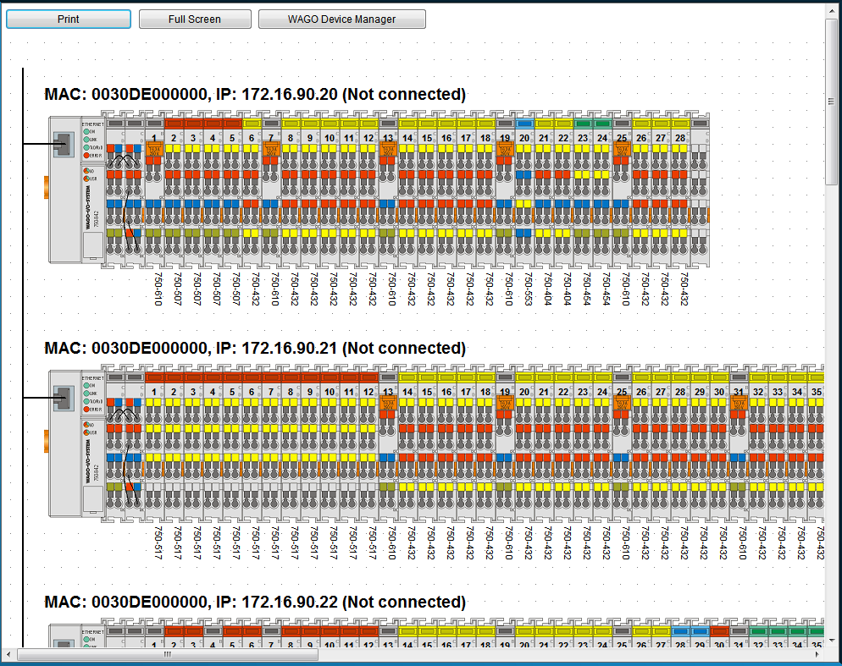

Figure 5‑54: Wago configuration

|  |  |
| --- | --- |
| **Detail** | **Description** |
| Print | Print the separate Wago-layouts for your convenience |
| Full Screen | Shows the Wago-layout full screen |
| Wago Device Manager | Opens a new window where you can set specific configuration settings |

When you click on a Wago, it will expand and show you the separate slices with the connected fields (see Figure 5‑55). Here you can fine-tune the selection, troubleshoot problems and calibrate sensors.

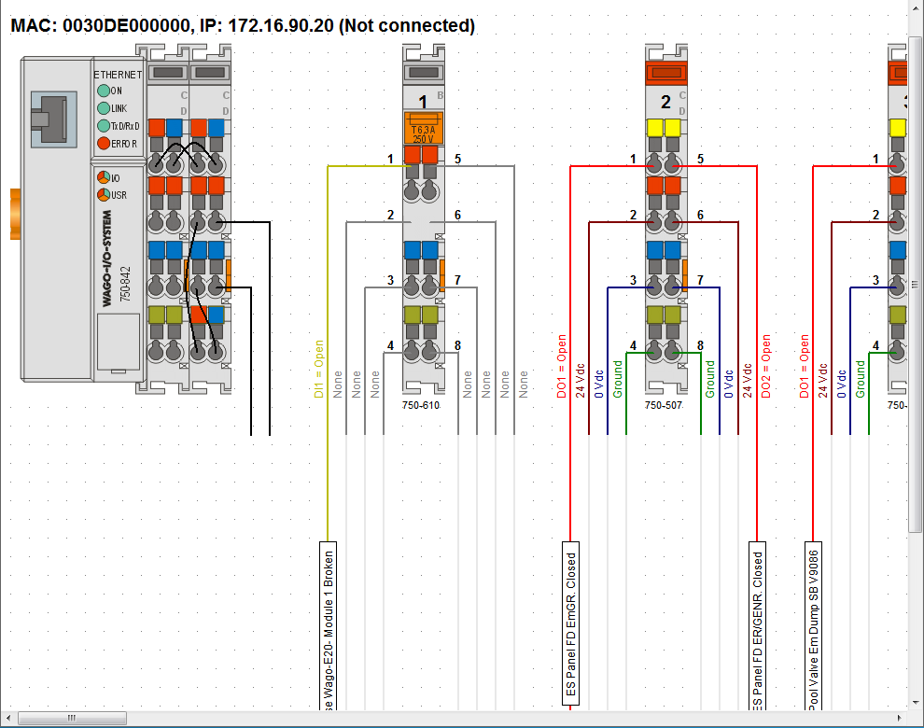

Figure 5‑55: Wago expanded view

### Adding a field to the Wago

If you want to add a new field to a Wago slice, just click on the field name box of the specific slice. If there was not already a field attached, the box will be blank (named sensor). By clicking it you will open a new window that shows all the fields within NavVision (see Figure 5‑56)

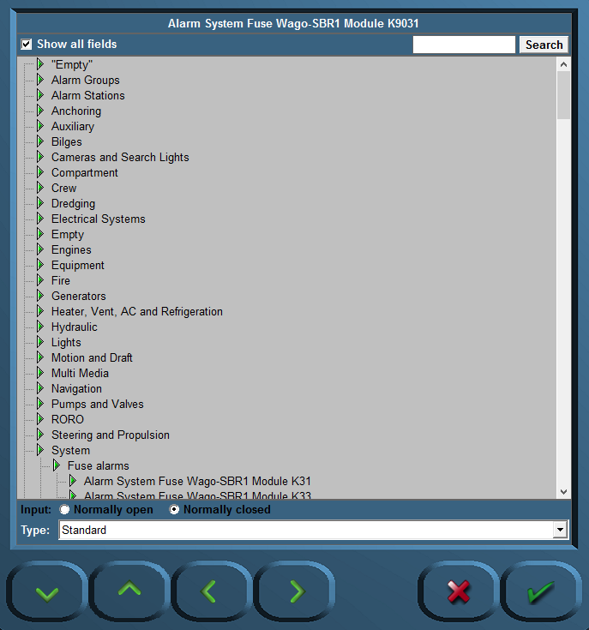

Figure 5‑56: Sensor-window

The following choices are possible:

|  |  |
| --- | --- |
| **Detail** | **Description** |
| Input | NO or NC |
| Type | The behavior of the field (see 5.8.3) |
| Show all fields | Toggling between all fields and fields available |
| Search | Search for a specific field |

### Wago “Type” explanation

The Type architecture needs some extra explanation. Each field in NavVision has its own behavior. It can be an alarm, a status, or an analogue value. Sometimes you need to give a field a specific task. As add-on to its original task, or if the field is just a standard field.

By default the sensor will have “standard” as its type-value. This will set the behavior to the standard mode of the field. The choices you have and their behavior will be explained in the next paragraph.

### Type and behavior

Under “Type” (sensor type) a variety of sensor types can be chosen. The most commonly used types are described.   
Click the arrow button of the dropdown menu to open the sensor type list (see Figure 5‑57).

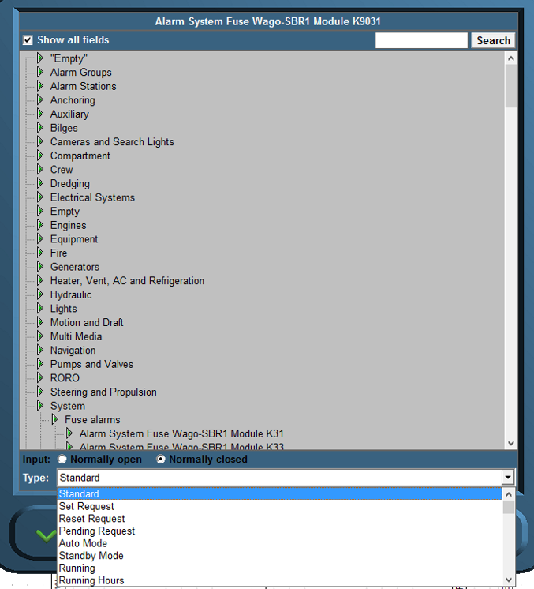

Figure 5‑57: Sensor type list

|  |  |  |
| --- | --- | --- |
| SensorType (Mode: Read) | | |
| Option | Sensor | Description |
| Standard | Value | Sensor value represents the state of the Data Field itself (Default) |
| Set | On | Request to turn on |
| Off | No action |
| Reset | On | Request to turn off |
| Off | No action |
| Pending | On | Processing a request. |
| Off | No action |
| Auto | On | Switched by an automatic control sequence |
| Off | Controlled by an operator |
| Manual | On | Controlled by an operator |
| Off | Switched by an automatic control sequence |
| Low Speed | On | Running at low speed |
| Off | Off, when not in “High Speed”. Otherwise no action |
| High Speed | On | Running at high speed |
| Off | Off, when not in “Low Speed”. Otherwise no action |
| Closed | On | Switched off |
| Off | Processing a request, when not “Open” |
| Open | On | Switched on |
| Off | Processing a request, when not “Closed” |
| Ready | On | Ready for use |
| Off | Not ready for use |
| Remote | On | Remote control. Controlled by AMCS |
| Off | Local control. Not controlled by AMCS |
| Ack | On | Acknowledgement of alarm on the assigned field |
| Off | No action |
| Request | On | Request to turn on |
| Off | Request to turn off |
| Push | On | Request to turn on, when off.  Request to turn off, when on. |
| Off | No action |
| Too Low | On | Value is too low |
| Off | Value is not too low |
| Low | On | Value is low |
| Off | Value is not low |
| High | On | Value is high |
| Off | Value is not high |
| Too High | On | Value is too high |
| Off | Value is not too high |
| Failure | On | Defect |
| Off | Not defect |
| Precision | On | High precision frequency counter in 0.01 Hz accuracy up to 10kHz |
| Off | Low precision frequency counter in 1 Hz accuracy up to 100kHz |
| Counter | Value | The changes in this counter value will be added to the field |
| Sign | On | The value read by “Standard” is negative |
| Off | The value read by “Standard” is positive |
| Index | Value | Value is the index of a serial message. See “Index” description |
| Pulse | On | Field’s value is counted 1 up |
| Off | No action |
| Pulse 1/2 | Value | Used in combination with “Pulse 2/2” to detect movement with two proximity switches. |
| Pulse 2/2 | Value |
| Pulse 1/3 | Value | Used in combination with “Pulse 2/3” and “Pulse 3/3” to detect movement with three proximity switches. |
| Pulse 2/3 | Value |
| Pulse 3/3 | Value |

|  |  |  |
| --- | --- | --- |
| SensorType (Mode: Write) | | |
| Option | Sensor | Description |
| Standard | Value | Requested state of the Data Field itself (Default) |
| Set | On | Request to turn on |
| Off | No action |
| Reset | On | Request to turn off |
| Off | No action |
| Pending | On | Processing a request. |
| Off | No action |
| Auto | On | Request to turn automatic control sequence on |
| Off | Request to turn automatic control sequence off |
| Low Speed | On | Request to run at low speed |
| Off | Request to turn off, when not in “High Speed”. Otherwise no action |
| High Speed | On | Request to run at high speed |
| Off | Request to turn off, when not in “Low Speed”. Otherwise no action |
| Impulse | On | Request to turn on, when off.  Request to turn off, when on. |
| Off | No action |
| Status | Value | Output value represents the state of the field/ device itself  (No control) |
| Ready | On | Ready for use |
| Off | Not ready for use |
| Remote | On | Remote control. Controlled by AMCS |
| Off | Local control. Not controlled by AMCS |
| Too Low | On | Value is too low |
| Off | Value is not too low |
| Low | On | Value is low |
| Off | Value is not low |
| High | On | Value is high |
| Off | Value is not high |
| Too High | On | Value is too high |
| Off | Value is not too high |
| Failure | On | Defect |
| Off | Not defect |

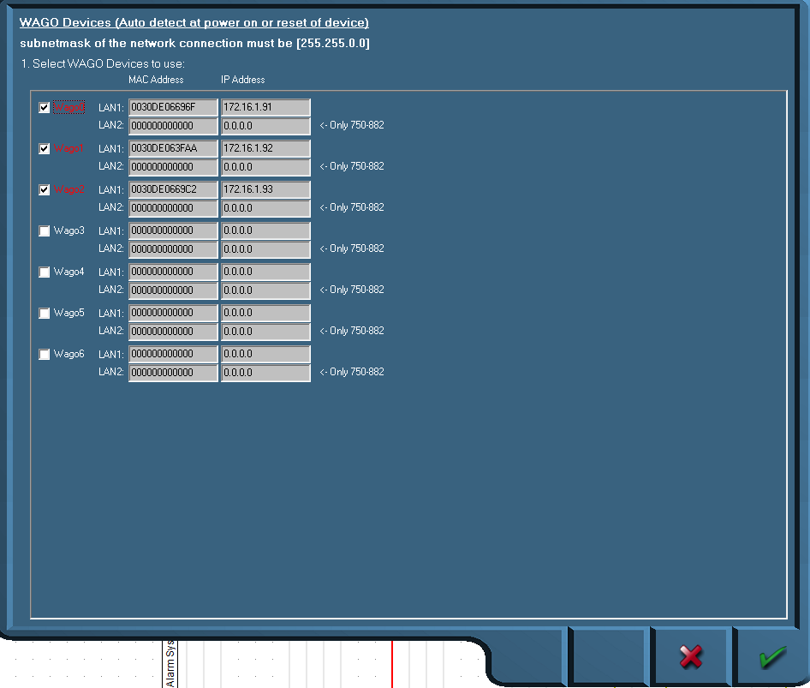

Figure 5‑58: Wago Device Manager

When the devices are correctly installed and connected, the respective MAC addresses will be shown via the “Wago Device Manager” window. The “Mod0” and others that are found are shown green. If a Wago is specified with an IP address and there is no connection, the Text will be red.

If the MAC addresses is not showing, it is possible that there is no connection with the specific Wago or the Wago devices need to be restarted. This can be accomplished by

* Disconnecting electrical power from the Wago device for a short period of time
* By pushing down the operating mode switch (see Figure 5‑59).

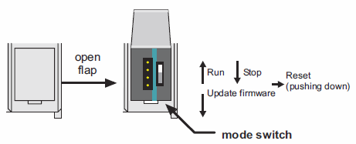

Figure 5‑59: Operating mode switch (Wago)

The operating mode switch (see Figure 5‑59) is a push/slide switch with 3 settings and a hold-to-run function.

|  |  |
| --- | --- |
| **Operating mode switch** | **Function** |
| From center to top position | Activate program processing (RUN) |
| From top to center position | Stop program processing (STOP) |
| Lower, bootstrap | For original loading of firmware, not necessary for user |
| Push down (i.e. with screwdriver) | Hardware reset.  All outputs and flags are reset; variables are reset to 0 or to FALSE or to an initial value.  Retain variables or flags are not changed.  The hardware reset can be performed with STOP as well as RUN in any position of the operating mode switch! |

If the device manager shows a MAC address, check this against the MAC address on the head station on the Wago. If it is right, click the check box.

Fill in the IP address the Wago device (must be in the same range as the PC, i.e. 172.16.x.x).  
For Wago the last digits are in the 90 range. The very first connected Wago will be set to 172.16.1.91 and the next available to 172.16.1.92 etc.

Confirm the settings by clicking the “OK” button. The screen will show the connected Wago devices, their respective MAC addresses, their given IP addresses and the server they are connected to.

### Wago calibration

In Wago you can calibrate the analogue sensors, which is especially proficient when it is non-linear. As example we’ll show the calibration of a tank.

The best steps to calibrate the tank sensors are as following:

1. Shut down all the NavVision installations (i.e. other servers and clients) except for one server. This must be done to make sure this server's calibration will not accidentally be overwritten by any other system on the network
2. On the running Server system, open the Wago configuration and follow the next steps for every field
3. Press the “W” on the (i.e 750-454) modules containing the tank level sensors. The 750-454 modules measures 4 to 20 mA (see Figure 5‑60)
4. You now see the old calibration or the standard linear one. Be aware of the measuring unit used.  
   The graph (see Figure 5‑61) shows the unity on the Y-axis; depending on the actual field settings
5. Write down the measured mA for an empty tank. The measured mA is shown below the graph.

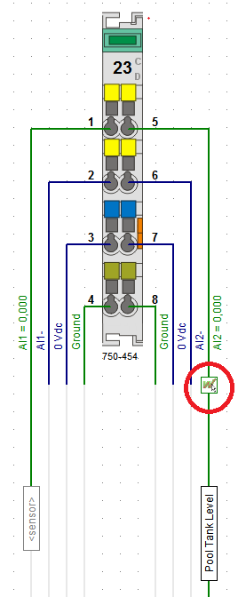

Figure 5‑60: Calibration

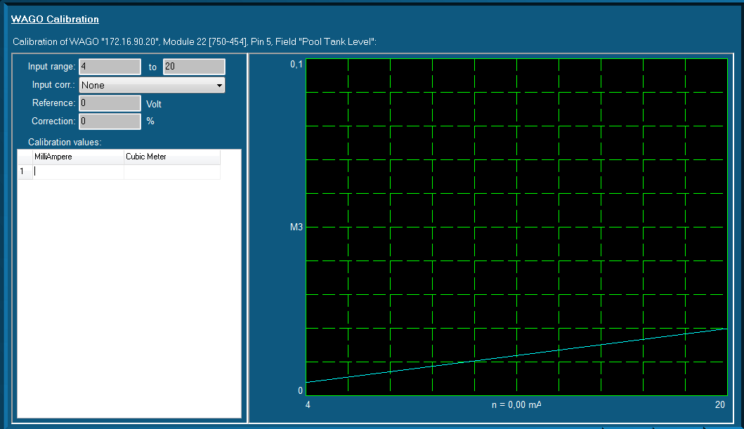

Figure 5‑61: Graph (WAGO calibration)

You can enter this value in the first row/first column of the table. In the right column, enter “0”. This column is the amount of unity's noted down in step four.

You now have configured that this amount of mA gives “0” (gallons/liters/...)

1. Fill the tank until you see the mA changing.   
   Depending on the sensor, it can be that the first amount is not measured
2. Write down this mA and amount of liters/gallons (depending on the unity) on the next row
3. Repeat the filling/noting down the values steps as much times as you like. If the tank is completely linear, four times could be a good choice. If not, it's better to make more measurements concerning the odd-shaped part of the tank
4. Finally, be sure to take a measurement with a full tank. You now see the blue line containing your calibration (see Figure 5‑62)
5. Repeat step 3 t/m 9 for every tank sensor available on the ship
6. Shut down NavVision ®
7. Copy the file "cal.ini" from the "config" folder of the configured NavVision to an USB stick. This file contains all the calibrations made
8. Copy this file ("cal.ini") FROM the USB stick TO every server system on the ship.   
   Choose to overwrite the old calibration of the servers.

From this particular moment each system is calibrated.

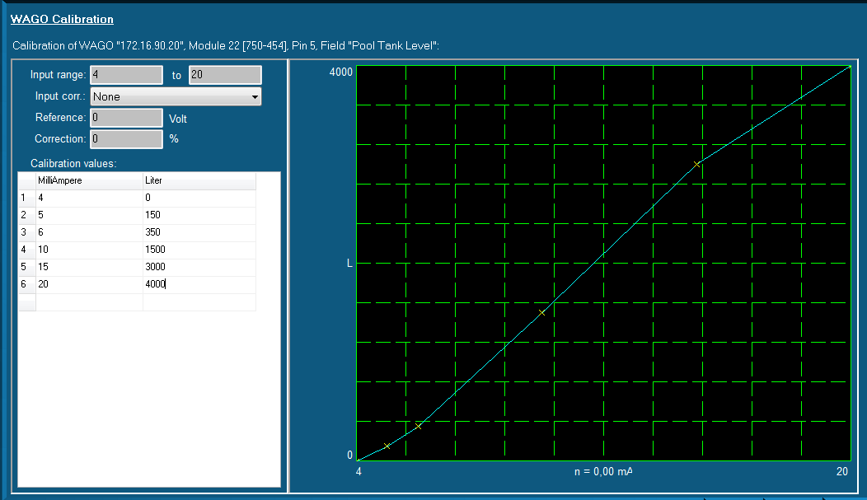

Figure 5‑62: Graph Calibrated

## Network

Under “Configuration > Network” the present network connections are shown (on right-hand side of window).

Select the IP-addresses of the network ports to use with the network server / client module (click and hold the Ctrl-key to select multiple network ports).

To confirm the settings, click “Accept and restart communications”.

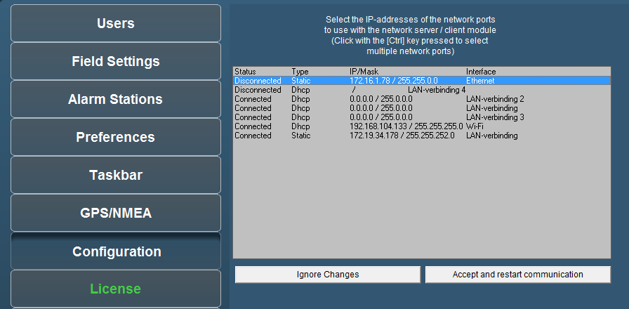

Figure 5‑63: Network

*If there is no connection between server-clients or server-server, this is the most appropriate way to check. If the network ports aren’t selected here, there is no connection possible. Make sure that all the network ports are selected and then acknowledge via button “Accept and restart communications”.*

## System Layout

The system layout is a visible representation of the complete topology. Here you can find all the devices and interfaces with their respective connections (see Figure 5‑64).

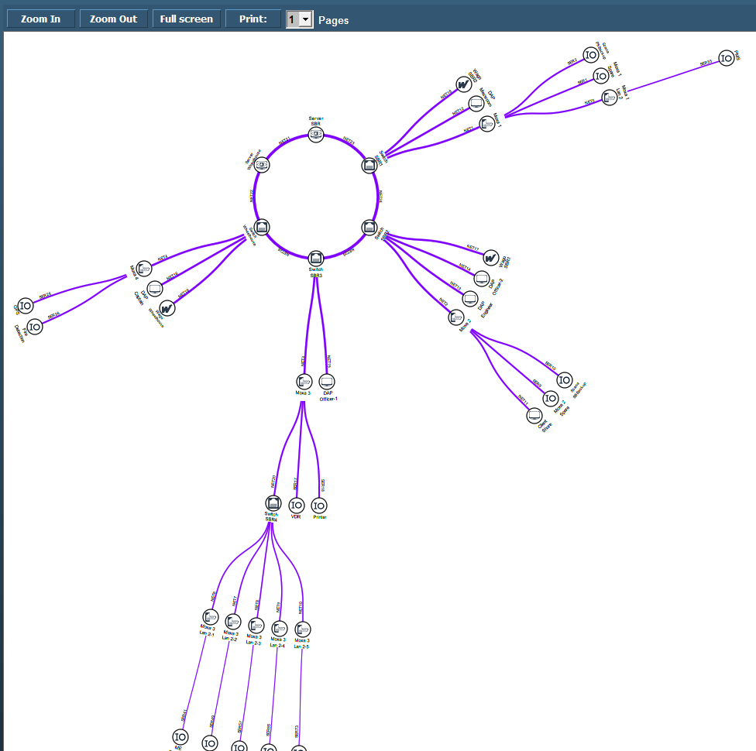

Figure 5‑64: System Layout

If set-up alright here you will find a perfect circle with all the separate devices attached. Also the names of the devices and interfaces will be available. You can zoom in and out and print the page.

The lines are at first purple, which means that the connection haven’t been seen yet. Once the connection is established, the lines should turn green. It is, of course, important that all the lines are green for the system to work properly. If a connection gets lost, the line, and all the adjacent lines that are influenced, will turn red, meaning that the connection is lost. An alarm will also appear.

This is perfect for quick troubleshooting of the network.

## Soft PLC

### General

A PLC (programmable logic controller) is an electronic device with a microprocessor that, on the basis of its various inputs, controls its outputs. A good example is the Wago PLC that we use often with our system. To make it easier to use and also to extend the range to use it with, we developed a soft PLC for NavVision. It is way beyond the scope of this manual to explain in depth the various ways to use this soft PLC, so we merely touch the handling features. For more information please refer to Free Technics and in the future to the Soft PLC Manual.

#### Basics

When you open Soft PLC for the first time you get an empty screen (see Figure 5‑65)

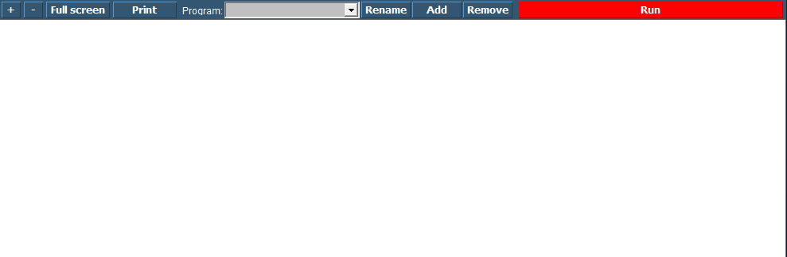

Figure 5‑65: Soft PLC

The following figures apply to the buttons on the screen:

|  |  |
| --- | --- |
| **Soft PLC Switch** | **Function** |
| +/- | Zoom in or out |
| Full Screen | Goto Fullscreen mode |
| Print | Print the Ladder Diagram |
| Program | Choose which PLC program you want to adjust by clicking the dropdown button |
| Rename | Rename the PLC program |
| Add | Add a new PLC program |
| Remove | Remove a PLC program |
| Run | Manually run or stop a specific PLC program |

### Simple example

Just to explain how it works, we will show a small example. This is merely to show how the diverse methods of implementing work in case you are already familiar with PLC programming.

#### Start

When you click “Add” you will start a new program. This program starts with an empty line an is called “SoftPLC1” if it is the first program you start. If you click “Rename” you can give it a distinctive name, which will pay off when you have a lot of PLC programs in your system (see Figure 5‑66).

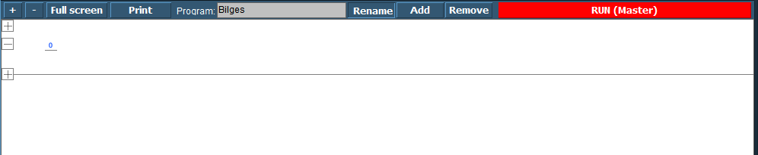

Figure 5‑66: SoftPLC Rename

Once you renamed it, you can go on with the program. For those familiar with PLC programming, you will recognize this as a ladder diagram. With the “+” you can add lines before or after and with “–“ you can remove the line.

We start this program with a bilge pump, which should run when a certain bilge alarm is high. When you click at the left side of the “0” a new pop-up appear with choices (see Figure 5‑67). These are beyond the scope of this manual to discuss, but if you know PLC programming, you will know what they are.

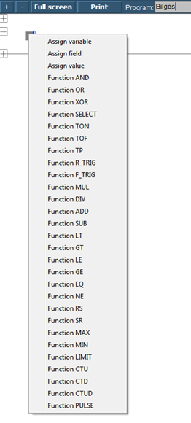

Figure 5‑67: SoftPLC pop-up

We choose for “Assign Field” to assign the Bilge Alarm as a trigger (see Figure 5‑68). Now we get into the FT part of the SoftPLC, the element-fields. After choosing this field the PLC line will look as in Figure 5‑69

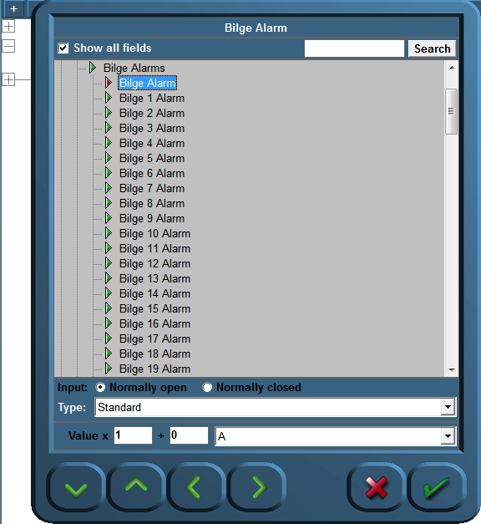

Figure 5‑68: SoftPLC Assign Field

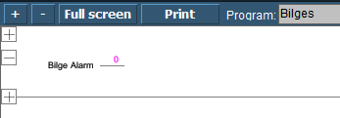

Figure 5‑69: SoftPLC first Line

We do the same at the right side of the “0” but this time we choose the Bilge Pump. We end up with a line like in Figure 5‑70.

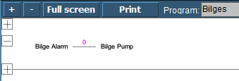

Figure 5‑70: SoftPLC First Line_2

So now when you press “Run” the program will run and check the bilge alarm over and over. Once it gets high, the connection in the line gets high (1) and the Bilge Pump starts running until the alarm is not high anymore.

#### Control

You can understand that you can control the NavVision installation much more once you use SoftPLC. You can make all kind of interactive switches and much more. Much of the ACS (automatic Control Sequences) will be made in SoftPLC.

## Tank Tables

### General,

Each ship must have some kind of device to show the content of the different tanks. Whether it is a glass tube, a pressure sensor, a capacitive sensor or a float unit, they are all designed to show the contents of the particular tank. While the first is a mechanical device, the rest is merely electrical.

The bigger ships will rely more on an accurate reading. Not only will they travel over longer distances, or need to be cost effective, they also often need to balance the ship by even things out in diverse ballast tanks. You can understand that the calibration of these sensors will have to be quite accurate.

### Types of sensors

We will focus here on the electrical sensors as the mechanical ones gets more and more obsolete. The most used ones are

* The floating sensor
* The capacitive sensor
* The pressure sensor

#### Floating sensor

The floating sensor can be compared with the float unit that is used in toilets. These type of sensors are level-sensors. They measure how high (or low) the level of the fluid in the tank is. They can be equipped with a floating device connected to a hinged part, where the hinged part is electrically connected to a resistor which will give a voltage or milli-amperage that can be used to show the actual level of the liquid. The floating device can also be a magnetic ring attached around a pipe.

#### Capacitive sensor

The principle of capacitive level measurement is based on change of capacitance. An insulated electrode acts as one plate of capacitor and the tank wall (or reference electrode in a non-metallic vessel) acts as the other plate. The capacitance depends on the fluid level. An empty tank has a lower capacitance while a filled tank has a higher capacitance. While this is also a level measuring type.

#### Pressure sensor

The pressure sensor is not a level indicator. It measures the liquid pressure (Pl) of the column of liquid above the sensor. In conjunction with the density of the liquid you can calculate the volume of the liquid. When the architect of the tanks has provided a sounding table, with the liquid pressure you can calculate the height of the liquid as well as the m3 of liquid. Again with the density you can calculate the mass (tonnage). You can see that this provides a very accurate and diverse scheme for the tanks that is very useful.

Within the NavVision system all this calculations are done automatically once you provided one of the variables (see Figure 5‑71).

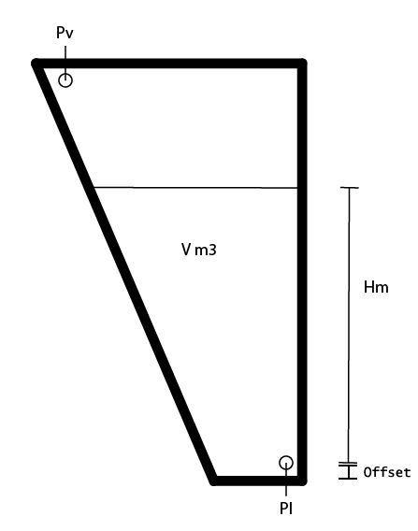

Figure 5‑71: Tank Pressure Sensor

|  |  |
| --- | --- |
| **Abrreviation** | **Explanation** |
| Pl | Liquid Pressure |
| Pv | Vent Pressure |
| V m3 | Volume in square meter |
| Hm | Height in meter |
| Offset | Offset sensor in meter |

Table 5‑4: Pressure sensor explanation

*When not provided with a Pressure Vent Sensor it might give some strange irregularities. Especially when the vent-pipe is too small it will interfere with a good reading of the pressure sensor, while the air above the liquid column will be shifting all the time. It might then be necessary to place a Vent Pressure Sensor to even this out. Also this calculation is done automatically within FT NavVision ©.*

### Calculations

Just for your understanding we will put down the calculations we make in NavVision.

Depending on which value you have, we distinct the following calculations:

$$H = \frac{Pc*100}{g*D}$$

$$Pc = \frac{H*g*D}{100}$$

Pc = Pl – Pv (mBar)

g = 9.80665 (m/s2)

D = Density (kg/m3)

|  |  |
| --- | --- |
| **Abrreviation** | **Explanation** |
| H | Height |
| Pc | Pressure column |
| g | Average gravity |
| D | Density |
| Offset | Offset sensor in meter |

### Offset

Every sensor will have an offset. None of the sensors will be exactly on the bottom of the tank. Especially when the tank expands upwards, a small offset can make a big difference when the tank is full.

When you know the offset of the sensor you can adjust this in the tune table of that particular tank. Goto Fieldsettings/tune and look for the tank that you are about to adjust. Make sure you use the “Height” value. See the following figure:



Figure 5‑72: Tune table

As shown in the x/y-matrix (see Figure 5‑73), it gives a linear line that is 0-output at 0-input and 1-output at 1-input.



Figure 5‑73: Tune Example 1

When you want to set an offset, you have to change at least 2 set-points to make the whole line go up and stay linear (see Figure 5‑74). If you change just 1 point it will skew in another direction. As soon as you set 2 new set-points in the tune-table, the line will move up- or downwards and will be linear adjusted (see Figure 5‑75).



Figure 5‑74: adjusted tune table



Figure 5‑75: Tune Example 2

### Inserting sounding tables

Under Configuration>Tank Tables you can find all the tanks (see Figure 5‑76).

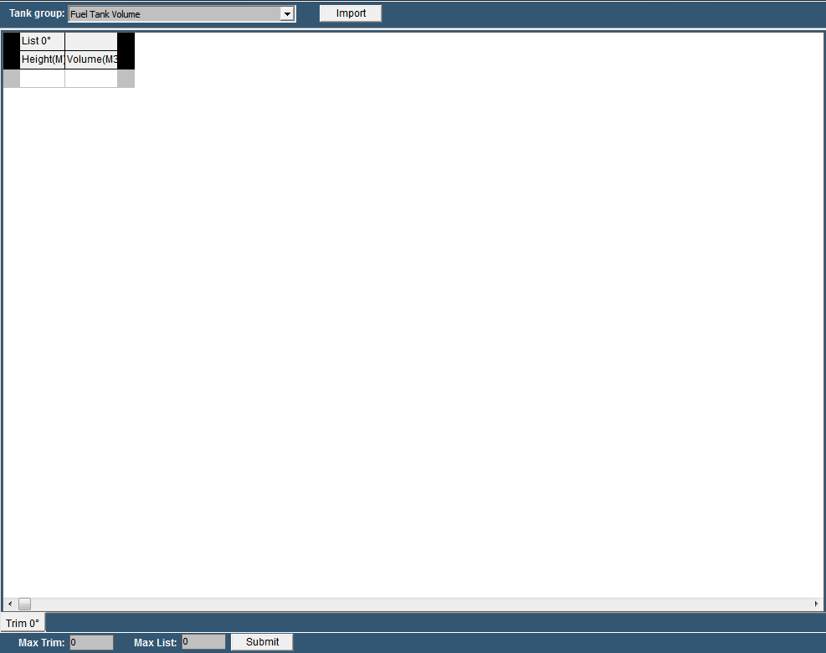

Figure 5‑76: Tank Tables

|  |  |
| --- | --- |
| **Detail** | **Description** |
| Tank Group | Find the tank you want to adjust a tank table for |
| Import | Import an Excel-sheet with sounding data |
| Max Trim | Max pitch (if provided in sounding table) |
| Max List | Max Roll (if provided in sounding table) |
| Submit | Submit Trim and List |

Table 5‑5: Tank Tables

#### 

#### Tank Group

In the drop down menu you can search for the tank that you are about to adjust. You will get all the tanks available. In this example we will use the Fuel Tank 1 Volume (see Figure 5‑77).

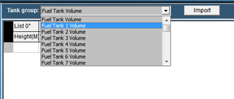

Figure 5‑77: Tank Group Drop Down

You’ll notice it only shows the tank group volumes, as that is what you get in the sounding table. As mentioned earlier with height and volume, FT NavVision © can calculate all the other values.

Now that you have chosen the right tank, you can manually fill in the diverse heights and volumes. Make sure you start with “0” and end with the highest value or your value will be the wrong way around.

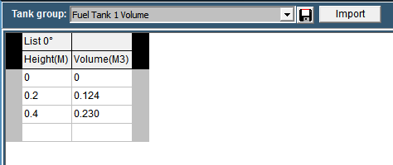

Figure 5‑78: Filling in tank tables

As soon as you start filling in the numbers you will see a “save button” appear next to the drop down menu (see Figure 5‑78). With this button you can save the calibration table to the specific tank. NavVision will immediately start working with this values.

Of course filling in large amounts of data like this will be quite time consuming. Therefor it is possible to import the data from an excel sheet providing the excel sheet is setup the right way.

#### Excel import

Most times the calibration tables or sounding tables will be available in some kind of excel format. It is wise to start with a new excel-sheet where you transfer the data from the sounding tables to, one by one. You can name the different tabs to the “trim” and “list” (see Figure 5‑79).

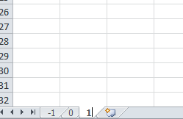

Figure 5‑79: Excel tabs

So for an example list we take the following sounding table:

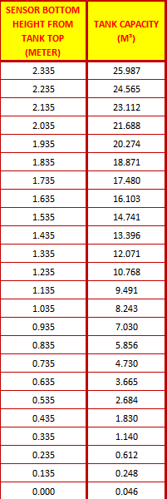

Figure 5‑80: Example Sounding Table

As you can see it goes from high to low, which is the wrong way around, but we change that later. First select all the values and “control-c” to copy the data. Go back to your original excel document and paste it on the SECOND row (see Figure 5‑81).



*Use Paste Special “values” or “Unicode”*



*In the first row you need to use an empty cell and the second cell with the “List” degree-number*

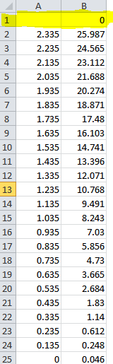

Figure 5‑81: Excel sheet import list

Now select all the values except for the upper row and choose “Sort>from low to high” to get the data in the right order. Once this is done you will have the right values for the list (see Figure 5‑82).

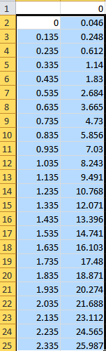

Figure 5‑82: Excel list sorted

Now save the new made table as “Excel97-2003 *.xls”file. In this case we name it “Fuel Tank 1”.

#### Import from excel

Now go back to the “tank tables” and click on “import”. Look for the excel file you just created and choose it for import. Click OK and the list will be imported and shown (see Figure 5‑83).

At this time you can save the table and it will be used within the calculation of NavVision.

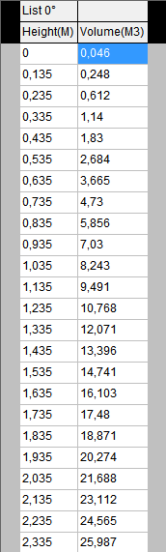

Figure 5‑83: Imported Table

### Trim and List

Ships move in different directions. They can roll over the latitude axis (the roll or list), or over the longitude axis (the pitch or trim). You can imagine that when the ship is moving, the liquids in the tanks will also move. This way the method of measuring with a pressure sensor will have some shortcomings.

For instance, when the ship is rolling over, the liquid column above the pressure sensor can alter. In this example it gets shorter (see Figure 5‑84). This way the calibration will alter. The pressure sensor thinks it has a smaller column of liquid and will refer to the calibration table. While the tank is abating here, there will be much more liquid available than the calibration table will say.

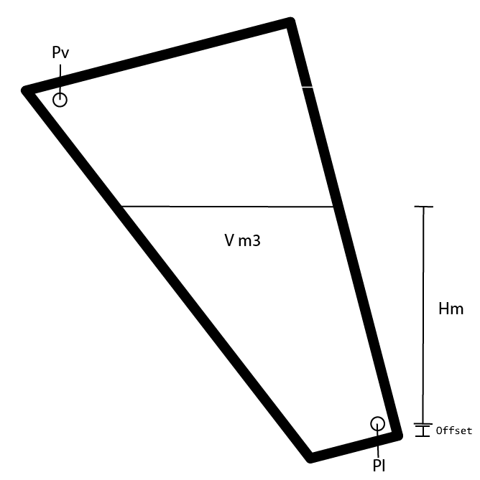

Figure 5‑84: Roll and Pitch

When an architect kept that in mind he surely will have the calibration or sounding table recalculated in different roll and pitch positions. This way you can make an even more accurate calibration.

#### Roll and Pitch in the Tank Table

In the tank table page you will find two “edit fields”. One for the Trim and one for the List. While Trim is the Pitch of the ship and List is the roll of the ship you can alter the number accordingly to the number of different sounding tables you have. If, let’s say, you have seven Trim Tables, fill in the number “3” and press “submit”. You’ll notice that there are now three tabs on either side of the 0-degree tab. -3,-2,-1,0,1,2 and 3 degree (see Figure 5‑85). For this you need to have 7 different sounding tables from the architect.

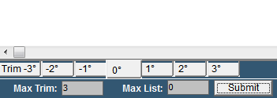

Figure 5‑85: Max Trim

Now let’s say that you have only three sounding tables for the roll (List). Fill in the number “1” and press “submit”. Now you will have three different columns for the sounding tables of the “List” -1,0 and 1 degree (see Figure 5‑86).

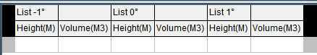

Figure 5‑86: Max List

This way you’ll have 3 different “list” columns for 7 different “trim” tabs so 21 different calibration points (see Figure 5‑87). In this ideal configuration you will have a very accurate calibration.

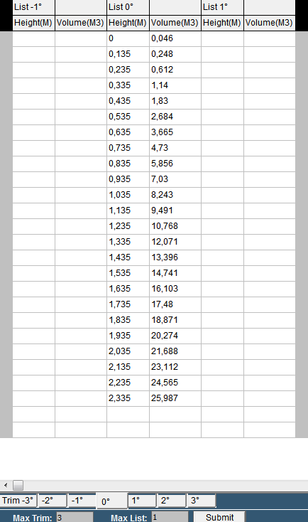

Figure 5‑87: Trim/List example

#### Trim and list in Excel

When you are importing sounding tables through an Excel list you would like to put in the trim and list at the same time. This is possible by doing the following:

Taken the previous as example you will have to make 7 tabs and rename them according to the degrees in the sounding table. For the trim you will make a column for each degree that you have in the sounding table and rename these in the upper row right cell of each separate column (see Figure 5‑88).

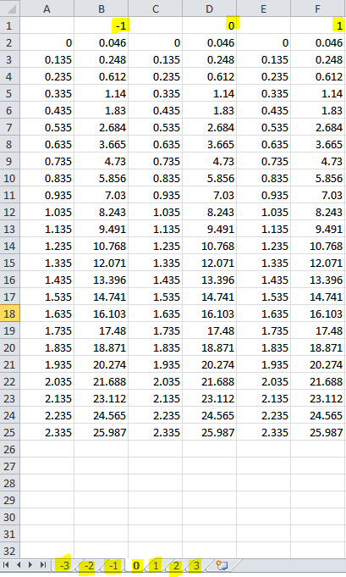

Figure 5‑88: trim and list excel example

Now save the excel sheet, import it in the tank table page, save it and you will have all the data ready to be used by NavVision (see Figure 5‑89)

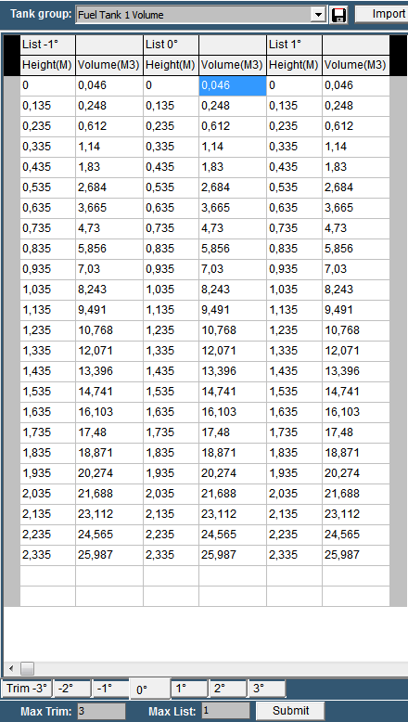

Figure 5‑89: Tank Table excel Trim and List import

**

*Max Trim and Max List is 20 degrees*

## WatchIO

WatchIO is the uniform language protocol of the Unimacs Bridge. NavVision can talk with the Unimacs Bridge using the WatchIO protocol.

This connection results in the following:

* Unimacs (sensor) data can be shown in NavVision and, if necessary, it can be changed by NavVision (i.e. the color scheme).
* NavVision data can be published through WatchIO to be used in other Unimacs Applications.

### Programming

The programming of the WatchIO is done by NavVision itself. Make sure that you use at least [revision 9.18.03.3904](http://freetechnics.eu/downloads/revisions/) or higher.

The best way to import the WatchIO fields that you want to use is by using the sensorlist. We refer to the sensorlist manual for information on how to setup WatchIO by importing a sensorlist.

Once imported and running you can see the fields that are imported under Tools>Configuration>WatchIO (see Figure 5‑90).

: 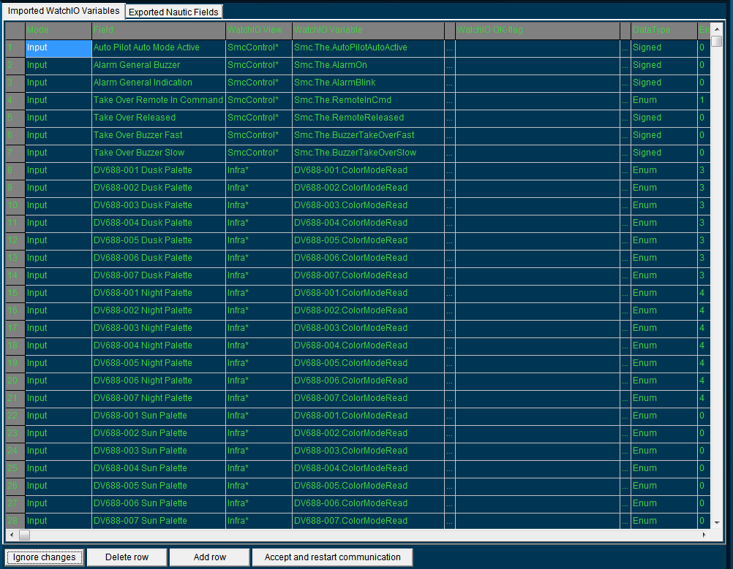

Figure 5‑90: WatchIO panel

Here you will find all the fields that are imported through the sensorlist along with all the variables that you have set in the sensorlist. By clicking on a field you can change these fields, either by a drop down menu or by changing the text. You can even add or delete complete rows. The fields that are published by NavVision are on the tab “Exported nautic fields” (see Figure 5‑91).

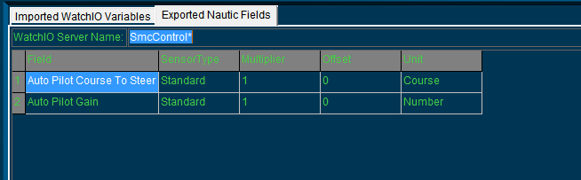

Figure 5‑91: Exported nautic fields

|  |  |
| --- | --- |
| **Detail** | **Description** |
| Ignore changes | Ignore all the changes that you have made |
| Delete row | Delete the row that you highlighted |
| Add row | Add a row at the bottom |
| Accept and restart communication | Save changes and restart communication |

Table 5‑6: WatchIO

### Communication problems

If you have imported the sensorlist and still do not see fields under Tools>Configuration>WatchIO, than there is probably something wrong in the ini-file. Look in the NavVision folder under config>local for the file “watchIO.uc.ini”. Double-click to open it. You will see something like the following”

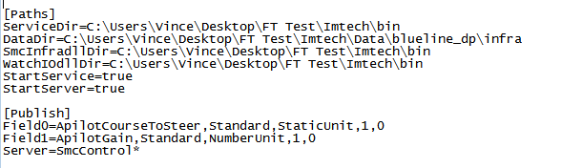

Figure 5‑92: watchIO.uc.ini

Under “Paths” check that these paths are pointing at the right location.

*Take care that the server names (the names of the main workstations in the NavVision system) are exact as they are in the Unimacs Bridge application. If these two names differ, there will be no connection. If you work in close cooperation with the bridge-engineers, this shouldn’t be a problem.*

# BNWAS Settings

Under the tab “Alarm Settings” you will find the BNWAS Configuration button. It will open up the following window.

‘

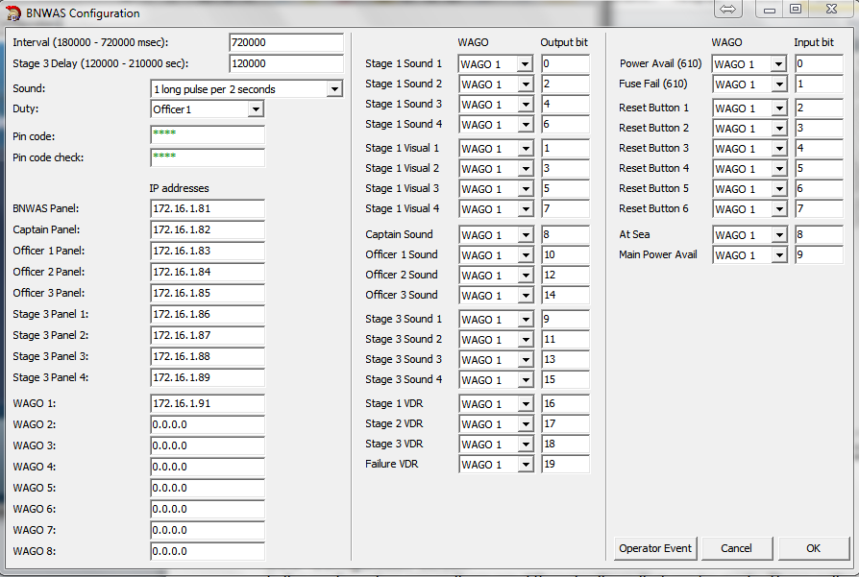

Figure 6‑1: BNWAS configuration screen

The different parts of this configuration screen will be discussed hereafter.

### Configuration screen

In the configuration screen there are different settings that can be made. These settings will be split up hereafter.

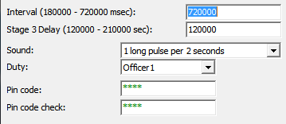

Figure 6‑2: General settings

In the general settings, the same settings can be made as can be done in the program itself under “setup”.

|  |  |
| --- | --- |
| **Setting** | **Detail** |
| Interval | Set interval of Td between 3 and 12 minutes (180000-720000 msec) |
| Stage 3 Delay | Delay of the stage 3 time between 2 and 3,5 minutes |
| Sound | Change the modulation of the alarm-sound |
| Duty | Select OOW on duty |
| Pin code | Set Pin code for setup |
| Pin code check | Pin code check |

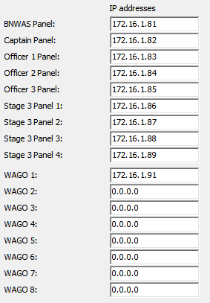

Figure 6‑3: IP address settings

In the IP address section, settings can be made to distinguish the different panels and WAGO’s. The main panel (the panel in charge) is always the BNWAS panel.

If used in the system other DAP’s can be set as 2nd or 3rd stage panels by selecting their respective IP addresses behind the right panel. There are four 2nd stage panels

* Captain panel
* Officer 1 panel
* Officer 2 panel
* Officer 3 panel

And four 3rd stage panels

* Stage 3 panel 1
* Stage 3 panel 2
* Stage 3 panel 3
* Stage 3 panel 4

The IP addresses of the DAP’s and the WAGO’s are first set in NavVision. Corresponding you can set these IP addresses to the right DAP panel or WAGO.

**

*If no other DAP or WAGO is used, leave the IP addresses at 0.0.0.0*

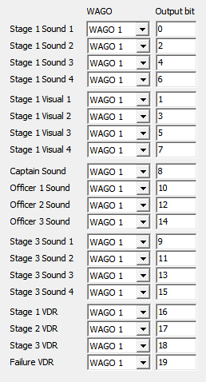

Figure 6‑4: Wago output bit setting

The Audible and visual outputs are set here. Each output represents a stage of the BNWAS system. These outputs will be set on the dedicated Wago slice. There are 3 different stages of alarm outputs and a separate output to the VDR.

* Stage 1 Visual 1 (2,3,4) – output to the bridge visual alarms
* Stage 1 sound 1 (2,3,4) – output to the Bridge Audible alarms
* Captain, Officer 1,2,3 sound – combined visual and audible output to the duty cabin
* Stage 3 sound 1 (2,3,4) – combined visual and audible output to the 3rd stage places
* Stage 1,2,3, failure VDR – output to the VDR for mandatory alarms

In the column “WAGO” you can choose on which WAGO the connection is made. This depends on the order of the setup. Normally it is just 1 WAGO, so you can leave it as is. If the setup is divided over more WAGO’s the order is set by the IP range

* 172.16.1.91 = WAGO 1
* 172.16.1.92 = WAGO 2
* 172.16.1.93 = WAGO 3
* Etc

In the column “Output bit” you can set the exact pin on the particular slice where that field is connected to.

*Notice that for the Output bit we count via the internal program of the WAGO. So we count all the available outputs from the beginning of the WAGO (see* Figure 6‑6*)*

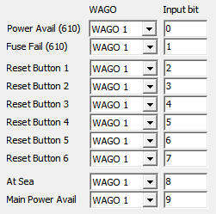

Figure 6‑5: Wago Input bit setting

In the column “WAGO” you can choose on which WAGO the connection is made. This depends on the order of the setup. Normally it is just 1 WAGO, so you can leave it as is. If the setup is divided over more WAGO’s the order is set by the IP range.

* 172.16.1.91 = WAGO 1
* 172.16.1.92 = WAGO 2
* 172.16.1.93 = WAGO 3
* Etc

In the column “Input bit” you can set the exact pin on the particular slice where that field is connected to.

**

*Notice that for the Output bit we count via the internal program of the WAGO. So we*

*count all the available outputs from the beginning of the WAGO (see* Figure 6‑6*)*

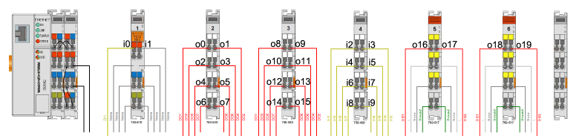

Figure 6‑6: Input Output counting Wago (i=Input, o=Output)

# Performance

### Preface

This section of the Operator Manual is for background information only. The Performance section does not contain essential information for the user to make full use of NavVision.

### Modules

Under “F11 > Modules” the time period is shown that each NavVision module uses in relation to the total NavVision time.

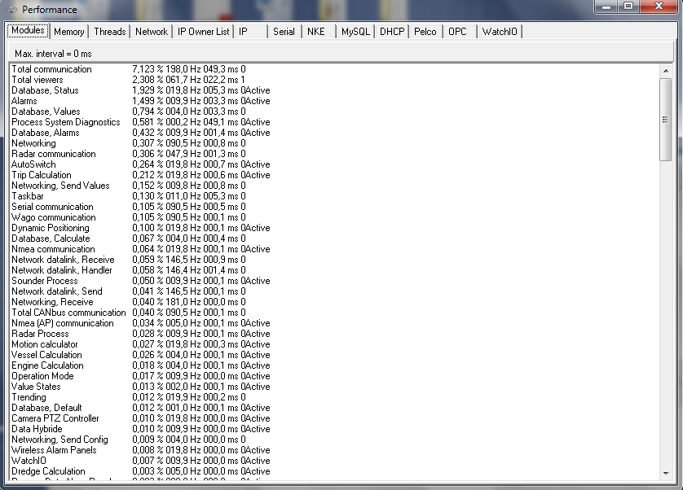

Figure 7‑1: Performance

The columns are arranged as follows:

|  |  |
| --- | --- |
| **Detail** | **Description** |
| Module Name | Internal name used by NavVision® to describe the module |
| Percentage | Percentage of processing time, where total NavVision® is 100% |
| Refresh Rate | Processing time in milliseconds |
| Total time | Total (module) processing time (in milliseconds) |
| Semaphore | Should be “0” or “1” |
| Active | Shows during refresh of screen |

### Memory

Under “F11 > Memory” developers can track for the presence of possible memory leaks.

By default the option “Activate memory manager” is disabled to avoid significant performance degradation.

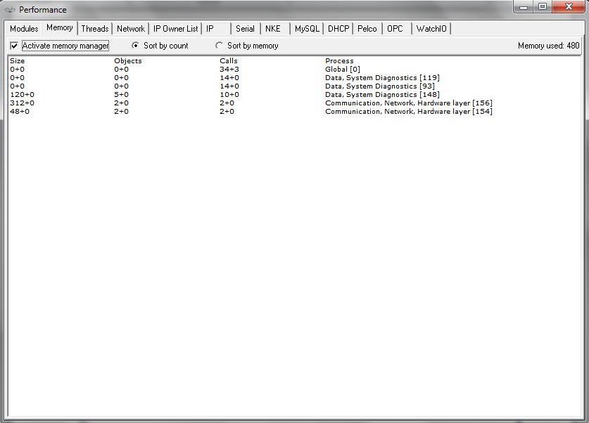

Figure 7‑2: Memory

The columns are arranged as follows:

|  |  |
| --- | --- |
| **Detail** | **Description** |
| Size | The size (bytes) of an object |
| Objects | Relative numberof objects created or deleted since activation of memory manager |
| Calls | Number of creation / deletion calls |
| Process | Process creating / deleting the objects |



: Take special notice of the “Memory Used” at the right top of the pane. If it keeps rising beyond your memory available, a memory leak is imminent.

### 

### 

### Threads

Under “F11>Threads” all the threads that are currently running will be visible. This option is quite easy for troubleshooting certain threads.

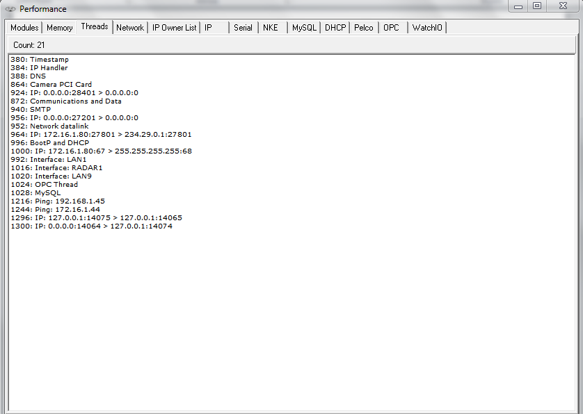

Figure 7‑3: Threads

### Network

Under “F11 > Network” the Connection to other workstations within the same system is shown. With all workstations connected and running, you will see your complete topology visible here.

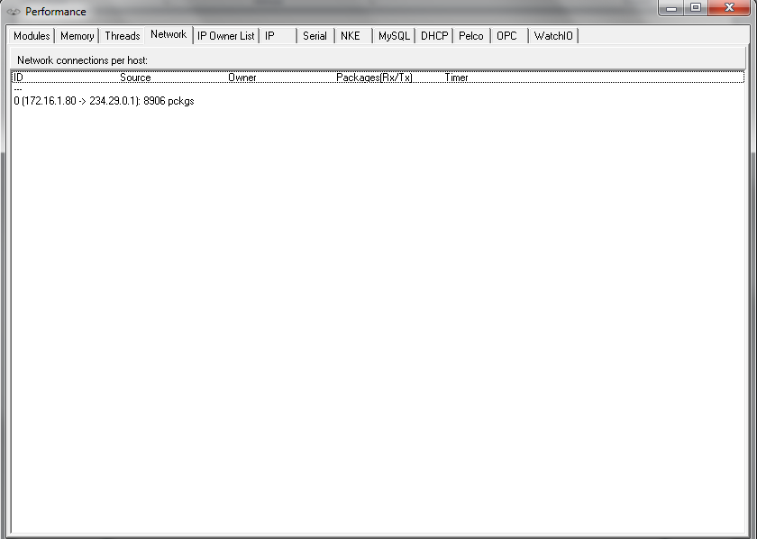

Figure 7‑4: Network

The columns are arranged as follows:

|  |  |
| --- | --- |
| **Detail** | **Description** |
| ID | Internal index used by NavVision®, not of importance in this list |
| Source | Active > when connected  Connect > when trying to connect  Closing > when closing the connection |
| Owner | UDP server, UDP client, TCP server or TCP client |
| Packages | The source of the connection. When “0.0.0.0:0” is shown, no source address was specified when opening the connection, where “0.0.0.0:x” means that port “x” on this computer is being used for server functionality |
| Timer | The destination of the connection |

### 

### IP Owner List (which OWS is handling which ip’s)

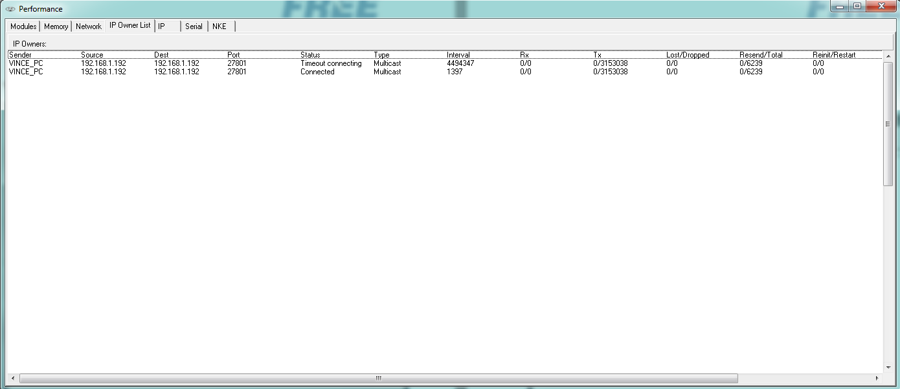

Figure 7‑5: IP Owners List

The columns are arranged as follows:

|  |  |
| --- | --- |
| **Detail** | **Description** |
| Sender | The workstation you are working on |
| Source | The workstation the connection is made from |
| Dest. | The interface that the source is (trying) to reach |
| Port | The port that is used for the connection |
| Status | The status of the connection |
| Type | Type of connection: Multicast, TCP, UDP |
| Interval | The interval between the last attempt |
| Rx | Receiving side |
| Tx | Transmitting side |
| Lost/Dropped | Packages lost/dropped |
| Resend/Total | Packages asked to be resend/total |
| Reinit/Restart | Reinitialisation/restart of the connection |

### IP

Under “F11 > IP” a list of all network connections as handled by the relevant NavVision workstation is shown

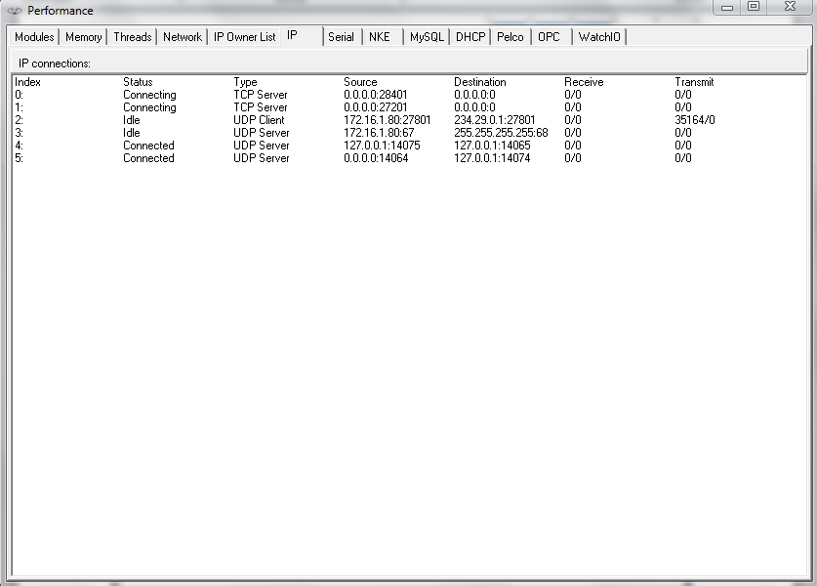

Figure 7‑6: Performance > IP

The columns are arranged as follows:

|  |  |
| --- | --- |
| **Detail** | **Description** |
| Index | Internal index used by NavVision®, not of importance in this list |
| Status | Active > when connected Connect > when trying to connect  Closing > when closing the connection  Idle > When doing nothing |
| Type | UDP server, UDP client, TCP server or TCP client |
| Source | The source of the connection. When “0.0.0.0:0” is shown, no source address was specified when opening the connection, where “0.0.0.0:x” means that port “x” on this computer is being used for server functionality |
| Destination | The destination of the connection |
| Receive | Number of Bytes left in the internal buffer / Number of bytes received |
| Transmit | Number of Bytes left in the internal buffer / Number of bytes sent |

### Serial

Under “F11 > Serial” the serial port status is indicated.

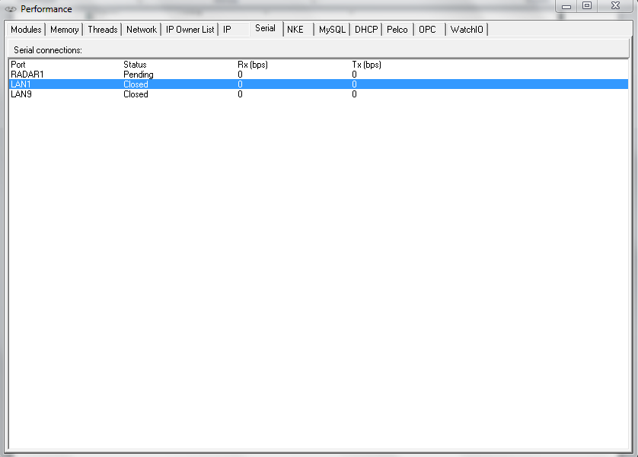

Figure 7‑7: Serial

The columns are arranged as follows:

|  |  |
| --- | --- |
| **Detail** | **Description** |
| Port | The serial port name. The possible radar port is also shown as a serial port, named “RADAR1”. When it is not used, the status stays on “Pending”. |
| Status | Serial port status i.e. “Failed”, “Pending”, “Closed” and “Open” |
| Rx (bps) | Number of bits “Received (Rx)” during the last second |
| Tx (bps) | Number of bits “Sent (Tx)” during the last second. |

For troubleshooting you can right-click on a serial port to see a pop-up you can click for additional data (See Figure 7‑8)

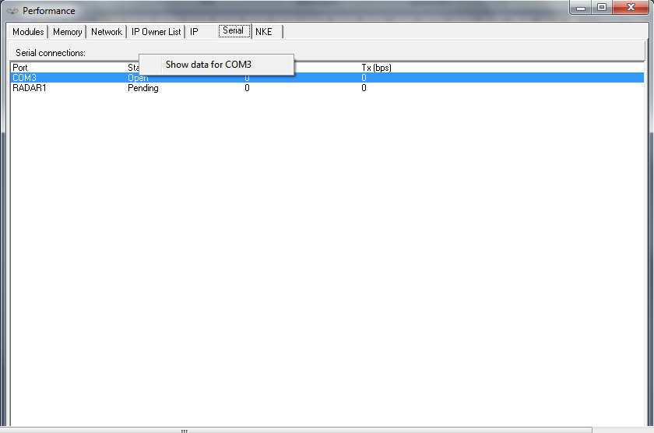

Figure 7‑8: Additional Serial Data

After clicking “show data for x” where x is the appropriate port, you will get a new pop-up field Communication Diagnostics (see Figure 7‑10 and Figure 7‑10)

This tool you can use to troubleshoot data over serial ports. Here it shows all the data that is actually seen by NavVision on the specific port.

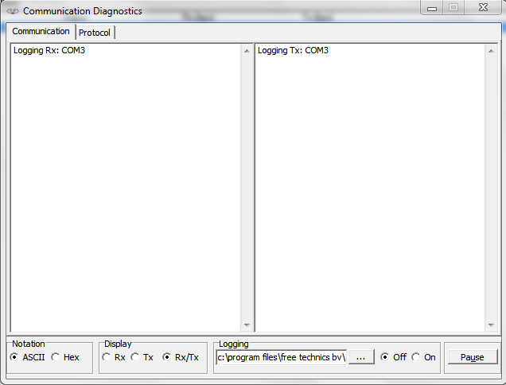

Figure 7‑9: Communication Diagnostics 1

|  |  |
| --- | --- |
| **Detail** | **Description** |
| Notation | Show data in ASCII or Hex |
| Display | Rx > Only show receiving side Tx> Only show transmitting side  Rx/Tx > Show receiving and transmitting side |
| Logging | Choose destination to save logfile and switch it off or on |
| Pause | Pause the data stream |

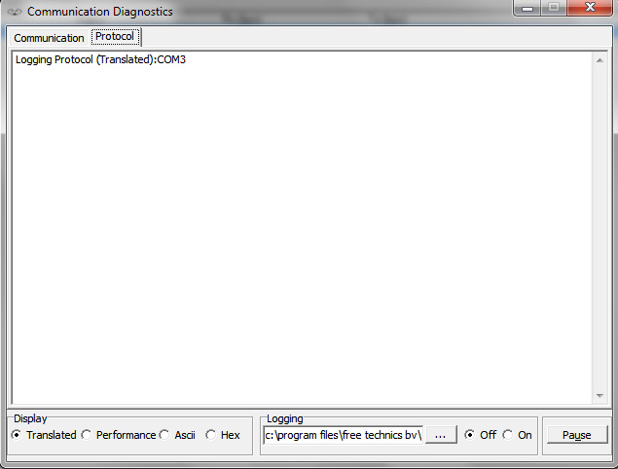

Figure 7‑10: Communication Diagnostics 2

|  |  |
| --- | --- |
| **Detail** | **Description** |
| Protocol | Shows the different protocols |
| Display | Translated > shows the data in readable output Performance > Shows the performance of the data  ASCII > Shows Data in ASCII  Hex > Shows Data in Hex |
| Logging | Choose destination to save logfile and switch it off or on |
| Pause | Pause the data stream |

# Commissioning

## Purpose

This chapter contains the information about the commissioning of NavVision on board of the vessel.

## Preconditions

* All NavVision system components like computers, switches, PLC, interfaces, have to be mounted, connected and powered
* All components like sensors, engines, generators, I/O components must be connected to the corresponding sensors and interfaces of the NavVision system
* The server computer(s) as well as client computer(s) must be up and running
* All network and serial cables, must be connected
* Engines, generators, radar and all other equipment within the NavVision system must be ready for testing
* The alarm system(s) must be working and ready for testing
* During the time of commissioning and acceptance tests there need to be assistance from a technician who is familiar with the system installation.

## Safety information

Commissioning must not start until you have ensured that the machine in which the components described here are installed as described in the relevant Installation Manual.

**

**WARNING**

* **NavVision devices and software must only be commissioned by suitably qualified personnel**
* **The personnel must take into account the information provided in the technical customer documentation for the product, and be familiar with and observe the specified danger and warning notices**
* **When the machine or system is operated, hazardous movements can occur**
* **All of the work carried-out on the electrical machine or system must be carried-out with it in a no-voltage condition**
* **When electrical equipment and motors are operated, the associated electrical circuits are at hazardous voltage levels**
* **The successful and safe operation of these devices depends on correct transport, proper storage and installation, as well as careful operation and maintenance.**
* **In addition to the danger and warning information provided in the technical customer documentation, the applicable national, local, and system-specific regulations and requirements must be taken into account.**

## Commissioning steps

### Wiring schematics

|  |  |  |
| --- | --- | --- |
| **Check** | **Contents of check** | **Passed** |
| Wiring schematics | Verify that all wiring connections are in conformity with the latest version schematic. |  |
| Check USB connections vs. COM port connections. |  |
| Check LAN port connection vs. IP-address. |  |
|  |  |  |
| Remarks |  | |

### Wiring, cables and connections

|  |  |  |
| --- | --- | --- |
| **Check** | **Contents of check** | **Passed** |
| Wiring / cables | Check that the correct category cable is used (e.g. UTP, STP, CAT5E etc.). |  |
| Check that the cables are free of kinks, knots or snags. |  |
| Check that the cables are not overstressed by overload. |  |
| Check that the cables are correctly tightened with tie wraps. |  |
| Check that the cables are properly supported. |  |
| Cable run:  Do not allow the cable to form right angles or sharp bends.  Check if the correct bend radius has been applied. |  |
| Check that the cables are not squeezed. |  |
|  |  |  |
| Remarks |  | |
| **Check** | **Contents of check** | **Passed** |
| Connections | Check that the electrical connections are correct. |  |
| Check that contacts are clean and that parts are correctly installed to protect them from dust and dirt. |  |
| Check the switch port connections vs. fault indications. |  |
|  | Check if CAT5 cable connectors are properly prepared (use Fluke). |  |
|  |  |  |
| Remarks |  | |

### System components

|  |  |  |
| --- | --- | --- |
| **Check** | **Contents of check** | **Passed** |
| System components | Verify that the components used are in conformity with the latest version schematic. |  |
| The mechanical and electrical environmental conditions at the installation site must be within the limits described in the technical data. Dusty, damp places, places susceptible to rapid temperature variations, powerful vibrations and shocks, surge voltages of high amplitude and fast rise time, hot places with no ventilation or AC, strong induced magnetic fields or similar extreme conditions should be avoided. |  |
| Check power and data connections. |  |
|  |  |  |
| Remarks |  | |

### System start-up

|  |  |  |
| --- | --- | --- |
| **Check** | **Contents of check** | **Passed** |
| Software | Check if the appropriate software version (latest software release) is installed. |  |
| Ensure that all change log specifications are correct for this installation (check on all systems). |  |
| Anomalies | Check if there are any irregularities at and during startup. Look for long startup, error messages, boot loader problems, boot loader icon problems etc. |  |
|  | Push F11 (Performance) for detailed information on the network.  If there is an alarm right away, write it down for later investigation and check if the other servers show the same. |  |
| Input devices | After starting tests, shutdown all servers and clients except for one server where you will work on. Check all input devices. |  |
|  | Check boot loader network icons for connection. Look for device data at viewers.  In menu “Settings > Configuration > Network” verify if all network adapters are available and connected. |  |
|  |  |  |
| Remarks |  | |

### NavVision software

|  |  |  |
| --- | --- | --- |
| **Check** | **Contents of check** | **Passed** |
| NavVision ® software version | Check if the appropriate software version (latest software release) is installed. |  |
| If necessary, install the new version on every computer in the network. |  |
| Check for changed subfolders (icons, symbols.dat, boot loader etc.) see sub.2 to make sure that all the specifications in the change log are correct for the current installation. |  |
| Push F11 for detailed information on the network.  If there is an alarm right away, write it down for later investigation and check if the other servers show the same. |  |
| Input devices | After starting tests, shutdown all servers and clients except for one server where you will work on. Check all input devices. |  |
| Check boot loader network icons for connection. Look for device data at viewers.  In menu “Settings > Configuration > Network” verify if all network adapters are available and connected. |  |
|  |  |  |
| Remarks |  | |

### Firmware devices

|  |  |  |
| --- | --- | --- |
| **Check** | **Contents of check** | **Passed** |
| V-Linx serial  interface | Check the current firmware version. |  |
| If necessary, upgrade the system with the latest version. |  |
| Axis IP camera | Check the current firmware version. |  |
| If necessary, upgrade the system with the latest version. |  |
| ICP DAS | Check the current firmware version. |  |
| If necessary, upgrade the system with the latest version. |  |
| Victron Mk2.2b | Check the current firmware version. |  |
| If necessary, upgrade the system with the latest version. |  |
| Moxa serial  interface | Check the current firmware version. |  |
| If necessary, upgrade the system with the latest version. |  |
|  |  |  |
| Remarks | Latest versions are to be found on the manufacturers website. | |

|  |  |  |
| --- | --- | --- |
| **Check** | **Contents of check** | **Passed** |
| Victron  J1708 – J1939 | Check the current firmware version. |  |
| If necessary, upgrade the system with the latest version. |  |
| GPRS modem | Check the current firmware version. |  |
| If necessary, upgrade the system with the latest version. |  |
| Ethernet  J1939 interface | Check the current firmware version. |  |
| If necessary, upgrade the system with the latest version. |  |
| Wago | Check the current firmware version. |  |
| If necessary, upgrade the system with the latest version. |  |
| NavVision | Check the current firmware version. |  |
| If necessary, upgrade the system with the latest version. |  |
|  |  |  |
| Remarks |  | |

### LAN and serial connections

|  |  |  |
| --- | --- | --- |
| **Check** | **Contents of check** | **Passed** |
| LAN connections | Test all LAN network connections.  If necessary, use the Fluke network-tester to test every individual LAN cable. |  |
| Check if crossed cabling (TX to RX) is used.  Use F11 for network information. |  |
| Serial connections | Test all serial connections.  Check the LED indicators (see supplier manual). |  |
| Check if the correct (type and brand) cabling (e.g. shielded twisted pair, CAT5e) is used.  Check that NavVision recognizes the connection. |  |
| Use Debug mode to see if there is any data transfer. Look at the RX/TX LEDs to see if data is transmitted.  For NMEA look under menu “Tools > Settings > NMEA” to see if the proper strings are coming in. |  |
|  |  |  |
| Remarks |  |  |

### CAN bus connections

|  |  |  |
| --- | --- | --- |
| **Check** | **Contents of check** | **Passed** |
| CAN bus connections | Verify the FT viewer readouts to ensure that the CAN bus connections are correct. |  |
| Check if the correct cabling (type and brand) is used. |  |
|  | If no connection is established, make a log of the specific Can bus channel. If a CANOP/ICP is used, check the RX/TX LEDs. |  |
|  |  |  |
| Remarks |  |  |

### Wago

|  |  |  |
| --- | --- | --- |
| **Check** | **Contents of check** | **Passed** |
| Sensor list | Use the enclosed sensor list to functional test each slice and pin. Use the sensor list as checklist.  Make sure it is recorded if there is no data on a pin. Notify the responsible technician or shipyard.  Do not intend to repair it yourself.  Making changes in the Wago is recommended only at completion of the relevant commissioning steps. If faults need to be corrected, use the sensor list as the update mechanism. |  |
| Check the Wago for its actual performance.  Go to menu “FT > Tools > Settings > Wago” to verify the status of operation.  Make sure the operating mode switch on the station is in the top (RUN) position.  Check if station is supplied with electrical power (see voltage status LED). Verify that the Wago slices are correctly installed and connected (monitor error LED). |  |
|  |  |  |
| Remarks |  |  |

### PLC program

|  |  |  |
| --- | --- | --- |
| **Check** | **Contents of check** | **Passed** |
| PLC program | Make sure you have the latest release PLC program with you. Test if the program is running with CODESYS on your laptop and connected to the Server. |  |
| Test the PLC program. Test each line of the program by running it on the server while checking it in CODESYS.    Modifying the PLC program software must only be done at completion of the relevant commissioning steps. |  |
|  |  |  |
| Remarks |  |  |

### Wago performance

|  |  |  |
| --- | --- | --- |
| **Check** | **Contents of check** | **Passed** |
| Actual performance | Check the Wago for its actual performance. Go to menu “FT > Tools > Settings > Wago” to verify the status of operation. |  |
| Make sure the operating mode switch on the station is in the top (RUN) position. Check if station is supplied with electrical power. Verify that the Wago slices are correctly installed and connected (see wiring schematic). |  |
| Performance connected devices | Check each device pin for proper connection. Use sensor list to mark if the right data is on the pin and if data is coming in. |  |
| Check all the pins one by one. Verify if the right sensor is connected (see wiring schematic). |  |
| If necessary change or adjust instrument in NavVision ®.  Continue until all slices have been done. Inform technician or shipyard for every connection that has no data or is wrongly connected. |  |
| Trigger the sensor and verify if the status indication LED on the Wago is blinking (digital slices). |  |
| If I/O must trigger another I/O, make sure that it works correct. |  |
| If it is an analogue IN signal, check the NavVision ® viewer to verify that data gets in. |  |
|  |  |  |
| Remarks |  |  |

### Buttons

|  |  |  |
| --- | --- | --- |
| **Check** | **Contents of check** | **Passed** |
| Buttons and mimics | Check all hardwired buttons to verify if they trigger the right pin on the Wago. When triggering a sensor check the respective mimic response. |  |
| In case of any irregularities or malfunctions please inform the shipyard or technician on their responsibilities. |  |
|  |  |  |
| Remarks |  |  |

### Alarms and viewers

|  |  |  |
| --- | --- | --- |
| **Check** | **Contents of check** | **Passed** |
| Alarms and viewers | Trigger the sensors (one-by-one) and verify if the respective alarm message is shown via NavVision ® (where applicable). |  |
| Check instruments, viewers and mimics to ensure that analogue data is presented. |  |
| In case of any irregularities or malfunctions please inform the shipyard or technician on their responsibilities. |  |
|  |  |  |
| Remarks |  |  |

### Tank calibration

|  |  |  |
| --- | --- | --- |
| **Check** | **Contents of check** | **Passed** |
| Calibration | Calibrate all analogue slices (especially tanks). |  |
| Where possible, fill up tank with a small amount of liquid (ratio = 1 to 20), and note the associated voltage on the calibration screen. |  |
| List all successive measurements (calibration screen) until the tank is full. |  |
| Where necessary, fine-tune instrument scaling (see “Tune” button). |  |
| Adjust min/max setting for each instrument to match the right instrument scale. |  |
|  |  |  |
| Remarks |  |  |

### Servers and clients

|  |  |  |
| --- | --- | --- |
| **Check** | **Contents of check** | **Passed** |
| Servers and clients | Check servers and clients for connectivity. |  |
| Select F11 to check connections. |  |
| Make sure that one of the servers (master) has all the connections. |  |
| Check if the viewers on the other servers and clients show the same data. |  |
|  |  |  |
| Remarks |  |  |

### Alarms

|  |  |  |
| --- | --- | --- |
| **Check** | **Contents of check** | **Passed** |
| Servers and clients | Check if incoming alarms are shown on all servers and clients. Check that silencing and acknowledging of alarms on each server / client functions in accordance with the unique alarm station setting. |  |
| Make sure there are no irregularities in the settlement on the different servers and clients. Make settings according to the respective entitlements of the specific station. |  |
|  |  |  |
| Remarks |  |  |

### Network connection

|  |  |  |
| --- | --- | --- |
| **Check** | **Contents of check** | **Passed** |
| Monitoring network connection | Disconnect the network cables one-by-one, and check if the system shows the right alarms and/or takeover the connection to other servers. |  |
| Check OWS takeover. |  |
| Check if renaming of cables and serial connections is right. |  |
| Check if connections come back quickly after disconnecting / connecting a network cable. |  |
| Check serial connections for alarms. |  |
|  |  |  |
| Remarks |  |  |

### Viewer and mimics

|  |  |  |
| --- | --- | --- |
| **Check** | **Contents of check** | **Passed** |
| Tuning of viewers and mimics | Adjust viewers and mimics to meet the customer’s demands. |  |
| Carry out small / minor adjustments.  No major changes in the mimics, only minor adjustments. Setting of instruments in the viewer and personal alarms.    Do not alter the layout of the mimics. |  |
|  |  |  |
| Remarks |  |  |

|  |  |  |
| --- | --- | --- |
| **Check** | **Contents of check** | **Passed** |
| Taskbar | Change taskbar settings to meet the customer’s demands. |  |
| Set the viewers that are available on the taskbar.  Set the viewer to startup automatically on which screen. |  |
|  |  |  |
| Remarks |  |  |

|  |  |  |
| --- | --- | --- |
| **Check** | **Contents of check** | **Passed** |
| Users | Setup a new user for the customer. |  |
| Setup a new user as an operator. Ensure that this new user starts up automatically. |  |
| Ensure that the new user has the proper user rights. |  |
|  |  |  |
| Remarks |  |  |

### Cold start and completion of test

|  |  |  |
| --- | --- | --- |
| **Check** | **Contents of check** | **Passed** |
| Cold start and completion of test | Shutdown full system and restart it. Ensure system functions correctly. |  |
| Verify all adjustments and settings as set before. |  |
| Make sure the system works properly. |  |
| Simulate sample alarms to verify if it functions properly. |  |
| Backup all the systems for storage. |  |
| Check electrical schematics and sensor list to see if you wrote down all adjustments. |  |
| Startup in export-mode to make a sensor list for storage. |  |
| Check if all “Warranty void” stickers are in place and in good condition. Replace / renew where necessary. |  |
| Ensure that the new user has the proper user rights. |  |
|  |  |  |
| Remarks |  |  |

|  |
| --- |
| Special remarks: |
| Owner’s/representative remarks: |
| Unfinished business: |
| Remarks for sales representative (contact, work to do, new quotation etc.) |